ALMA MATER STUDIORUM
UNIVERSITÀ DI BOLOGNA

Second Cycle Degree Programme in
DIGITAL HUMANITIES AND DIGITAL KNOWLEDGE

Unifying Khmer Cultural Heritage: A Semantic Data Model for Cross-Institutional Integration

Dissertation in Information Science and Cultural Heritage

Supervisor
Prof. Francesca Tomasi

Co-Supervisor
Valentina Pasqual

Presented by
Rubens Fernandes Junior

Graduation Session II October/ 2026
Academic Year 2025/2026
Contents
List of Figures 4
List of Tables 5
List of Codes 5
List of Queries 5
Acknowledgements 6
Introduction 7
Chapter 1. Background and State of the Art. 10
1.1. Digital Humanities Background: Terminologies and definitions 10
1.2. Ontologies and Controlled Vocabularies 15
1.3. The State of the Art 18
Chapter 2. Khmer Heritage, the Case Study. 24
2.1. UNESCO Khmer Heritage Sites and Institutional Context 24
2.2 Historical Formation of the Khmer Heritage 28
2.3. Transmission, Documentation, and Institutionalization of Khmer Heritage 37
Chapter 3. Research and Methodology 43
3.1. Research Question and Objectives 43
3.2. Methodology 44
3.2.1. Sources and Datasets 45
3.2.2. Semantic Modeling (The Ontology) 49
3.2.3. Knowledge Graph 58
Chapter 4. Results 64
4.1. Competency Questions 64
4.2. Model Application 72
4.2.1. Case 1. Publication and Activity 72
4.2.2. Case 2. Object and Site 74
Chapter 5. Discussion 78
5.1 Semantic Modeling as an Epistemic Process 78
5.2 From Historical Sources to Semantic Data: Metadata Mediation 80
5.3 Harmonization, Uncertainty, and the Limits of Semantic Interoperability 83
5.4 Interlinked Data as a Basis for Multidimensional Visualization 85
5.5 Weaknesses and Further Steps 88
Conclusion 91
References 94
Disclosure on the Use of Generative Artificial Intelligence 99

List of Figures
Figure 1. Growth of the LOD Cloud, 2007-2026. 14
Figure 2. Example of a formal CIDOC CRM relation. 16
Figure 3. Cambodia’s World Heritage Khmer sites. 26
Figure 4. Physical geography of Cambodia and its adjacent areas, including the Mekong River and its tributaries. 29
Figure 5. Sambor Prei Kuk temple UNESCO Site. 31
Figure 6. Preah Vihear temple UNESCO Site. 32
Figure 7. Koh Ker complex UNESCO Site. 33
Figure 8. Image collage of Banteay Srei showing the temple complex, architecture, and carved details. 33
Figure 9. Angkor Wat complex UNESCO Site. 34
Figure 10. Angkor Wat temple. 35
Figure 11. Museum Objects conceptual model architecture. 51
Figure 12. Scientific publication conceptual model architecture. 53
Figure 13. Places and Sites conceptual model architecture. 54
Figure 14. Activities and Projects conceptual model architecture. 56
Figure 15. Complete conceptual model. 58
Figure 16. RDF Visualization on WebVOWL platform. 63
Figure 17. Instance-level representation for Publications axis. 73
Figure 18. Instance-level representation for Activity axis. 74
Figure 19. Instance-level representation for Objects axis. 75
Figure 20. Instance-level representation for Site axis. 77

List of Tables
Table 1. UNESCO World Heritage Khmer sites inscription. 26
Table 2. Ontology prefixes and namespaces. 49
Table 3. Controlled vocabularies prefixes and namespaces. 50
Table 4. URI naming conventions and identifier minting patterns for the kh: localized entities. 60
Table 5. Publication by field; top 10 rows out of 42 retrieved results. 65
Table 6. Objects documented in publications; top 10 rows out of 12 retrieved results. 67
Table 7. Materials employed in Sambor Prei Kuk temples; 3 retrieved results. 67
Table 8. Countries hosting institutions with 9th century Khmer objects; 3 retrieved results. 68
Table 9. Number of publications about Preah Vihear by author’s institution; top 10 rows out of 58 retrieved results. 70
Table 10. Projects held on Jayavarman IV's commissioned buildings; 7 retrieved results. 71
Table 11. Knowledge retrieval parameters across ontology axes 71

List of Codes
Code Listing 1. Excerpt of the Khmer Ontology defining the Site Condition Scheme. 59
Code Listing 2. Excerpt of SHACL validation rules for the Knowledge Graph. 61

List of Queries
Query 1. Publications by field query. 65
Query 2. Objects documented in publications query. 66
Query 3. Materials employed in Sambor Prei Kuk temples query. 67
Query 4. Countries hosting institutions with 9th century Khmer objects query. 68
Query 5. Number of publications about Preah Vihear by author’s institution query. 69
Query 6. Projects held on Jayavarman IV's commissioned buildings query. 70

Acknowledgements
This master’s thesis began with an encounter. While visiting Cambodia at the end of 2024, I had the opportunity to visit the library of Mr. Mey Kosal, a man deeply passionate about his country and its culture. As we spoke about Khmer history outside the library, surrounded by maps, questions, and ideas, we lost track of time and never even made it inside. As evening approached, he asked me what I was studying. I explained that I was pursuing a master’s in Digital Humanities, and his immediate response was: “I want to work with you.”
Mr. Mey Kosal is a Project Coordinator at UNESCO, and although no formal institutional collaboration was established between us, that meeting gave rise both to a friendship and to the idea of creating a database devoted to Khmer knowledge and cultural heritage. I would therefore like to express my special gratitude to him, together with the hope that one day, through our respective institutions, we will be able to nurture this idea and bring it into concrete form.
This journey, however, was also shaped by many other encounters. I am deeply grateful to everyone who contributed, directly or indirectly, to the development of this work and to the years of study I spent in Bologna. I am especially thankful to my friend Carla, with whom I shared tasks, challenges, and many adventures; and to my life partner, Giovanni, who gave me the support I needed throughout every stage of this path.
I would also like to express my gratitude to the University of Bologna and to the many remarkable professors who crossed my path and contributed to my academic and intellectual formation. I am especially thankful to my supervisor, Prof. Francesca Tomasi, and my co-supervisor, Valentina Pasqual, whose ideas and analyses were always insightful and clarifying. This thesis, like all knowledge, is the result of a collective construction.

Introduction
The growing availability of cultural heritage resources in digital form has substantially expanded possibilities for access, preservation, and scholarly research. Museum catalogs, archaeological databases, bibliographic repositories, conservation reports, and geospatial datasets provide increasingly extensive documentation of cultural heritage. Nevertheless, digital availability does not necessarily imply interoperability. Information concerning the same cultural entities is frequently distributed across independent institutional systems that employ different metadata structures, terminologies, identifiers, and levels of descriptive detail. As a result, relationships that are evident from a scholarly perspective may remain difficult to retrieve computationally across different sources.
This problem is particularly evident in the case of Khmer cultural heritage. Archaeological sites, movable objects, scholarly publications, and research or conservation activities are documented through different institutional and disciplinary environments. A sculpture preserved in a museum, for example, may be historically associated with an archaeological site in Cambodia, discussed in academic publications, connected to a particular chronological period, and related to research or conservation projects. These associations, however, are generally distributed across separate databases and documentary resources rather than represented within a common information environment.
The fragmentation of Khmer heritage information is also the result of its historical trajectory. The monuments and objects examined in this study have undergone processes of documentation, classification, collection, displacement, conservation, and reinterpretation involving different institutions and scholarly traditions. Their contemporary digital representations therefore reflect multiple documentary contexts. A museum catalog entry, an archaeological report, a bibliographic record, and a geospatial dataset may describe related aspects of the same heritage entity while employing different conceptual and descriptive structures. Integrating such information consequently requires not only technical conversion but also a method for establishing meaningful relationships across heterogeneous representations.
Semantic Web technologies provide one possible framework for addressing this problem. Resource Description Framework (RDF) enables information to be represented as networks of explicitly identified entities and relationships, while ontologies and controlled vocabularies provide shared conceptual structures that facilitate semantic interoperability. Within the cultural heritage domain, the CIDOC Conceptual Reference Model (CIDOC CRM) offers an established framework for representing relationships among objects, places, actors, events, and temporal contexts. When complemented by additional vocabularies and persistent identifier systems, it can support the integration of information originating from different documentary environments.
This thesis investigates the application of these principles to Khmer cultural heritage through the development of a semantic data model and a populated RDF knowledge graph. The model integrates information through four principal operative axes: Sites, Objects, Publications, and Activities. CIDOC CRM provides the main conceptual framework, complemented by established vocabularies for bibliographic information, persons and organizations, geographical entities, and controlled terminology. Rather than reproducing the complete metadata structures of the institutions from which the information originates, the model establishes a comparatively lightweight semantic layer designed to connect selected entities and relationships across these documentary domains.
The study is guided by the following research question:
How can fragmented data be integrated to provide a comprehensive digital representation of a domain in cultural heritage within the Semantic Web?
Here, comprehensive does not imply an exhaustive representation of every characteristic or historical relationship associated with Khmer cultural heritage. Instead, it refers to the integration of several complementary dimensions of the domain within a coherent structure capable of supporting cross-source and cross-institutional retrieval.
To address this question, the research seeks to aggregate and harmonize heterogeneous cultural heritage information; align different metadata practices through established semantic models; manage variation in temporal, geographical, and terminological descriptions; support relationships between the historical contexts of cultural objects and their present locations; and evaluate how integrated data can enable forms of retrieval and visualization that would be difficult to obtain from the original datasets independently.
The corpus consists of a representative sample assembled from museum collections, bibliographic repositories, archaeological and geospatial resources, and documentation concerning research and conservation activities. These sources differ not only in their technical formats but also in their descriptive purposes and levels of granularity. Their integration therefore involved processes of data selection, cleaning, normalization, entity reconciliation, and semantic mapping. Controlled vocabularies and external identifiers were used where appropriate to reconcile equivalent concepts and entities while reducing dependence on literal string matching.
The resulting model is evaluated through a series of competency questions translated into SPARQL queries. These questions test whether relationships across the four axes can be retrieved computationally, including connections between publications and museum objects, sites and materials, institutions and geographical locations, and research activities associated with particular monuments. The evaluation therefore focuses on whether the semantic structure supports the intended patterns of cross-domain retrieval rather than on whether the knowledge graph constitutes an exhaustive representation of Khmer heritage.
An important premise of the study is that semantic integration is not a neutral process of transferring information from one format to another. Decisions concerning entity identity, equivalence, granularity, chronology, and geographical attribution inevitably influence what becomes computationally expressible within the resulting graph. Some differences among sources can be normalized through shared vocabularies and identifiers, whereas others derive from uncertainty or from legitimate differences in institutional and disciplinary interpretation. The purpose of the model is consequently not to replace existing source systems with a single authoritative representation, but to provide an interoperable layer through which selected information from those systems can be connected and collectively interrogated.
The principal contribution of this research is therefore the development and evaluation of a semantic architecture for integrating heterogeneous Khmer cultural heritage information. The implementation should be understood as a research prototype based on Semantic Web and Linked Data principles rather than as a complete public Linked Open Data infrastructure. Its corpus is necessarily conditioned by the availability and accessibility of digital sources, and further development would be required to expand provenance representation, automate reconciliation processes, and implement a complete public visualization and access interface.
The thesis is organized into five chapters. Chapter 1, Background and State of the Art, introduces the principal concepts and technologies employed in the study and examines existing semantic cultural heritage infrastructures. Chapter 2, Khmer Heritage: The Case Study, establishes the historical, geographical, and documentary context of the selected heritage domain. Chapter 3, Research and Methodology, presents the research question, corpus construction, data harmonization procedures, ontology design, and implementation of the RDF knowledge graph. Chapter 4, Results, evaluates the model through competency questions and cross-axis retrieval examples. Finally, Chapter 5, Discussion, examines the results in relation to semantic modeling, interoperability, metadata mediation, uncertainty, visualization, and the methodological and technical limitations of the proposed approach.

Chapter 1. Background and State of the Art.
This chapter establishes the conceptual and technical foundations of the study by situating its methodological choices within the development of Digital Humanities, the Semantic Web, and Linked Data. It introduces the principal concepts and standards used throughout the thesis, including RDF, ontologies, metadata schemas, controlled vocabularies, persistent identifiers, and semantic interoperability. Particular attention is given to CIDOC CRM and the complementary ontologies and vocabularies employed in the proposed model, clarifying their roles in the representation and integration of heterogeneous cultural heritage information.
The chapter then examines the current state of the art in semantic cultural heritage infrastructures and Digital Humanities projects. Through the analysis of initiatives such as Europeana, Fasti Online, and the Arches Platform, it identifies different strategies for aggregating, structuring, linking, and visualizing cultural heritage data. These examples provide comparative reference points for the present research while also revealing the specific challenge addressed by this thesis: the integration of Khmer cultural heritage information distributed across museum collections, scholarly publications, archaeological and geospatial datasets, and documentation of research and conservation activities within a shared semantic framework.

Digital Humanities Background: Terminologies and definitions
At the beginning of the World Wide Web, the digitization of physical objects into the digital environment, through transcription or imagery, paved the way for a network that eliminated the need for physical media to access and consume them. Initially, possessing a digital copy of a document already represented a significant step toward the digitization of collections and procedures that once accumulated in paper archives. The development of the Web also led to increasing complexity in virtual processes: the need to establish protocols, ensure interoperability standards, and pursue greater automation changed the very conception of what it means to be digital.
The emergence of the concept of “digitalization”, distinct from earlier “digitization”, illustrates this growing complexity. Brennen and Kreiss (2016) present digitization as “the material process of converting analog streams of information into digital bits”. However, the authors argue that a resource only becomes functionally digital through digitalization, as “the way many domains are restructured around digital communication and media infrastructures.” (Brennen and Kreiss 2016). In this view, digitization is a technical prerequisite, whereas digitalization is the transformative process that actualizes a digital state and makes it functional to digital operations.
The field of Digital Humanities, as part of this extensive digital transformation, also evolved from this reorientation. DH is defined not only by the digitization of cultural artifacts but also by the application of computational methods to organize, store, analyze, and visualize humanistic knowledge. In this context, Berry (2011) observes that computational techniques “not only […] introduce new methods, which tend to focus on the identification of novel patterns in data as against the principle of narrative and understanding, they also allow the modularisation and recombination of disciplines within the university itself” (Berry 2011).
One of the technological approaches adopted within Digital Humanities is the Semantic Web. The Semantic Web was conceived as an extension of the World Wide Web in which information is represented in forms that enable machines to interpret and process its meaning, described by Berners-Lee, Hendler, and Lassila (2001) as “Web content that is meaningful to computers.” Rather than replacing the existing Web, the Semantic Web extends its document-oriented architecture by enabling resources and their relationships to be explicitly represented through machine-processable data. Berners-Lee, the inventor of the World Wide Web and a central figure in the development of its foundational technologies, also founded the World Wide Web Consortium (W3C), which develops and maintains many of the Web standards employed in this study.
A semantic transition, however, requires an underlying transformation. To be automated, argue Berners-Lee et al. (2001), knowledge must have a specific formal representation, distinct from the traditional centralization of data in static databases. Instead, data must be stored in logical and distributed structures that support different forms of inference and automated reasoning without direct human mediation (Berners-Lee et al. 2001). This new approach changes the way knowledge is organized and represented in the virtual environment. The conventional Web therefore primarily connects documents through hyperlinks, whereas Semantic Web technologies make it possible to formally represent and connect the entities, concepts, and relationships described within and across those documents.
The technologies required for this paradigm shift already existed at the time: the eXtensible Markup Language (XML) and the Resource Description Framework (RDF). The former was already used to create data structures, in this case, syntaxes or serialization formats, while the latter standardized the representation of semantic meaning. RDF employs a subject-predicate-object triple structure to describe relationships. These relationships connect into knowledge graphs that are both meaningful to humans and readable by machines.
Berners-Lee (2006) introduces Linked Open Data (LOD), an infrastructure that supports RDF graphs from open-licensed databases interlinked across distributed networks via Web protocols. LOD uses persistent Uniform Resource Identifiers (URI) both to identify things (such as people, places, or concepts) and to trace machine-readable descriptions (Berners-Lee 2006). In Linked Data environments, when machines perform HTTP GET requests on these URIs, they receive RDF data, triples that can be parsed, queried, and linked across datasets. Notably, this infrastructure also enables proprietary counterparts that apply the same principles within closed commercial systems.​
The evolution of data querying is another transformative advancement on the LOD. The U.S. National Information Standards Organization (NISO) states that, before the RDF triple approach, search engines relied primarily on keyword and string matching, and, in the case of searches within relational databases, data were treated as records in tables, loaded in batches through custom processes or entered manually (Riley 2017). The use of the SPARQL Protocol and RDF Query Language (SPARQL), a query language for retrieving information from RDF graphs, using the subject-predicate-object triple structure, creates an alternative form of data processing. SPARQL enables pattern-based graph traversal across distributed endpoints, and semantic filters can exclude undesired meanings of a searched term (Scherp et al. 2024), moving from static data storage to a web of interlinked queryable data.
The final requirement for the Semantic Web is the use of structured data supported by standardized terms and clearly defined datasets. In other words, it involves categorizing the semantic complexity of natural language into conceptual contexts, the domains, where the connotations and denotations of terms are explicitly defined for machine interpretation. These structured conceptual frameworks are the ontologies.
It is essential to adhere to the definition of “ontology” within the Web context, as the term carries differing connotations across many scientific fields. Studer et al. (1998) define an ontology as a “formal, explicit specification of a shared conceptualization” (Studer et al. 1998). In this sense, “formal” refers to a defined structure for machine readability; “specification” denotes the explicit mapping of the domain and its logical relations; and “shared conceptualization” implies a consensual definition of knowledge that accounts for the non-universal meanings of terminologies.
At first glance, the ontology definition may suggest that ontologies are closed systems, coherent only within their own internal definitions. Such isolation would be undesirable for a Semantic Web intended to integrate multiple ontologies simultaneously. To prevent the mismatch between them, the necessary integration is facilitated by RDF Schema (RDFS), which provides a language for interoperability, and the Web Ontology Language (OWL). OWL is an RDF-based computational language that provides a framework for relating ontologies across the Web. By enabling inference across domains, OWL serves as a mediator for automated reasoning. As declared in W3C standards, it manages relations such as symmetry, equivalence, intersection, functions, among others; and also provides formal mechanisms for feature deprecation (W3C 2004; W3C 2012).
While formal ontologies facilitate interoperability by providing explicit conceptual structures, their application also requires decisions concerning entity definition, granularity, normalization, and the interpretation of heterogeneous source descriptions. Semantic interoperability should therefore be understood not as the elimination of interpretative differences but as their formal management within a shared computational environment.
In addition to defining ontology within Digital Humanities, it is important to distinguish related concepts such as metadata standards and metadata schemas. Metadata standards establish agreed principles, elements, or requirements for describing and managing information in order to support consistency, retrieval, exchange, and interoperability. A metadata schema, more specifically, defines the logical organization of metadata elements and the relationships among them, including rules governing their semantics, syntax, and optionality (ISO 2017). Metadata schemas are not inherently Web-based and may be implemented in different technical environments. In the digital context, however, they can provide structured representations that facilitate the exchange and processing of metadata across systems.
Ontologies differ in that they formally represent the concepts and relationships of a domain and may additionally provide logical semantics that support inference. Metadata schemas and ontologies can therefore complement one another, but the terms should not be treated as synonymous. In this study, metadata standard is used in the broader sense of an agreed framework for metadata description, while metadata schema refers more specifically to the logical organization of metadata elements and the rules governing their relationships and use.
With the foundational concepts and historical development established, it is essential to examine the current state of the Semantic Web adoption after more than two decades of its implementation. Scherp et al. (2024) point out that “using graph data on the Web has become a widespread practice.” (Scherp et al. 2024). This statement is validated by the consistent growth of the LOD Cloud, as presented in the Figure 1, across both private and public sectors, supported by industry giants such as Bing, Google, and Yandex, using standardized formats like JSON-LD, as well as governmental institutions such as the European Commission, U.S. and U.K. governmental agencies websites, which provide statistical and transparency data in RDF format with SPARQL query endpoints or REST APIs (Scherp et al. 2024).
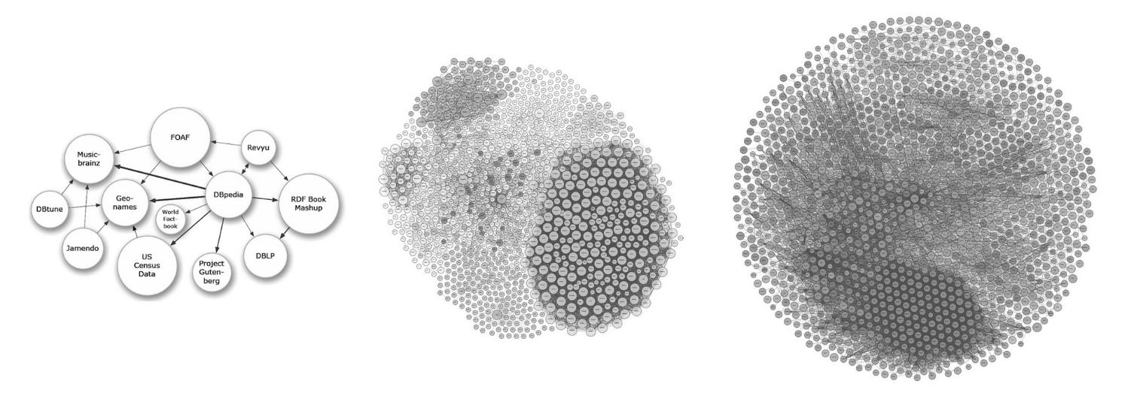
2007 2014 2026
Figure 1. Growth of the LOD Cloud, 2007-2026.
Source: LOD Cloud Draw, 2026.

Another significant development in Linked Data research is its increasing convergence with adjacent fields, including Natural Language Processing (NLP), machine learning, and, more recently, Large Language Models (LLMs) (Scherp et al. 2024). These approaches can complement Semantic Web technologies in tasks such as information extraction, entity recognition, entity linking, and the construction or enrichment of knowledge graphs from unstructured textual sources. In this relationship, ontologies and structured knowledge representations can provide explicit domain semantics against which automatically extracted information may be organized and evaluated. However, the existence of structured RDF data does not by itself guarantee the reliability or verifiability of information: these qualities also depend on the provenance, quality, and authority of the underlying sources. Similarly, outputs generated by LLMs require validation because probabilistic language generation may produce inaccurate statements.
An example of this convergence is the ATR4CH methodology (Adaptive Text-to-RDF for Cultural Heritage), a framework designed to support the extraction of Cultural Heritage information from textual sources and its transformation into RDF using domain-specific vocabularies (Schimmenti et al. 2026). The approach combines LLM-based information extraction with ontological structures in a pipeline for knowledge graph construction. The process decomposes the target knowledge representation into smaller components associated with JSON schemas, which mediate between information extracted from natural language and its subsequent representation as RDF triples. Such approaches illustrate how generative AI may assist semantic data production while maintaining ontological structures as an explicit representation layer.
Conversely, some authors claim that Semantic Web adoption has fallen far short of initial expectations. Most web pages still rely predominantly on pre-Semantic Web protocols: Hogan (2020) identifies several critiques that explain this trend: semantics is difficult to understand, invisible to most users, and laborious to add manually to content; moreover, standards are overly verbose. Additionally, Hogan (2020) highlights that dependence on reliable publishers, the complexity of ontology axioms and their slow learning curves, and high implementation costs have confined its applications to niche contexts. At the same time, the interaction of Semantic Web technologies with adjacent fields continues to create new applications for machine-readable structured knowledge.
Within Cultural Heritage, however, Semantic Web and Linked Data approaches have achieved more sustained institutional adoption. Organizations and infrastructures such as Europeana, the Library of Congress, and the Getty Research Institute demonstrate the use of persistent identifiers, controlled vocabularies, semantic data models, and Linked Data principles for the publication and integration of cultural heritage information. Rather than constituting a universal de facto standard for Digital Humanities, Linked Data can therefore be considered a well-established approach within cultural heritage information management and several areas of Digital Humanities, particularly where interoperability across heterogeneous collections and institutions is required (Hyvönen 2023).

Ontologies and Controlled Vocabularies
While the broader Web had a limited semantic adoption, the Cultural Heritage field began formalizing its conceptual frameworks a decade earlier, addressing the challenges of institutional data exchange. This trajectory began in 1994, when the International Council of Museums (ICOM) established the Documentation Standards Working Group within the International Committee for Documentation (CIDOC) to develop a global resource for research, exchange and advanced querying, taking into account the field's information heterogeneity.
The primary result of this effort was the CIDOC Conceptual Reference Model (CIDOC CRM). Released in 1999 and subsequently aligned with RDF standards in 2003, the CIDOC CRM provides the formal logic necessary to integrate distinct datasets. The model was formalized as ISO 21127 in 2006 and updated to the current version in 2023. Since then, CIDOC CRM has served as the reference model for GLAM institutions (Galleries, Libraries, Archives and Museums) and has consequently been widely used in Digital Humanities, and its support to semantic interoperability complies with the FAIR framework (Richards et al. 2022).
The CIDOC CRM is defined as:
A theoretical and practical tool for information integration in the field of cultural heritage … by providing definitions and a formal structure for describing the implicit and explicit concepts and relationships used in cultural heritage documentation … Such models are also known as formal ontologies. These formal descriptions allow the integration of data from multiple sources.
As mentioned above, the FAIR framework is a set of good practices in knowledge organization that encompasses four principles: Findability, Accessibility, Interoperability, and Reusability, for both humans and computers. This approach is fundamental for the Digital Humanities, as alignment with these principles ensures the long-term viability and utility of data. Furthermore, it moderates machine action in an environment where data volume, complexity, and creation velocity are increasing (Wilkinson et al. 2016).
To understand the methodological choices presented in this study (Chapter 3 Methodology), it is necessary to examine the CRM's concepts and formal structure. All definitions and declarations herein are based on the CIDOC CRM version 7.1.3, released in February 2024. This version updates the model by refining, deprecating, and removing certain previously used classes and properties.
The CIDOC CRM is a formal, logical system designed to organize Cultural Heritage data, providing 81 classes and 160 properties for relational descriptions. Classes represent types of cultural heritage entities, such as “Actor (E39)”, “Activity (E7)”, “Event (E5)”, and “Period (E4)”. These classes are semantically connected via properties, which define relationships such as “has type (P2),” “has time-span (P4),” or “took place at (P7)” (see Figure 2).
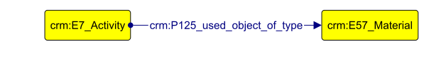
Figure 2. Example of a formal CIDOC CRM relation.

Although the model offers an extensive vocabulary, entities cannot be related in arbitrary ways; they must obey a strict inheritance hierarchy and defined domain and range restrictions (axioms). The valid relationships between entities are declared in the official CIDOC CRM documentation, ensuring that the resulting data remains interoperable across different institutional repositories and sources (Doerr, Ore, and Stead 2007).
The CIDOC CRM features many extension models, such as CRMgeo (a spatiotemporal model), CRMdig (for provenance metadata), CRMarcheo (for archaeological management), and CRMtex (for the study of ancient texts), among others. One of the most widely used extensions is FRBRoo (Functional Requirements for Bibliographic Records, object-oriented), currently updated as LRMoo (Library Reference Model, object-oriented), tailored for bibliographic data in Cultural Heritage contexts as libraries and archives. Although LRMoo supports complex archival modeling, this study utilizes the Dublin Core vocabulary to manage publication metadata.
The former Dublin Core Metadata Element Set (DCMES), later extended as the Dublin Core Metadata Initiative Terms (DCMI), hereafter referred to as DC and DC Terms respectively, provides a lightweight metadata description standard for bibliographic and other resources. Primarily with 15 broad descriptive elements, DC was later expanded into DC Terms, which includes 55 properties and 22 classes, and refined into a formally defined RDF structure.​ Compared to LRMoo's hierarchical and highly structured model, DC is simpler and less rigid, making it widely used for scholarly article indexing in digital repositories and web-based contexts (DCMI 2026).
The bibliographical datasets used in this study include properties derived from the fifteen primary elements of Dublin Core: Title, Subject, Description, Source, Language, Relation, Coverage, Creator, Publisher, Contributor, Rights, Date, Type, Format, and Identifier.
The Bibliographic Ontology (BIBO), a specialized ontology for documentation and citation, complements this approach by providing additional, domain-specific classes. Another supporting ontology employed is Friend of a Friend (FOAF), which provides lighter and more direct representations of human relationships than equivalent representations in CRM, as the latter would require a granular conceptualization to satisfy the ontology's formal axioms.
Beyond ontologies, an essential feature supporting data integration in Linked Open Data is the use of controlled vocabularies, authority resources, and persistent identifiers. Controlled vocabulary constitutes a catalog of standardized set of terms, names, or identifiers designed to ensure consistency in the description and retrieval of information via a persistent URI (Harpring 2010). Controlled vocabularies distinguish entities sharing identical nomenclature (homographs) and unify references to entities known by multiple names, either due to language and translation differences or to the use of synonyms, generic terms, or lexical variations (Harpring 2010).
External authority and identifier resources are also employed in this study. The Virtual International Authority File (VIAF) provides authority records for personal and corporate names, while Wikidata is used as a general-purpose knowledge base for entity reconciliation and for supplementary identifiers when equivalent information is unavailable in more specialized resources. The Digital Object Identifier (DOI) provides persistent identifiers for scholarly publications and other digital objects, while the Open Researcher and Contributor ID (ORCID) provides persistent identifiers for researchers. GeoNames, a geographical database, is used for the identification and reconciliation of geographical entities and toponymic nomenclature.
Additionally, the Simple Knowledge Organization System (SKOS) serves as a controlled vocabulary model, functioning as a classification framework for thesauri, taxonomies, and similar classification schemes. It provides semantic structure for concept mapping and disambiguation, ensuring that relationships between conceptual entities are explicitly defined and preventing these concepts from becoming machine non-iterable character strings (W3C 2009). It is important to note that SKOS does not provide the vocabulary itself, but rather the structural model that other agents, such as UNESCO, use to render their concepts semantically meaningful. The aforementioned thesauri, on the other hand, constitute curated sets of specific concepts and their definitions, as glossaries, which can be encoded using SKOS to support consistent description, retrieval, and interoperability. This study utilizes vocabularies from Getty Art & Architecture Thesaurus (AAT) and UNESCO Thesaurus.

The State of the Art
During the preparation of this study, no specific Khmer heritage LOD projects with public SPARQL endpoints were identified in the LOD Cloud (lod-cloud.net, accessed February 2026) or via targeted searches on Google Scholar and data catalogs. This observation does not imply an absence of digital initiatives concerning Khmer heritage, but of a semantic infrastructure integrating the heterogeneous documentary categories addressed in this research. Several Digital Humanities and cultural heritage initiatives nevertheless provide important comparative reference points for the application of semantic technologies and interoperable data models. Among them, Europeana, Fasti Online, and the Arches Platform illustrate different approaches to cultural heritage aggregation, archaeological documentation, spatial information, and semantic data management.
Europeana is an exemplary application of DH principles and one of the most extensive infrastructures for the aggregation and dissemination of digital cultural heritage. Often described as a digital library of cultural heritage objects, the platform aggregates material from more than a thousand institutions across the European Union (EU). Concordia et al. (2009) and Doerr et al. (2010) observe that this description captures only a small part of its functionality: rather than functioning as a traditional archive, Europeana exposes an Application Programming Interface (API) that enables semantic operations via Linked Open Data (Concordia et al. 2009), providing rich contextualization and visualization of object representations that would not be supported by a conventional digital library interface (Doerr et al. 2010).
A central component of this infrastructure is the Europeana Data Model (EDM) ontology, developed to integrate heterogeneous descriptions supplied by institutions employing different metadata structures (Doerr et al. 2010). With a strong emphasis on the searchability and reusability of data for both human users and automated processes, EDM formal specification directly reuses elements from RDF and RDFS, CRM, Dublin Core, LRMoo (FRBR), SKOS, OAI-ORE, and other established ontologies. EDM does not incorporate the complete conceptual structures of models, but a flexible integration that requires reconciliation (Doerr et al. 2010).
This approach demonstrates a central principle relevant to the present research: interoperability does not necessarily require reproducing the complete semantic granularity of every contributing system within a single ontology.
Concordia et al. (2009) and Doerr et al. (2010) accurately predicted the transformative impact of the Europeana Data Model (EDM). Since its 2010 implementation, Europeana's successive Strategic Plans (2011-2030) have evolved from content aggregation and standards adoption (notably IIIF) toward operational maturity and leadership in the Common European Data Space for Cultural Heritage, prioritizing AI-ready 3D assets and machine learning datasets, representing the current state of the art in digital cultural heritage management (Europeana Foundation 2011; 2015; 2025).
At the same time, Europeana illustrates the institutional requirements of large-scale interoperability. Its operation depends on sustained technical infrastructure, networks of aggregators and contributing institutions, common metadata requirements, data-quality processes, and substantial long-term institutional and financial support (European Commission 2026). Consequently, its architecture cannot simply be reproduced in every cultural heritage environment. The relevant lesson for the present study is not that a smaller infrastructure should reproduce Europeana at a reduced scale, but that shared semantic structures can provide an integration layer while remaining proportionate to available data, analytical requirements, and implementation scope.
As a methodological note, the Museum Collections component of the present model follows this principle. It adopts a considerably reduced descriptive scope compared with EDM, retaining only those entities and relationships necessary for the research questions and for integration with the other documentary categories represented in the knowledge graph. This reduction should therefore be understood as a deliberate modeling decision. Where richer object documentation is available, the model can subsequently be extended without requiring every source to provide the same level of descriptive granularity.
While Europeana represents a large-scale aggregation model, Fasti Online exemplifies a more decentralized and participatory approach to digital Cultural Heritage management. Fasti Online is an API-based database for archaeological documentation, covering data from 2000 onwards, published by the International Association for Classical Archaeology (AIAC) in partnership with other institutions. Fasti Online provides three sections of reports and metadata: archaeological surveys, conservation projects and excavation projects; and also hosts a peer-reviewed Journal, Fasti Online Documents & Research (Fold&r). The platform encompasses fifteen countries and metadata in fifteen languages (Fasti Online, 2026).
Johnson et al. (2018) examined the development of Fasti Online across excavation, conservation, and survey documentation and discussed attempts to increase the interoperability of its archaeological information. At that stage, further integration with semantic technologies, including RDF-based publication, formed part of the project's development trajectory rather than constituting a fully implemented Linked Open Data infrastructure. The technical environment has subsequently changed: Fasti Online and FOLD&R have migrated to Omeka S platform, which provides a Linked Data-oriented architecture based on RDF vocabularies and JSON-LD. However, at the time of this study, Fasti Online did not provide a publicly documented SPARQL endpoint or mechanism for retrieval of its archaeological dataset.
Fasti Online spatial dimension is particularly relevant. The platform employs GIS approaches that allow visualization methods for archaeological interventions and survey projects to be related to geographical locations. Fasti Online Survey developed partly from the earlier MAGIS project and facilitates the publication of open archaeological survey data and metadata through a geospatial interface.
The relevance of Fasti Online to the present study therefore lies primarily in its relationship between archaeological activities, documentary records, and spatial contexts. Excavations, surveys, and conservation projects generate information concerning particular sites, periods, researchers, institutions, and publications. This provides an important comparative precedent for connecting research and conservation activities to heritage places rather than representing these elements as independent records. Its significance for this thesis consequently derives less from the direct replication of its technical architecture than from its treatment of archaeological documentation as distributed information associated with activities occurring at particular locations.
A third and technically closer comparison is provided by the Arches Platform an open-source cultural heritage information-management platform originally developed by the Getty Conservation Institute and the World Monuments Fund. Arches was designed as a standards-based and configurable environment in which cultural heritage organizations can construct their own resource models while retaining semantic interoperability. Its data structures are graph-based, and CIDOC CRM is provided as the default semantic ontology for resource modeling. The platform also supports controlled vocabularies, geospatial information, APIs, and Linked Data formats such as RDF and JSON-LD. Several projects hosted on Arches share common approaches with the present study, as the Nepal Heritage Documentation Project, the HistoricPlacesLA, and the Soqotra Heritage Database.
The Nepal Heritage Documentation Project (NHDP), developed by Heidelberg University in cooperation with the Department of Archaeology of the Government of Nepal, documents monuments through geolocated data, providing historical context, conservation status, and assessments of potential risks. The platform also includes glossaries and photographic documentation, which can be accessed via a web interface or mobile applications. Additionally, it offers touristic thematic routes focused on selected historical contexts by the user. The database is structured in RDF, enabling advanced search functionalities across its datasets.
The HistoricPlacesLA (HPLA) is an interactive mapping tool developed by the City of Los Angeles from municipal records, presenting a wide range of cultural heritage assets, including architecture, historic neighborhoods, bridges, and landscapes. The project includes numerous classification categories that allow for multiple layers of visualization. It also offers specific search filters, such as architectural styles, zoning categories, and the social groups that shaped the city’s heritage. The platform is based on CIDOC CRM and allows data export in CSV and shapefile formats.
Lastly, the Soqotra Heritage Database is a project funded through the British Council’s Cultural Protection Fund. It offers a geolocated interface for cultural objects of interest and the biodiversity of Socotra Island and also includes a bibliographic catalog that links publications to their corresponding study locations, although it does not present structured metadata.
Taken together, these projects demonstrate different strategies for addressing cultural heritage heterogeneity. Europeana emphasizes cross-institutional metadata aggregation and semantic interoperability at large scale; Fasti Online demonstrates the integration of distributed archaeological documentation, activities, and spatial information; and Arches provides a configurable graph-based environment in which heritage organizations can structure heterogeneous information using shared semantic models. None of these approaches is directly equivalent to the problem addressed in this thesis, but each provides methodological principles that inform particular aspects of the proposed model.
The Khmer heritage case presents a distinct integration problem. Information concerning related cultural entities is distributed across museum collection records, scholarly publications, archaeological and geospatial datasets, and documentation of research and conservation activities. As Chapter 2 demonstrates, these resources were also produced within different historical, disciplinary, and institutional contexts. Their heterogeneity therefore concerns not only technical formats but also terminology, descriptive granularity, provenance, and the purposes for which the documentation was originally created.
No project identified during this research provided a shared semantic layer integrating these documentary dimensions specifically for Khmer cultural heritage. The present study therefore investigates whether a comparatively lightweight semantic model, based primarily on CIDOC CRM and complementary established vocabularies, can provide an interoperable structure for connecting these heterogeneous sources. Rather than reproducing the complete descriptive systems of the contributing institutions, the model identifies selected entities and relationships required for cross-source retrieval and evaluates their integration through an RDF knowledge graph. In this sense, the research applies Linked Data principles as an interoperability strategy while recognizing that the construction of a knowledge graph does not by itself constitute a complete public Linked Open Data infrastructure.

Chapter 2. Khmer Heritage, the Case Study.
This chapter establishes the geographical and historical scope for the research by examining the UNESCO-inscribed Khmer heritage sites. It provides an overview of the formation, zenith, and decline of the Angkorian state while introducing the four primary sites of analysis: the Angkor Complex, the Temple of Preah Vihear, the Temple Zone of Sambor Prei Kuk, and the Koh Ker Complex. It also contextualizes the creation and transmission of the sources that constitute the documentary corpus of this study.
The historical development of these sites is relevant not only for understanding their archaeological and cultural significance, but also for understanding their contemporary documentary context. Khmer heritage has been successively documented, classified, restored, managed, and studied by different actors and institutions. The information available today therefore reflects different historical periods, institutional practices, and forms of documentation. This chapter first defines the contemporary geographical and institutional scope of the case study, then examines the historical formation of the selected Khmer heritage sites, and finally considers the processes through which this heritage has been documented and transmitted into the present.

2.1. UNESCO Khmer Heritage Sites and Institutional Context
The United Nations Educational, Scientific, and Cultural Organization (UNESCO) defines cultural heritage as “the entire corpus of material signs - either artistic or symbolic - handed on by the past to each culture and, therefore, to whole of humankind” (UNESCO 1989). Operationally, it distinguishes tangible heritage, including movable objects such as sculptures and paintings and immovable heritage such as monuments and sites, from intangible heritage, including oral traditions and rituals. This project's data model focuses primarily on tangible, movable, and immovable Khmer cultural heritage.
The management of Cambodian cultural sites is governed by the framework of UNESCO's 1972 Convention Concerning the Protection of the World Cultural and Natural Heritage, which identifies and protects sites of “Outstanding Universal Value” (OUV). These natural or cultural properties, whose significance transcends national boundaries and is considered of universal importance to humanity, are inscribed on the World Heritage List upon demonstrating adequate integrity and authenticity and satisfying at least one of ten selection criteria. The first six criteria apply to cultural heritage (UNESCO 2025):
(i) Represent a masterpiece of human creative genius;
(ii) Exhibit an important interchange of human values, over a span of time or within a cultural area of the world, on developments in architecture or technology, monumental arts, town-planning or landscape design;
(iii) Bear a unique or at least exceptional testimony to a cultural tradition or to a civilization which is living or which has disappeared;
(iv) Be an outstanding example of a type of building, architectural or technological ensemble or landscape which illustrates (a) significant stage(s) in human history;
(v) Be an outstanding example of a traditional human settlement, land-use, or sea-use which is representative of a culture (or cultures), or human interaction with the environment especially when it has become vulnerable under the impact of irreversible change;
(vi) be directly or tangibly associated with events or living traditions, with ideas, or with beliefs, with artistic and literary works of outstanding universal significance.

In UNESCO's Operational Guidelines, integrity measures a property's completeness, including whether the elements necessary to convey its Outstanding Universal Value are present. Authenticity concerns whether cultural values are “truthfully and credibly expressed through a variety of attributes” (UNESCO 2025). These attributes include “form and design; materials and substance; use and function; traditions, techniques, and management systems; location and setting; language and other forms of intangible heritage; spirit and feeling; and other internal and external factors” (UNESCO 2025).
These concepts are particularly relevant to archaeological heritage because a heritage property is not defined exclusively by an individual monument. Its significance may also depend on its material characteristics, landscape, historical functions, spatial relationships, and broader cultural setting. Consequently, the spatial delimitation and management of UNESCO properties provide an important contemporary framework for examining the Khmer sites included in this study.
Cambodia currently has five UNESCO World Heritage Sites, four of which correspond to ancient Khmer archaeological heritage and constitute the geographical focus of this research. Their locations are presented in Figure 3, while their inscription dates, Outstanding Universal Value criteria, and responsible protection bodies are summarized in Table 1.
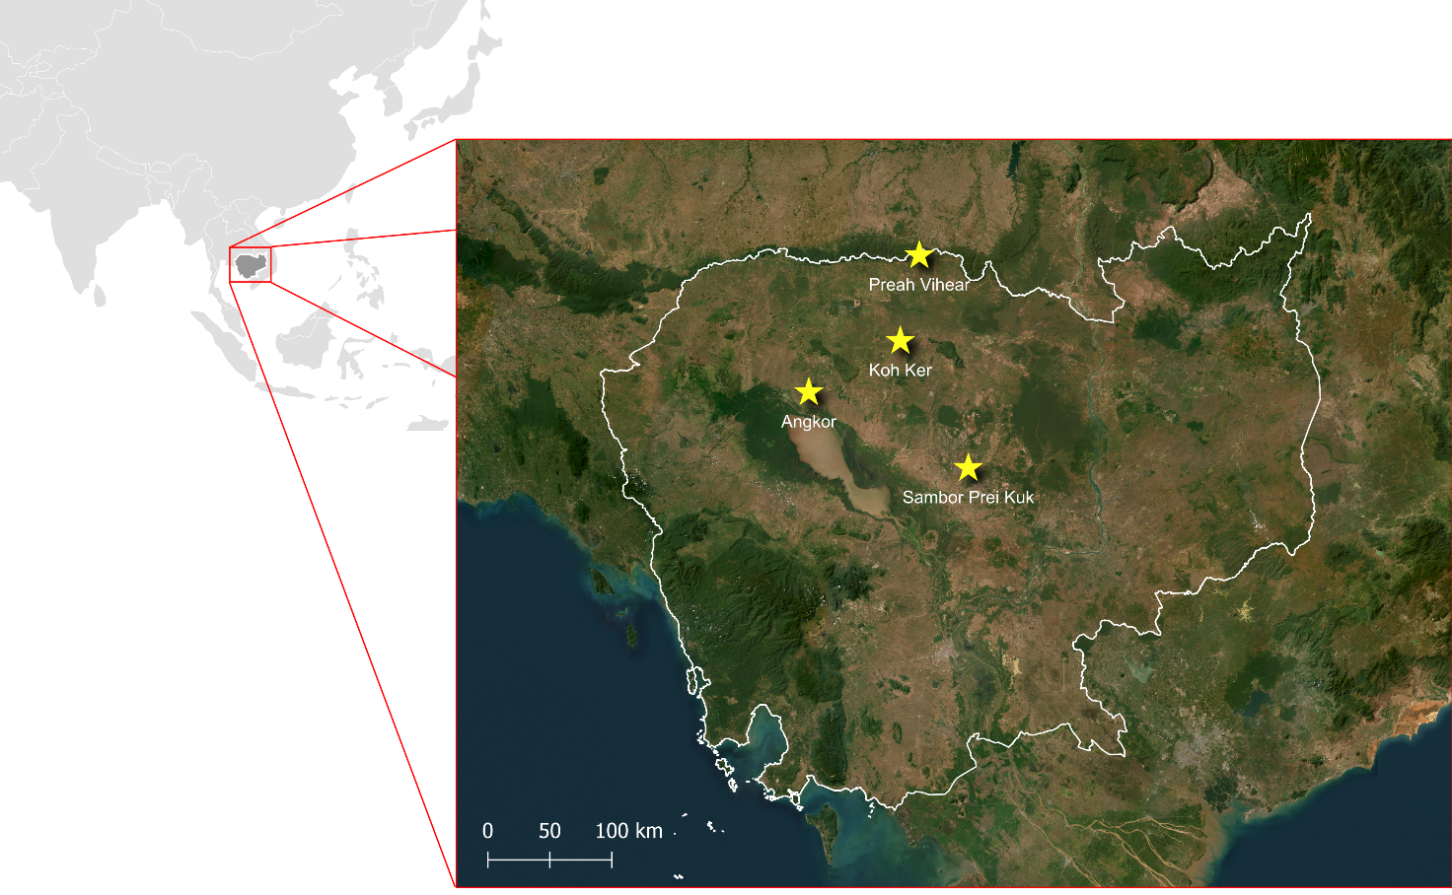
Figure 3. Cambodia’s World Heritage Khmer sites.
Source: Data from UNESCO; ESRI Satellite / Created by author.

Site Designation | Inscription | OUV | Protection Body
Angkor Archaeological Park | 1992 | (i), (ii), (iii), (iv) | APSARA National Authority
Temple of Preah Vihear | 2008 | (i) | National Authority for Preah Vihear (NAPV)
Temple Zone of Sambor Prei Kuk,  Archaeological Site of Ancient Ishanapura | 2017 | (ii)(iii)(vi) | National Authority for Sambor Prei Kuk (NASPK)
Koh Ker: Archaeological Site of Ancient Lingapura or Chok Gargyar | 2023 | (ii), (iv) | National Authority for Preah Vihear (NAPV)

Table 1. UNESCO World Heritage Khmer sites inscription.

The four properties comprise the Angkor Archaeological Park, inscribed in 1992; the Temple of Preah Vihear, inscribed in 2008; the Temple Zone of Sambor Prei Kuk, Archaeological Site of Ancient Isanapura, inscribed in 2017; and Koh Ker: Archaeological Site of Ancient Lingapura or Chok Gargyar, inscribed in 2023. Although all four properties belong to the broader history of Khmer cultural heritage, they represent different chronological periods, geographical contexts, and functions. Sambor Prei Kuk provides the principal pre-Angkorian site considered in this study, while Angkor, Preah Vihear, and Koh Ker are associated primarily with the subsequent Angkorian period.
The Operational Guidelines also delineate a protection and management framework for World Heritage properties: “All properties inscribed on the World Heritage List must have adequate long-term legislative, regulatory, institutional and/or traditional protection and management to ensure their safeguarding” (UNESCO 2025). Cultural heritage properties therefore require defined boundaries encompassing areas highlighting Outstanding Universal Value, referred to here as the nominated or inscribed property. Buffer zones may additionally surround these areas and provide complementary protection for the property's setting, integrity, community occupation, and economic land uses.
These spatial distinctions are important in the present case because contemporary heritage boundaries do not necessarily correspond to the historical extent of the settlements, political territories, or cultural landscapes with which the archaeological sites were associated. The boundaries used for contemporary heritage management should be distinguished from the historical geography of Khmer political and cultural influence, which extended beyond the borders of present-day Cambodia.
The four properties are currently administered by different Cambodian heritage authorities. The Authority for the Protection and Management of Angkor and the Region of Siem Reap (APSARA National Authority) is responsible for the Angkor property and its surrounding region. The National Authority for Sambor Prei Kuk (NASPK) is responsible for the management and conservation of Sambor Prei Kuk, while the National Authority for Preah Vihear (NAPV) is responsible for Preah Vihear and Koh Ker. These institutions operate under the Cambodian Ministry of Culture and Fine Arts and participate, together with UNESCO and international partners, in the conservation, research, management, and documentation of the respective heritage properties.
The Temple Zone of Sambor Prei Kuk nominated property covers an area of approximately 840 hectares, or 2,523.6 hectares including the buffer zone. It is located in Kampong Thom Province and is administered by the National Authority for Sambor Prei Kuk (NASPK), a public administrative organization under the Ministry of Culture and Fine Arts responsible for its Management Plan and fifteen-year Conservation Plan.
The Temple of Preah Vihear nominated property covers approximately 154.7 hectares, or 2,642.5 hectares including the buffer zone. The property is located in Preah Vihear Province, on the edge of the Dangrek escarpment marking the border region between Cambodia and Thailand. Its buffer zone was delineated partly through pre-existing roads and a sector extending from the temple promontory in order to preserve the surrounding landscape. The property is administered by the National Authority for Preah Vihear (NAPV), which, in cooperation with international partners, is responsible for its heritage management and conservation.
The Koh Ker nominated property covers approximately 1,187.6 hectares, or 3,523.7 hectares including its buffer zone. It is also located in Preah Vihear Province and is administered by NAPV, in cooperation with the International Coordinating Committee (ICC). Its contemporary management framework includes measures for conservation, tourism management, risk prevention, and protection of the archaeological property.
The Angkor property constitutes the largest and most complex of the four selected heritage areas. The nominated property covers approximately 20,800 hectares, or 40,100 hectares including its buffer zone, and encompasses the principal archaeological areas of Angkor, Banteay Srei, and Roluos. Located in Siem Reap Province, it is administered by the APSARA National Authority, which is responsible for heritage management, archaeological research, conservation, tourism planning, community development, and the management of natural and cultural resources. Angkor was also included on the List of World Heritage in Danger between 1992 and 2004, during which emergency conservation and management measures were implemented (UNESCO 2025).
The contemporary management structures of the four properties are relevant beyond their administrative functions. Heritage authorities and international organizations also produce and maintain different forms of documentation, including nomination dossiers, management plans, conservation reports, maps, archaeological records, risk assessments, and documentation of research and restoration activities. Consequently, the four properties exist not only as archaeological landscapes but also within contemporary institutional environments through which information about them is continuously produced, organized, and preserved.

2.2. Historical Formation of the Khmer Heritage
Historical contextualization of Khmer heritage is essential to understanding the four archaeological properties examined in this case study. The emergence of the monumental and religious landscapes conventionally associated with the Angkorian period was preceded by earlier political formations connected to regional exchange networks in mainland Southeast Asia.
From the first centuries CE, settlements in the lower Mekong region participated in maritime trade networks connecting Southeast Asia with China, India, and, indirectly, the Mediterranean world. Chinese sources refer to one of the principal political formations of this period as Funan, whose trading centers in the Mekong Delta participated in the exchange of agricultural products, metals, and other commodities (Coe 2003). Sanskrit inscriptions and archaeological evidence also indicate the increasing incorporation of Indian religious, political, and cosmological concepts into local societies. This process, traditionally described in scholarship as “Indianization,” did not represent a simple colonization or replacement of local cultural traditions. Rather, religious concepts and political practices were selectively adopted and transformed within existing Southeast Asian contexts, particularly through elite networks and regional exchange (Briggs 1951; Coe 2003; Stark 2006).
From approximately the sixth century onward, the political configurations conventionally identified in Chinese sources as Funan and Chenla (or Zhenla), underwent substantial transformation. Earlier historiography, points Stark (2006), frequently interpreted this transition as the decline of Funan followed by its replacement by an expanding Chenla polity. More recent interpretations, however, have emphasized the complexity of these political formations and the limitations of reconstructing their relationships as a straightforward territorial succession. What can be observed more clearly is the increasing political importance of inland settlements connected to the Mekong basin and the emergence, during the seventh century, of Isanapura, corresponding to present-day Sambor Prei Kuk, as an important political and religious center under Isanavarman I, inaugurating the so-called “Pre-Angkor Period” (Coe 2003).
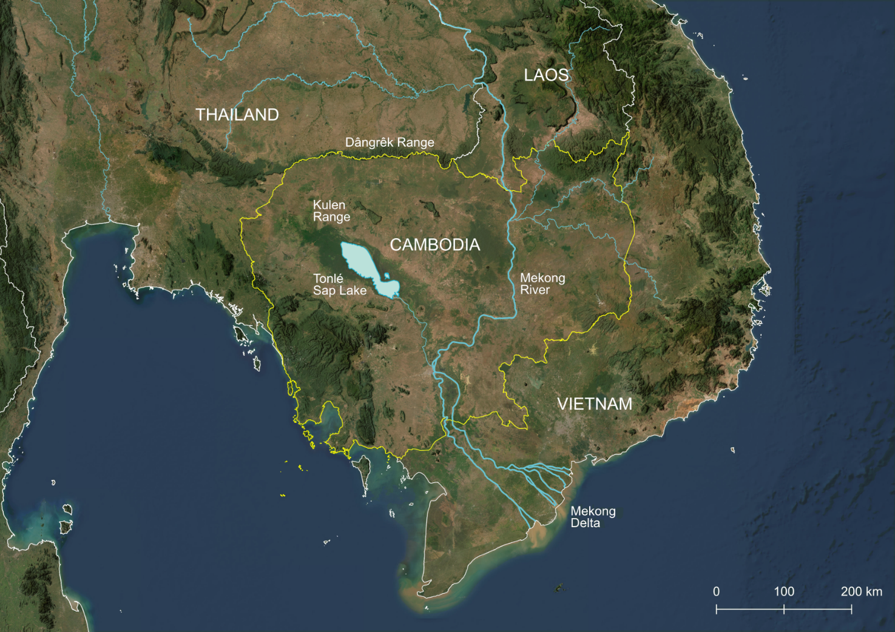
Legend
Cambodia boundary
International boundaries
Mekong River
Mekong tributaries
Figure 4. Physical geography of Cambodia and its adjacent areas, including the Mekong River and its tributaries.
Source: ESRI Satellite, opendevelopmentmekong.net, gadm.org / Created by author.
The geographical context illustrated in Figure 4 is important for understanding these developments. The Mekong River, its tributaries, the Tonlé Sap basin, and the surrounding uplands formed interconnected environmental and communication systems rather than fixed political boundaries. Although the figure represents present-day territorial divisions, it provides a geographical reference for the river systems, plains, and orography within which pre-Angkorian and later Angkorian centers developed.
Sambor Prei Kuk already exhibited foundational elements that would later become patterns in the following Khmer periods. First, monumentality became closely associated with political and religious authority. Each king commissioned additional temples, forming architectural ensembles structured around Hindu cosmology; initially constructed of brick but later incorporating laterite after the development of the iron industry enabled its extraction (Hendrickson and Evans 2015). Construction relied on communal corvée labor, war prisoners, and khñum (temple servants) (Coe 2003). Many of these sanctuaries are designated by the Khmer term prasat, meaning a temple or sanctuary, which occurs frequently in the names of monuments throughout the archaeological documentation.
Second, hydraulic engineering played an indispensable role in the relationship between settlements, agricultural production, and monumental landscapes. Extensive artificial water networks facilitated wet-rice cultivation across the Mekong Valley and the Tonlé Sap plains, providing control over seasonal flooding, particularly significant the large artificial reservoirs known as baray. These systems, beyond fulfilling religious functions, helped regulate the humidity of the clay soils on which the temples were built, preventing the soil from contracting during dry periods and damaging their structural stability. The abandonment and drying of these reservoirs were, in many cases, major factors behind the collapse of numerous monuments (Coe 2003).
Third, the period is important for the development of written documentation. Sanskrit remained prominent in royal and religious inscriptions, while Old Khmer increasingly appeared in administrative and other documentary contexts (Stark 2006). Epigraphy constitutes the principal surviving body of written evidence from this period. Other forms of written documentation were likely produced on perishable materials, whose preservation was severely constrained by the tropical environment, while successive periods of political instability and transformations in institutions and practices of transmission further contributed to their disappearance (Vickery 2004; Coe 2003). Stone inscriptions, by contrast, survived as material objects and preserve information concerning rulers, religious foundations, places, social relationships, donations, land, and institutional practices. The surviving documentary record is therefore highly selective: contemporary knowledge of the period depends disproportionately on information considered appropriate for inscription in durable materials, particularly in religious and elite contexts.
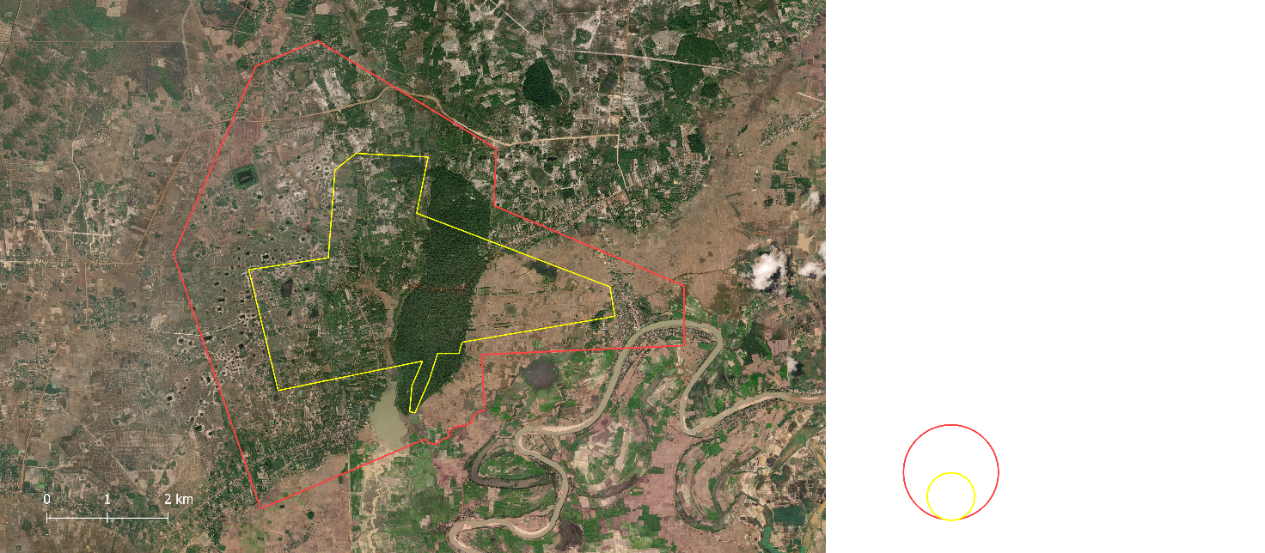
Buffer Zone
Nominated property

Legend

Figure 5. Sambor Prei Kuk temple UNESCO Site.
Source: Data from UNESCO; ESRI Satellite / Created by author.

Political authority during the Chenla period was not necessarily uniform across the territory. Different regional centers could maintain considerable autonomy, such as Banteay Prei Nokor and Champassak. Central authority fluctuated between rulers, resulting in periods of stronger or weaker control (Stark 2006). Economic exchange included agricultural products, handicrafts, metals, and other resources, while inscriptions document systems of taxation, donation, and collective labour. Evidence for coinage and monetization remains limited compared with some neighboring regions (Stark 2006).
This fragmented configuration changed with the rise of Jayavarman II in 802, inaugurating the so-called “Angkorian Period” (Coe 2003). Rather than representing an abrupt cultural rupture, the beginning of the Angkorian period should be understood in relation to earlier political, religious, architectural, and economic developments already visible at sites such as Sambor Prei Kuk.
Jayavarman II altered the rules of succession to a patrilineal system, employed military force to expand Khmer territory westward, and declared himself chakravartin (“universal monarch”) under Hindu rites, becoming the personification of a deity (Coe 2003). The king of the emerging Khmer Empire established a new capital north of the Tonlé Sap Lake, at Hariharalaya, corresponding to today's Roluos Group within the Angkor UNESCO World Heritage site (See Figure 9). His successors continued this expansion, marking the extent of imperial territory through the construction of cities and temples, many of them in difficult-to-access locations (Coe 2003), such as Preah Vihear temple (Figure 6), another UNESCO World Heritage site built atop the Dangrek mountain range, developed through successive phases of construction and royal patronage. The Khmer term preah is attributed to sacred or venerable persons, objects, and places.
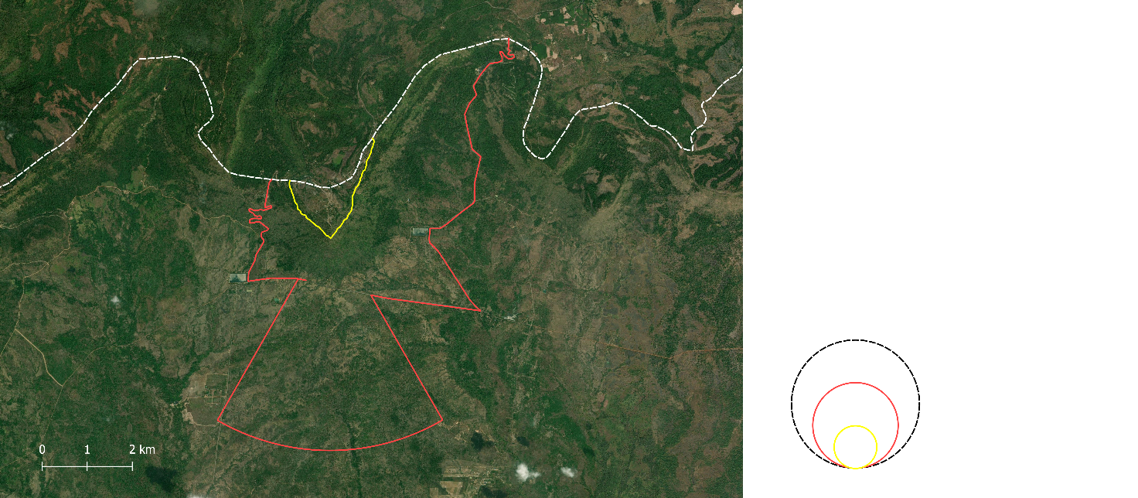
Legend

International Boundary (white)
Buffer Zone
Nominated property

Thailand
Cambodia
Figure 6. Preah Vihear temple UNESCO Site.
Source: Data from UNESCO; ESRI Satellite / Created by author.

The region between the northern shores of the Tonlé Sap and the Kulen Range offered environmental conditions favorable to the development of increasingly extensive settlements and water-management systems. In the late ninth century, Yasovarman I established Yasodharapura in the Angkor region. The area subsequently remained the principal center of Angkorian political power for much of the following centuries (Coe 2003).
Angkor developed as an extensive anthropogenic landscape shaped by successive rulers through the establishment of temples, reservoirs, royal compounds, roads, and settlements across a broad territory. Shifts in political authority generated new centers of monumental construction while earlier centers remained part of the wider landscape.
In a brief interval another coexisting capital, Chok Gargyar (Koh Ker), was established in the Kulen Range (See Figure 7) by Jayavarman IV. Koh Ker was built for reasons that remain uncertain. The city served as the capital of the Khmer Empire from 928 to 941, after which the court returned to Angkor following Jayavarman IV’s death. The site features Prasat Thom, a large seven-stepped pyramid and extensive infrastructure for rainwater collection, since its location atop the Kulen plateau did not offer the same availability of fresh surface water as the lower Angkor city (Coe 2003). Another consequence of its relative isolation is the large number of preserved sandstone sculptures recovered during early twentieth-century expeditions by the École Française d’Extrême-Orient (EFEO), an abundant material due to its proximity to the sandstone quarries that supplied Angkor, which used sandstone as a replacement for brick in temple construction (Coe 2003).
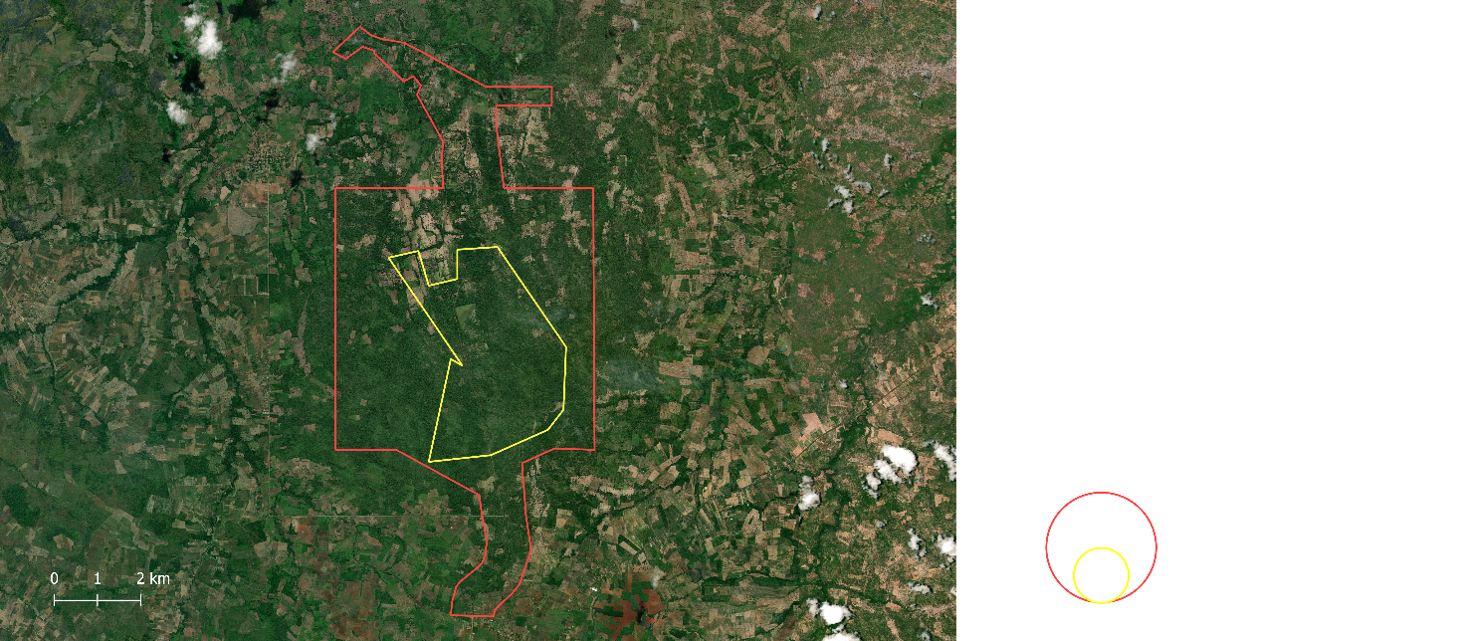
Buffer Zone
Nominated property

Legend

Figure 7. Koh Ker complex UNESCO Site.
Source: Data from UNESCO; ESRI Satellite / Created by author.

Following the death of Jayavarman IV in 941, royal power returned to the Angkor region. Rajendravarman II (944 - 968) subsequently consolidated royal authority at Angkor and sponsored important religious and architectural projects. One of the most significant monuments of the later tenth century is Banteay Srei (see Figure 8), another temple complex within the Angkor World Heritage site (see Figure 9), consecrated in 967 and associated principally with the Brahman Yajnavaraha, a high-ranking member of the royal court. Constructed primarily in reddish sandstone and distinguished by exceptionally elaborate carving, the temple demonstrates the participation of powerful non-royal elites in the production of the Angkorian sacred landscape (Coe 2003).
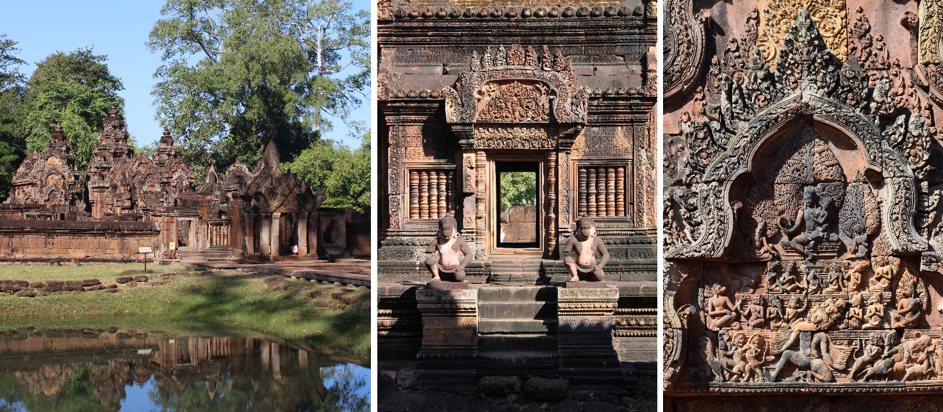
Figure 8. Image collage of Banteay Srei showing the temple complex, architecture, and carved details.
Source: Photos by author
During the eleventh and twelfth centuries, Angkorian political influence expanded across substantial areas of mainland Southeast Asia, while monumental construction and hydraulic infrastructure continued to transform the Angkor region. Royal foundations increasingly expressed relationships among political authority, religious cosmology, monumental architecture, and landscape organization.
One of the most prominent examples is Angkor Wat (Figures 9 and 10), commissioned during the reign of Suryavarman II in the first half of the twelfth century. The term wat, used in Khmer for a Buddhist temple or monastery, forms part of the monument's modern name, although it was originally constructed as a Hindu temple dedicated to Vishnu. The temple complex is organized through concentric galleries, terraces, towers, causeways, and extensive sculptural decoration. Its bas-reliefs depict episodes from Hindu epics and mythology alongside representations of royal and military activity, while its architectural organization has conventionally been interpreted in relation to Mount Meru and Hindu cosmology (Coe 2003).
The monument formed part of a much larger cultural landscape. Temples, barays, canals, roads, agricultural areas, and settlements were integrated into the broader Angkor region, demonstrating the scale at which human occupation transformed the environment. Coningham et al. (2007) describe this relationship between monumental construction, political organization, and landscape through the concept of a “theocratic landscape,” emphasizing that Angkorian religious architecture cannot be interpreted independently from the social and spatial systems surrounding it.
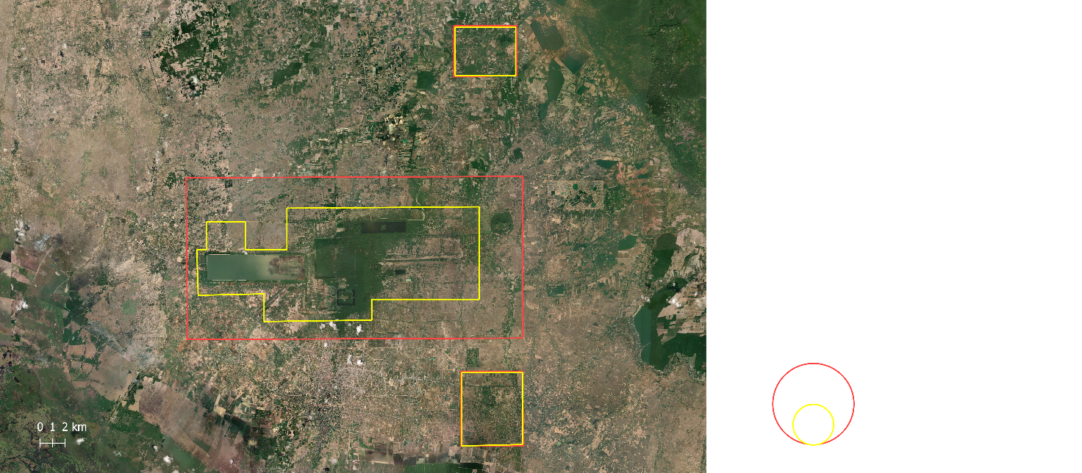
Legend

1 – Angkor
2 – Banteay Srei
3 – Roluos

Buffer Zone
Nominated property

2
1
3
Figure 9. Angkor Wat complex UNESCO Site.
Source: Data from UNESCO; ESRI Satellite / Created by author.

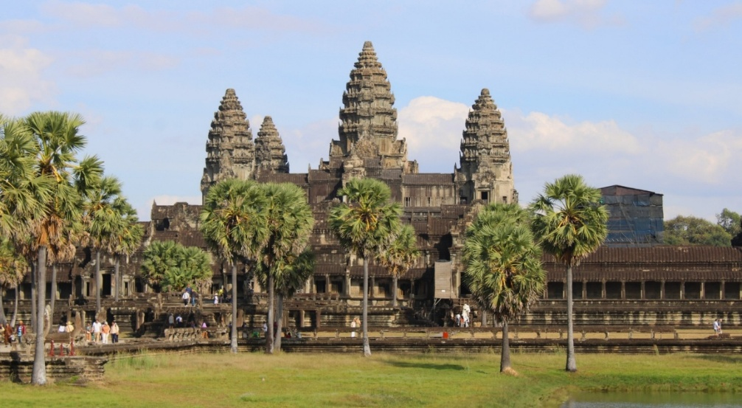
Figure 10. Angkor Wat temple.
Source: Photo by author.

Political stability was interrupted in 1177 when Cham forces attacked Angkor. Jayavarman VII subsequently defeated the Cham and consolidated royal authority, beginning one of the most intensive periods of monumental construction in Angkorian history (Higham 2001). His reign is conventionally associated with the political and territorial zenith of the Angkorian state.
Jayavarman VII's architectural program included Angkor Thom and the Bayon, as well as restoration of temples, roads, bridges, reservoirs, rest houses (Dharmasalas), and hospitals (Arogyasalas). The Bayon occupied the center of Angkor Thom, a temple with 54 towers bearing 216 Avalokitesvara faces sculpted in sandstone, associated with Mahayana Buddhist ideology (Coe 2003). Jayavarman VII thereby curbed the chaos of city-state independence while cultivating an image as a benevolent and tolerant ruler (Higham 2001).
The reign of Jayavarman VII demonstrates the scale and diversity of activities associated with monumental heritage. Temples were infrastructural systems involving construction, maintenance, religious practices, movement, and institutional organization. Surviving architecture, inscriptions, sculptures, and landscape features consequently document different aspects of these historical processes.
His successor, Indravarman II (1218-1243) maintained elements of his predecessor's Buddhist patronage, while the reign of Jayavarman VIII was associated with a major reaction against Buddhist religious imagery and the modification or destruction of numerous Buddhist representations (Coe 2003). This is particularly relevant to the surviving heritage landscape. The contemporary classification of a monument as “Hindu” or “Buddhist” may summarize a dominant phase of its history but does not necessarily represent all periods of its religious use. The material layers of Khmer monuments can preserve successive interventions and reinterpretations, requiring attention to chronology when relating religious classifications to particular sites, objects, or historical activities.
From the late thirteenth and fourteenth centuries, the documentary and political landscape of Angkor underwent substantial transformation. Stone inscriptions, which constitute one of the principal sources for reconstructing earlier Angkorian political and institutional history, became considerably less frequent (Vickery 2004). This change in the surviving documentary record makes the later history of Angkor more difficult to reconstruct and has contributed to continuing historiographical debate concerning the causes, chronology, and character of its political transformation.
Several explanations have been proposed for the weakening of the Angkorian political system. Earlier scholarship emphasized the economic burden of extensive royal construction programs, corvée labour and taxation (Briggs 1951). Religious explanations have also associated the expansion of Theravada Buddhism with changes in the ideological structures that had supported earlier forms of divine and imperial subservience (Briggs 1951). More recent research also point to paleoclimatic evidence indicating periods of prolonged drought and extreme monsoon variability during the fourteenth and fifteenth centuries, creating substantial pressures on Angkor's extensive water-management infrastructure and agricultural systems (Buckley et al. 2010). Most significantly, however, persistent external pressures from the east by Dai Viet and from the west by Ayutthaya, a Thai Kingdom, were steadily absorbing Khmer territories. The capital, however, persisted for another century amid economic decline (Coe 2003).
The Ayutthayan occupation of Angkor in the fifteenth century, conventionally dated to 1431, provides a useful chronological marker for the end of the Angkorian period, but it did not result in the complete abandonment of the region (Stark 2006). Courtly and political power increasingly shifted toward southeastern Cambodia and the Mekong corridor, while parts of Angkor continued to be inhabited and used.
This distinction is particularly important in the case of Angkor Wat. Rather than being abandoned and “rediscovered” centuries later, the temple retained religious significance and continued to function as a Buddhist site during the post-Angkorian period. Its continued use is documented in inscriptions, foreign accounts, and evidence of pilgrimage.
Understanding how these sites and objects were subsequently maintained, described, interpreted, displaced, and institutionalized is essential for explaining their present configuration. Section 2.3 therefore moves from the historical formation of the Khmer heritage landscape to the processes through which this heritage was transmitted and documented from the post-Angkorian period to the present.

2.3. Transmission, Documentation, and Institutionalization of Khmer Heritage
Although this study primarily examines cultural heritage associated with the pre-Angkorian and Angkorian periods, the historical trajectory following the decline of the Angkorian political system is also required for understanding the present configuration of these elements. Monuments and objects that originated during these earlier periods continued to be used, transformed, documented, displaced, collected, and interpreted over subsequent centuries. The documentary record available today is therefore also the result of the historical processes through which Khmer heritage was transmitted and institutionalized.
Following the decline of Angkor as the principal political center, Cambodia entered an intermediate period from the fifteenth to the nineteenth century, characterized by changing political centers and increasing pressure from Siam and Vietnam (Vickery 2004; Coe 2003). The nature of the surviving written evidence also changed significantly. The decline of the epigraphic tradition discussed in the previous section means that the extensive corpus of inscriptions available for the pre-Angkorian and Angkorian periods has no direct equivalent for much of the post-Angkorian period, making the reconstruction of its early centuries particularly difficult (Nhim 2009).
Historical reconstruction consequently depends on different categories of evidence, including Cambodian Royal Chronicles, Siamese and Vietnamese records, and accounts produced by foreign merchants, missionaries, and travelers. The Khmer Royal Chronicles (baṅsāvtār) constitute an especially important indigenous historiographical tradition, principally concerned with royal genealogies and the deeds of rulers (Thun 2020). However, their surviving versions were compiled and copied centuries later than the events they describe, and their narratives combine historical traditions with legendary and supernatural elements (Thun 2020; Nhim 2009).
The period was also characterized by substantial political, economic, and religious transformations. Royal power progressively shifted toward southeastern Cambodia, while political and commercial hubs developed closer to the Mekong and maritime trade networks. Longvek, for example, became an important port connected to Asian and European merchants (Vickery 2004). At the same time, Theravada Buddhism became increasingly prominent within Cambodian religious life, transforming patterns of religious use of earlier monuments.
Despite the relocation of political power, Khmer monuments were not uniformly abandoned. Angkor Wat, in particular, continued to function as an important Buddhist religious and pilgrimage site. Sixteenth-century Portuguese accounts provide evidence of continued activity at Angkor (Vickery 2004), while Japanese inscriptions from the seventeenth century provide further evidence of pilgrimage and interaction with the monument (Coe 2003). Other archaeological complexes experienced different trajectories. More peripheral sites such as Koh Ker were less intensively occupied and maintained, allowing vegetation and environmental processes to affect their monuments and hydraulic structures. The physical preservation of Khmer heritage was therefore uneven, just as the documentary evidence concerning it was unevenly transmitted.
A major transformation in the documentation and institutional treatment of Khmer heritage occurred during the colonial period. In 1863, King Norodom sought a French protectorate to ensure the kingdom's survival against Siamese and Vietnamese encroachment, leading to Cambodia’s incorporation into French Indochina. The colonial administration significantly restructured the political and economic landscape by the introduction of private landownership (thereby diminishing the king’s absolute rights), tax reforms, and the abolition of slavery (Tully 2006). Critically, the French mission civilisatrice placed a heavy emphasis on the study and preservation of Khmer cultural heritage.
In 1900, France established the École Française d’Extrême-Orient (EFEO) to undertake the systematic documentation and restoration of Angkorian monuments. EFEO activities contributed substantially to modern knowledge of Angkorian history, but they were simultaneously embedded within the political and intellectual structures of colonial rule. Archaeological research involved processes of identification, classification, naming, dating, reconstruction, and interpretation. Decisions concerning which monuments were recorded, how structures were classified, which architectural phases were distinguished, and which elements were restored contributed to the formation of the modern scholarly representation of Angkorian heritage. The terminology, chronologies, inventories, and spatial classifications found in contemporary scholarship therefore have their own documentary histories, many of which extend back to colonial archaeological practices (Tully 2006).
The colonial period also contributed to the formation and expansion of museum collections containing Khmer cultural objects, many of them directed to European institutions, such as the Musée Guimet. Sculptures, architectural elements, inscriptions, and other archaeological materials entered Cambodian and foreign institutional collections through different processes of excavation, transfer, acquisition, donation, purchase, and removal. Consequently, objects originally associated with a particular monument or archaeological landscape may today be physically separated from that context and documented primarily through museum collection records. Their present location, institutional history, and archaeological origin therefore constitute distinct aspects of their historical trajectories.
This process is particularly relevant to the contemporary documentary landscape. An archaeological object may be described in an early excavation or inventory, subsequently discussed in scholarly literature, transferred to a museum collection, assigned one or more inventory numbers or classifications, photographed, reattributed, and eventually represented in a digital catalog. These records concern the same material object but were created by different institutions, at different times, and for different purposes. Contemporary digital records should therefore be understood as the most recent layers within longer histories of documentation rather than as neutral starting points for the description of Khmer heritage.
The colonial period also transformed Cambodia's modern political geography. The Franco-Siamese agreements of the early twentieth century contributed to the delimitation of Cambodia's modern borders and to subsequent disputes concerning the Preah Vihear temple region (Tully 2006), disputes that employed military interventions in the 1960’s (International Court of Justice 1962) and reinitiated in 2025. French colonial rule was interrupted by Japanese occupation during the Second World War, and Cambodia ultimately achieved independence in 1953 (Tully 2006). The relationship between archaeological heritage, territorial sovereignty, and national identity consequently continued beyond the colonial period.
In the post-independence period, Cambodia, under the leadership of Norodom Sihanouk, initially pursued a policy of neutrality during the Cold War. However, by the late 1960s, the country was destabilized by internal dissent and the spillover of the Vietnam War (Tully 2006). Following a military coup in 1970, Cambodia descended into civil war, which culminated in 1975 with the seizure of power by the Communist Party of Kampuchea, commonly known as the Khmer Rouge, under the leadership of Pol Pot (Tully 2006).
The Democratic Kampuchea regime (1975-1979) implemented a radical and violent “agrarian utopia” (Davis 2011). Cities were evacuated compelling urban populations into rural labor camps, money was abolished, and “class enemies” were executed. Pol Pot’s vision fused secularist communism with an idealized agrarian Angkorian past, prioritizing the Khmer Empire’s modes of production over its religious significance (Davis 2011). The effects on Cambodian heritage, however, extended beyond the Khmer Rouge period itself. Decades of civil war, political instability, limited institutional control, and insecurity created conditions in which archaeological sites became particularly vulnerable to illicit excavation and trafficking.
Looting and the international circulation of Khmer antiquities produced lasting consequences for the documentation of cultural objects. Sculptures and architectural elements removed from archaeological contexts frequently lost information concerning their precise place of origin, circumstances of removal, and subsequent chain of ownership. Objects could later enter private collections or museums with incomplete, uncertain, or reconstructed provenance histories (Davis 2011).
Conflict also directly affected archaeological research and conservation. Landmines and unexploded weapons remained present in and around archaeological areas, restricting access and complicating conservation activities for decades (Davis 2011). The disruption of institutions and the loss or dispersal of documentation further affected the continuity through which archaeological and cultural information could be preserved. The contemporary fragmentation of Khmer heritage documentation must therefore be understood partly in relation to this history of political disruption and material displacement.
The fall of Democratic Kampuchea in 1979 was followed by Vietnamese intervention and another period of political conflict. The 1991 Paris Peace Agreements and subsequent United Nations-supervised transition created the conditions for a new phase of reconstruction and international cooperation (Tully 2006). Cultural heritage became an important component of this process.
The inscription of Angkor on the UNESCO World Heritage List in 1992, initially also on the List of World Heritage in Danger, marked an important stage in the internationalization of Cambodian heritage conservation. The establishment of the APSARA National Authority in 1995 subsequently created a permanent Cambodian institution responsible for the management of Angkor and its surrounding region. As discussed in Section 2.1, later institutional frameworks were established for Preah Vihear, Sambor Prei Kuk, and Koh Ker, while cooperation with UNESCO and international research and conservation institutions expanded.
These developments generated new forms of heritage documentation. Archaeological surveys, conservation projects, management plans, UNESCO nomination dossiers, monitoring reports, risk assessments, maps, restoration records, and scholarly publications document different aspects of the same heritage landscape. The contemporary institutionalization of Khmer heritage has therefore increased both the quantity and the diversity of information available concerning monuments, objects, archaeological areas, and conservation activities.
The recovery and repatriation of displaced cultural objects has become another significant aspect of contemporary Cambodian heritage policy. Investigations into the provenance of Khmer antiquities held abroad have resulted in the return of objects from museums, private collections, and other institutions (Socheat et al. 2021). Repatriation consequently produces additional documentation while also revising or supplementing earlier records concerning the same objects.
At the same time, an increasing proportion of Khmer heritage documentation has become available through digital environments. Museums publish collection catalogs containing descriptions and images of Khmer objects; UNESCO and Cambodian heritage authorities provide reports, nomination documentation, and maps; scholarly publications are indexed through bibliographic databases; archaeological projects disseminate research results digitally; and geographical information can be represented through GIS datasets. Digitization and digital publication have substantially expanded access to these materials, but they have not eliminated the differences among the institutions and documentary traditions from which the information originates.
The present documentary landscape is consequently the product of successive historical layers. These layers are interconnected but are not equivalent. A museum catalog record describing a sculpture, for example, is not the sculpture itself, nor is it equivalent to an archaeological publication discussing its original context. Similarly, a UNESCO management document, an archaeological site record, a historical inscription, and a modern geospatial dataset may refer to the same place while describing it according to different purposes, scales, chronologies, and institutional conventions. The history of Khmer heritage documentation has therefore produced a heterogeneous information environment in which related evidence is distributed across multiple sources and institutions.
This historical development is directly relevant to the problem addressed by the present research. The fragmentation encountered in contemporary Khmer heritage information is not exclusively a consequence of incompatible digital formats or database structures. It also reflects the longer histories through which monuments and objects were produced, preserved, documented, classified, displaced, collected, restored, and interpreted. Understanding these processes provides the necessary context for examining, in the following chapter, how heterogeneous information from these different documentary environments was selected, structured, and integrated for the purposes of this study.

Chapter 3. Research and Methodology
This chapter presents the methodological framework and technical development of the proposed knowledge graph for integrating heterogeneous Khmer cultural heritage data. It defines the research question and objectives, introduces the knowledge-engineering methodology, and describes the construction and harmonization of the research corpus across four interconnected axes: museum collections, scientific publications, archaeological and geospatial resources, and reports on heritage-related activities. Particular attention is given to the normalization of metadata, temporal and spatial information, multilingual terminology, controlled vocabularies, and identifiers.
The chapter then presents the semantic modeling of these four axes and their integration into a unified ontology through established standards and vocabularies, including CIDOC CRM, DC Terms, BIBO, FOAF, SKOS, and GeoSPARQL. It also describes the implementation of the RDF Knowledge Graph, the conventions adopted for entity instantiation and URI construction, and the procedures used to assess logical and structural consistency through reasoning and validation. Together, these stages establish the methodological pipeline through which heterogeneous source data are transformed into an interoperable semantic representation of Khmer cultural heritage.

3.1. Research Question and Objectives
The research question (RQ) of this study is:
How can fragmented data be integrated to provide a comprehensive digital representation of a domain in cultural heritage within the Semantic Web?
To address this question, the study explores the following objectives:
- O1 - To aggregate and harmonize heterogeneous data originating from cultural heritage institutions and related domains.
- O2 - To align diverse metadata description practices within a formal semantic modeling framework based on widely adopted ontologies.
- O3 - To manage variability in temporal and spatial attributions, aiming to reduce ambiguity in approximate temporal mappings and uncertain geographic provenance.
- O4 - To use integrated datasets to generate new forms of knowledge, as well as visualization methods that enhance access and interaction for diverse audiences.
- O5 - To contextualize the geographical displacement of objects over time.
This research question arises from the hypothesis that a platform linking information from fragmented sources can enhance accessibility and interpretability, and that this model can be replicated in contexts beyond the case study with the necessary adaptations.

3.2. Methodology
This study adopts the Simple Knowledge-Engineering Methodology proposed by Noy and McGuinness (2001). The methodology is grounded in the premise that knowledge may be represented through multiple conceptual structures and that the intended purpose and application context of the ontology should guide ontological design decisions. Accordingly, ontology development is conceived as an iterative and incremental process comprising the following stages:
- Definition of the domain: this study seeks to unify Khmer heritage information under a single ontology, drawing on four areas of knowledge production with distinct archival traditions: (i) publications in scientific repositories, (ii) movable cultural objects in museums, (iii) geolocated immovable cultural objects, and (iv) reports from in situ projects. Based on this scope, a set of competency questions was formulated to guide the ontology engineering process and to support the subsequent validation of the ontological representation. The following competency questions exemplify the intended analytical capabilities of the ontology:
- Which scientific fields produce most publications related to Khmer heritage?
- Which publications are associated with museum objects?
- Which countries host institutions that preserve objects dating back to the ninth century?
- Which materials were employed in the construction of temples at Sambor Prei Kuk?
- Which institutions produce the largest volume of publications concerning Preah Vihear Temple?
- Which projects focus on constructions commissioned during the reign of Jayavarman IV?

- Reuse existing ontologies: for interoperability purposes, the majority of classes and properties used in this ontology are reused from existing ontologies. The overall architectural structure of the model is grounded in the international standard for cultural heritage information management, CIDOC CRM (ISO 21127:2023), complemented by additional ontologies (DC, BIBO, GeoSPARQL, FOAF, Schema, RDFS) to facilitate the integration of data from other fields.
- Enumerate important terms: This study identifies numerous terms with classificatory functions, such as types of immovable cultural objects (prasat, terrace, bridge, baray, arogyasala) and materials composing movable cultural objects (sandstone, bronze, gold), among others. These terms are assigned a regulated semantic value through controlled vocabularies and thesauri.
- Define the classes and the class hierarchy: The classes used are provided by their respective ontologies, such as dct:BibliographicResource and crm:E27_Site, and their hierarchies follow the formal axioms established by those ontologies.
- Define the properties of classes and
- Define the facets of the slots: Steps 5 and 6 are treated jointly. As classes, the properties used in this model are provided by the source ontologies, such as rdfs:subClassOf and crm:P108i_was_produced_by, along with their slot-value types (string, integer, float, boolean) and their domain and range. Their hierarchies follow the formal axioms established by those ontologies. For instance, in the property crm:P108i_was_produced_by, the suffix “i” associated with “P108” designates the inverse relation from the original property crm:P108_has_produced, following the conventions defined by CIDOC CRM.
- Create instances: Establish conventions for data standardization, whether for naming (case sensitivity, prefixes and suffixes, abbreviations) and for managing dates and times. This study standardizes data nomenclature, accounting for platform-specific metadata differences, and adopts ISO 8601 and xsd:gYear to represent dates and times consistently; its implementation is detailed in the Sources and Datasets section.

3.2.1. Sources and Datasets
To construct the dataset, data acquisition and processing were conducted across the four axes constituting the proposed model: Museum Collections (movable cultural objects); Bibliographic Repositories (scientific research publications); Archaeological and Geospatial Resources (immovable cultural heritage with spatial context); and Project Reports (ongoing conservation and research initiatives). Data were systematically collected to build a representative sample dataset for a Khmer culture case study, rather than the complete corpus for each axis. These datasets are hosted in the project's GitHub repository [Link] and available for consultation.
Data acquisition varied according to the nature of the source and the degree of accessibility to the information. The keywords used for database searches were the names (and their variants) of the studied sites (Angkor, Preah Vihear, Koh Ker, Sambor Prei Kuk) and “Khmer.”
- Museum Collections: Primary sources include the Guimet Museum, the National Museum of Cambodia, the Cernuschi Museum, the Loire Museum (all previously mentioned accessed via the Grand Palais RMN platform), the Museum of Asian Art (Berlin), the British Museum, the Metropolitan Museum of Art, and the Cleveland Museum of Art.
- Bibliographic Repositories: Sources include major academic databases, Web of Science, Scopus, and Google Scholar.
- Archaeological and Geospatial Resources: Sources comprise UNESCO World Heritage documentation, Cultural Management Plans, and open geospatial repositories such as the United States Geological Survey (USGS), ESRI Open Data, and OpenStreetMap.
- Project Reports: Sources include institutional reports produced by the APSARA National Authority, UNESCO, and international cooperation programs.
The extraction strategy was tailored according to the data accessibility of the source:
- API and Structured Exports: For institutions with advanced digital infrastructures, such as the Metropolitan Museum of Art and the Cleveland Museum of Art, data were retrieved via REST APIs, returning structured JSON metadata. The British Museum datasets were obtained via CSV exports, while bibliographic data from Web of Science and Scopus were extracted in BibTeX format.
- Web-Based Extraction: Data from the Grand Palais RMN and the Staatliche Museen zu Berlin were aggregated through their respective open-access platforms, querying specific keywords (e.g., “Khmer”, “Angkor”) to retrieve images (TIFF and JPG formats) and metadata, then manually aggregating.
- Manual Data Collection: Due to the absence of machine-readable exports, data from Google Scholar, APSARA and UNESCO institutional reports, and UNESCO Cultural Management Plans were manually extracted. This process involved synthesizing narrative reports and PDF documentation into a structured internal database.
- Geospatial Processing: Spatial boundaries and heritage zones were derived from shapefiles downloaded from GIS repositories or digitized directly from official heritage boundary definitions.
Following the acquisition phase, the raw data underwent processes of cleaning and enrichment to ensure interoperability across the four axes. For each axis, a different sampling strategy was used to maintain a representative balance.
For bibliographic data, a corrected proportional sampling strategy was applied. It is important to note that Angkor generates a significantly higher volume of publications than the other sites, reflecting its historical significance and scholarly prominence. However, the term “Angkor” is also used in a broader sense, often encompassing multiple archaeological locations and related heritage contexts; therefore, a manual disambiguation process was undertaken to ensure semantic precision. As a result, a corrected proportional distribution of 5:2:2:1 was established. Within this framework, a minimum threshold of 20 publications was defined for Sambor Prei Kuk. Although this allocation is intentionally disproportionate relative to Angkor, it preserves controlled proportional relationships among the remaining sites while preventing underrepresentation of less-documented corpora.
For museum data, a corrected proportional sampling strategy was applied based on the number of objects on display within each institution. Consequently, institutions such as Musée Guimet and the National Museum of Cambodia are more heavily represented due to their larger publicly accessible collections. However, the sampling strategy was not strictly proportional. A maximum threshold of 50 records per institution was established to prevent overrepresentation of larger collections. Conversely, in cases where institutions contained only a limited number of relevant records, a complete census of available data was performed, resulting in very small subsets (1 to 4 entries for certain institutions).
It should also be noted that the information for the National Museum of Cambodia items originates from French institutional catalogs and reflects objects initially documented during the French colonial period. Furthermore, digital datasets were not available on the websites of Cambodian institutions, which constrained the completeness of the corpus.
Regarding geospatial data, information was collected exclusively for temples and structures located within the nominated property boundaries, excluding buffer zones. An exception was made for Preah Vihear, whose management plan does not provide sufficiently granular spatial data for individual architectural components or structures, and because part of its associated architectural remains extend beyond the contemporary Cambodian border into Thai territory.
For projects data, the main source was the series of documentation from the International Coordinating Committee for the Safeguarding and Development of the Historic Site of Angkor and the publication 20 Years of International Cooperation for Conservation and Sustainable Development, an annual report available through the UNESCO platform that provides updated information on ongoing activities. The APSARA National Authority website also provides a dedicated section on projects. However, because this section had not been regularly updated, the relevant projects were already represented in the UNESCO report series. The identified projects were subsequently mapped and manually verified against their respective institutional websites in order to retrieve additional information required by the model.
Each dataset was subsequently mapped to a standardized schema composed of interlinkable attributes, conceived to support diverse methods of categorization and visualization:
- Museum Objects: (Label, Identifier, Type, Description, Religion, Dimension, Representation, Use, Medium, Current Keeper, Current Location, Acquisition Date, Production Location, Time-Span, Ruler).
- Scientific Publications: (Title, Type, Identifier, Affiliation, Provenance, Year, Authors, Language, Publisher, Keywords, Journal, Book, Abstract, Spatial Coverage, Field).
- Archaeological and Geospatial Resources: (Name, Native name, Alternative names, Typology, Condition, Religion, Contextual Site, Geometry, City, District, Province, Country, Time-Span, Builder, Latitude, Longitude, Material).
- Project reports: (Title, Acronym, Identifier, Scope, Status, Start date, End date, Contextual Site, Specific Site, Time-Span, Organization, Authority, Responsible, Funder, Field, Activities, Material Focus, Generated outputs).
To address the challenges of Khmer heritage representation, specifically the inconsistencies between absolute dates and artistic style periods across different institutions, a normalization logic was applied to enable computational processing of temporal data. This logic involves converting abstract descriptors, such as “Late 11th Century,” into standardized ISO 8601 date ranges (1075-01-01 to 1100-12-31). Furthermore, specific art styles, such as “Bayon Style” or “Koh Ker Style,” are mapped to their historically accepted chronologies to establish an “average date” for quantitative analysis. The resulting system is inherently hybrid, allowing for the seamless coexistence of precise modern dates alongside these estimated historical ranges.
Many sites and objects carry multiple names across Khmer, French, and English. To prevent data duplication and ensure accurate retrieval, a multilingual mapping approach was adopted. Specific columns were created to store administrative names, native names (in Khmer), and alternative names.
A methodologically pragmatic decision was to adopt “Builder” and “Ruler” as points of convergence across the different axes. The majority of objects are not dated with precision but rather classified according to stylistic criteria. These styles, such as “Bayon Style” or “Koh Ker Style,” generally correspond to the reign of a particular ruler during the period of production, although this correlation may vary in reliability depending on the political stability of the time. In certain cases, particularly for objects lacking archaeological documentation, it is not possible to ascertain their exact place of production. As a result, the spatial attribution of some objects may extend beyond present-day Cambodia to regions such as Thailand and Vietnam, reflecting the historical territorial expansion of the Khmer Empire. However, for practical reasons, this project does not consider Khmer cultural heritage located outside Cambodia's contemporary boundaries.
The final stage focused on standardizing the storage and access of digital representations, a crucial step for the visualization methods to be presented in a future platform. Because the source material consists of a wide variety of formats, the system manages two distinct layers: High-Resolution Assets, which include direct links and metadata for archival-grade images (such as TIFF or JPG) intended for visual analysis, and Referential Links, which are used when direct files are unavailable. These referential links store URLs that redirect users back to the original institutional landing page or to the object's digital surrogate within its native context.

3.2.2. Semantic Modeling (The Ontology)
This section introduces the conceptual model of the four axes that comprise the proposed ontology, establishing a logical compartmentalization for the representation of their respective domains. Furthermore, it details the integration of these axes into a unified ontology.
In conjunction with the presented ontologies, the Khmer ontology (kh:) was developed to serve as the base namespace and endpoint URI for instance creation. It introduces additional properties and concepts designed to complement semantic gaps not addressed by the reused ontologies. Tables 2 and 3 outline the prefixes and corresponding namespaces of the ontologies and controlled vocabularies used throughout the following subsections, figures, and model descriptions.

Prefix | Namespace URI
kh: | < http://www.semanticweb.org/ontologies/2026/khmerLOD/>
bibo: | <http://purl.org/ontology/bibo/>
coar: | < http://purl.org/coar/access_right/>
crm: | <http://www.cidoc-crm.org/cidoc-crm/>
dct: | <http://purl.org/dc/terms/>
foaf: | <http://xmlns.com/foaf/0.1/>
geo: | <http://www.opengis.net/ont/geosparql#>
owl: | <http://www.w3.org/2002/07/owl#>
rdf: | <http://www.w3.org/1999/02/22-rdf-syntax-ns#>
rdfs: | <http://www.w3.org/2000/01/rdf-schema#>
schema: | <http://schema.org/>
skos: | <http://www.w3.org/2004/02/skos/core#>
wgs84: | <http://www.w3.org/2003/01/geo/wgs84_pos#>

Table 2. Ontology prefixes and namespaces.
Prefix | Namespace URI
loc: | <http://id.loc.gov/vocabulary/>
aat: | <http://vocab.getty.edu/aat/>
geonames: | <http://sws.geonames.org/>
orcid: | <http://orcid.org/>
unesco: | <http://vocabularies.unesco.org/thesaurus/>
wd: | <http://www.wikidata.org/entity/>

Table 3. Controlled vocabularies prefixes and namespaces.

The following graphs present three main entity types: (i) classes (represented as yellow boxes), which define the concepts within the domain; (ii) literals (represented in green), which provide non-semantic descriptive metadata and map entity values (datatypes) adhering to the standardized XSD (XML Schema Definition) format; and (iii) instances (represented as pink nodes), which correspond to controlled vocabularies and specific semantic entities.

3.2.2.1. Museum Collections

The first axis of the conceptual model, as illustrated in Figure 11, represents movable cultural heritage objects preserved within museum collections. This module leverages the CIDOC CRM as its core ontology, integrated with complementary vocabularies from DC Terms (dct:), Schema (schema:), and OWL (owl:). Although participating institutions utilize local metadata standards, a core set of common elements remains consistently present across all ingested datasets.
At the center of this conceptual model is the crm:E22_Human-Made_Object class, which serves as the primary entity for representing the physical artifact. Each object is formally contextualized using datatype properties linked to xsd:string literals, including its human-readable title (rdfs:label), institutional identifiers (crm:P1_is_identified_by), physical dimensions (schema:size), and textual descriptions (dct:description).

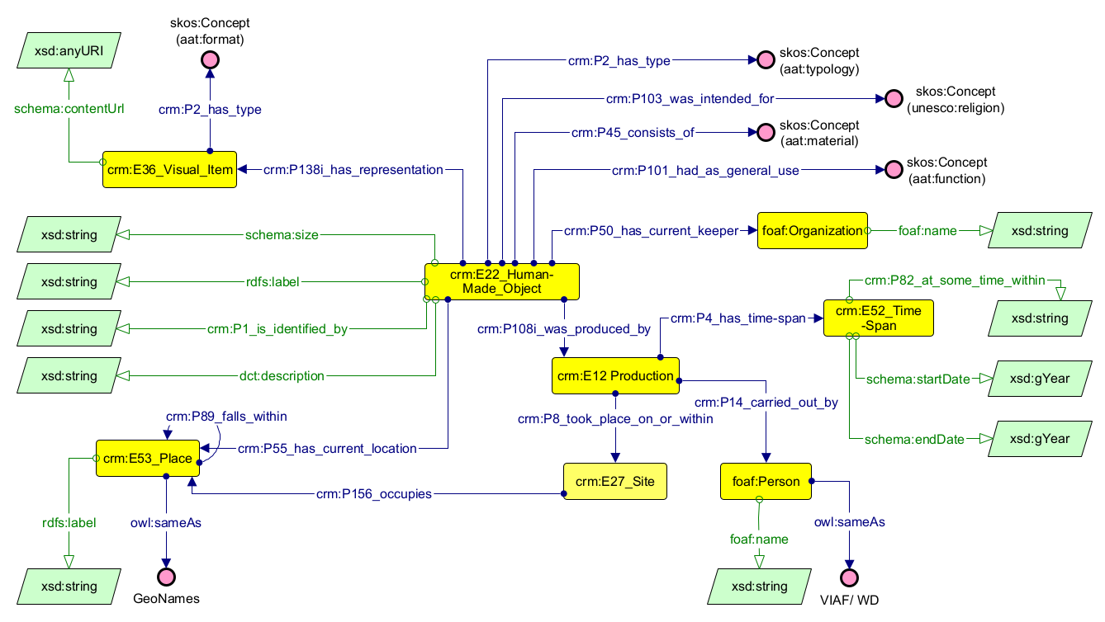

Figure 11. Museum Objects conceptual model architecture.

The object is further enriched with semantic metadata and thematic classifications. These include religious context, typology, material composition, and functional use, all managed via skos:Concept nodes mapped to controlled vocabularies such as the Getty Art & Architecture Thesaurus (aat:) and UNESCO Thesaurus (unesco:). This approach standardizes local data by mapping it to established taxonomies.
To capture the historical lifecycle of the object and adhere to the event-centric architecture of CIDOC CRM, the model utilizes the crm:E12_Production event. This event links the artifact to its creator or historical commissioner, modeled as a foaf:Person whose identity is aligned with external authority files like VIAF or Wikidata (owl:sameAs), and establishes the specific temporal boundaries of its creation. The time-span (crm:E52_Time-Span) is recorded using a dual temporal structure: textual abstract datation (e.g., “Early 10th century”) is captured via crm:P82_at_some_time_within, while machine-readable temporal bounds are normalized using schema:startDate and schema:endDate (xsd:gYear) to enable computational analysis and cross-collection querying.
The geographical and administrative provenance of the object is established by linking the production event to a crm:E27_Site (the light-yellow box represents that this class has its own axis) which is situated within a broader crm:E53_Place. This spatial entity is further aligned to an authority identifier via GeoNames (owl:sameAs). Administratively, the model tracks the institutional custodian of the item using the crm:P50_has_current_keeper property directed to a foaf:Organization. Finally, to facilitate digital visualization, accessibility, and research, a digital layer is incorporated via crm:E36_Visual_Item. This entity connects the physical object to its web-accessible digital assets via a schema:contentUrl pointing to an xsd:anyURI destination.

3.2.2.2. Scientific Publications.
The second axis of the conceptual model, depicted in Figure 12, is designed to represent scholarly literature concerning Khmer heritage. This module utilizes DC Terms (dct:) as its foundational framework to maintain structural simplicity, thereby avoiding the creation of intermediate nodes typically required by the event-centric architecture of CRM. To provide typological distinctions, the Bibliographic Ontology (bibo:) is integrated, enabling the precise categorization of document types through its specialized class hierarchy.
At the core of this module is the dct:BibliographicResource class, which serves as the generic superclass for all publications. It is subsequently specialized via rdfs:subClassOf relations into the subclasses: bibo:Article, bibo:Report, bibo:Thesis, bibo:Proceedings, and bibo:Chapter. Structural hierarchies and nested containments, such as an article within a bibo:Issue (further nested within a bibo:Journal) or a chapter within a bibo:Book, are modeled using the dct:isPartOf property. Metadata for serial issues is preserved via data properties like bibo:volume, bibo:number, and bibo:issue mapping to literal integer datatypes. Basic bibliographic attributes are captured through datatype properties, including dct:title (xsd:string), dct:date (xsd:gYear), and dct:identifier (modeled as an xsd:anyURI) to accommodate Digital Object Identifiers, or DOIs. Contextual and specific content, such as dct:abstract and schema:keywords, is stored as standardized xsd:string literals due to subjectivity and the lack of uniformity in keyword assertions across different institutional datasets. For temporal alignment, the model standardizes publication dates (dct:date) to the xsd:gYear format based on the public release year, omitting finer-grained administrative milestones such as manuscript submission or peer-review dates.
The model also implements a semantic representation of specific academic areas using skos:Concept linked via the dct:subject property. To ensure multilingual interoperability and data control, language values are linked via dct:language to the ISO 639 authority file (Library of Congress language), while publication access conditions (restricted or open access) are regulated using dct:accessRights directed to a skos:Concept from the Confederation of Open Access Repositories (coar:) controlled vocabulary.
Authorship and institutional context are managed with an emphasis on authority control. Individual authors are represented as foaf:Person entities and are cross-referenced using academic identifiers such as ORCID or VIAF via owl:sameAs. Institutional affiliations are represented via foaf:Organization, connected to the author through foaf:member. The foaf:Organization also represents publishers, mapped via dct:publisher. The organization's geographic context is situated by dct:spatial to crm:E53_Place, which is then linked to a GeoNames authority via owl:sameAs.

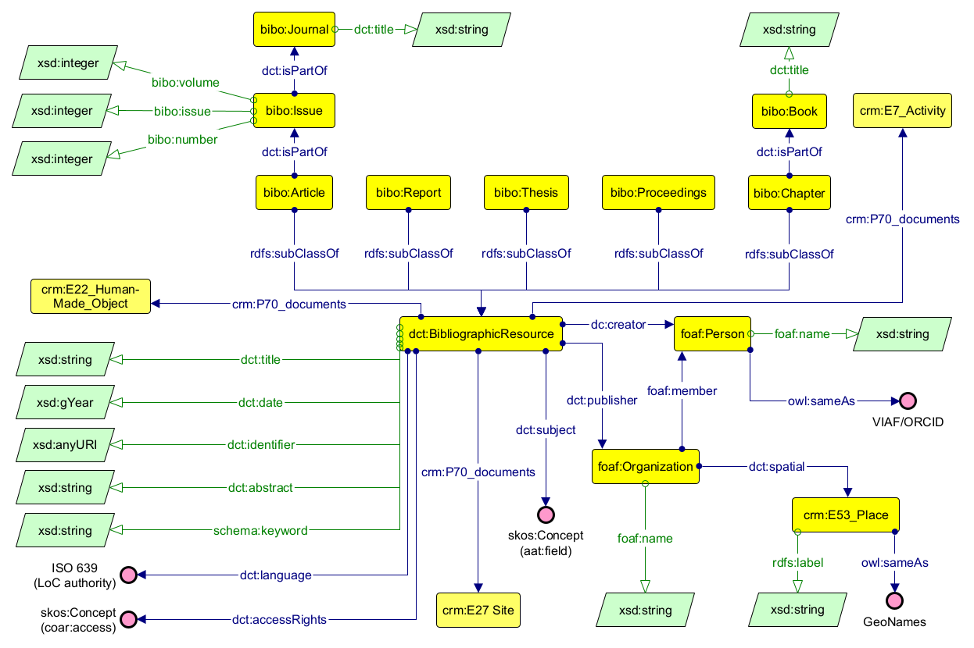
Figure 12. Scientific publication conceptual model architecture.

Finally, this axis acts as a semantic bridge connecting textual knowledge to physical heritage assets and archaeological interventions. Utilizing the CIDOC CRM property crm:P70_documents, the bibliographic resource is directly linked to the three other axes: the movable objects (crm:E22_Human-Made_Object), the heritage sites (crm:E27_Site), and the historical or institutional field operations (crm:E7_Activity), such as excavations, restorations, or conservation campaigns.

3.2.2.3. Places and Monuments.
The third axis of the conceptual model, as depicted in Figure 13, is designed to represent the immovable cultural heritage objects and their geographical context, utilizing CIDOC CRM as the primary ontology. At the center of this model is the class crm:E27_Site, which serves as the primary entity for architectural structures, monumental complexes, and archaeological zones. This axis ensures that fragmented spatial data is semantically aligned with the other structural components of the knowledge graph.
Geographical representation is achieved through a multi-layered approach to spatial data. Precise point geolocation is captured using latitude wgs84:lat and longitude wgs84:long coordinates to locate specific monuments, such as temples or hydraulic structures. More complex spatial boundaries, such as site perimeters, are defined through Well-Known Text (WKT) polygon geometries expressed as geo:asWKT using the geo:wktLiteral datatype. These sites are situated within a topological hierarchy via the crm:P156_occupies property which links them to crm:E53_Place, which is further disambiguated through external authority file from GeoNames. Nested relationships between structures, such as a baray forming part of a larger archaeological complex, are modeled using the crm:P46i_forms_part_of inverse property.
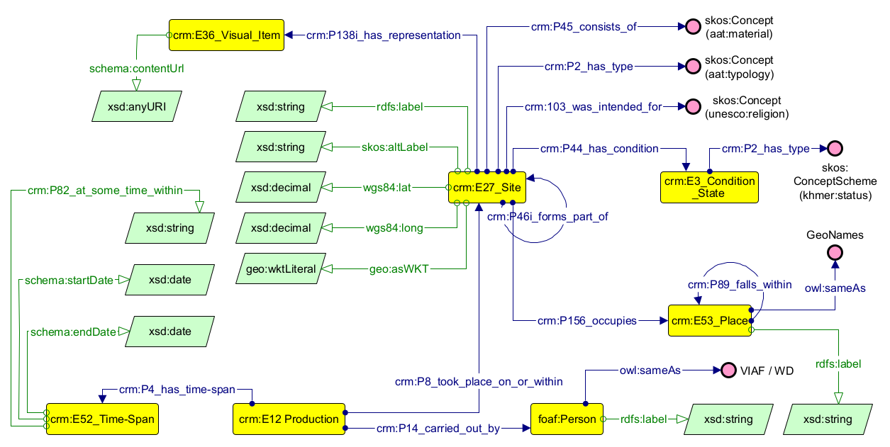
Figure 13. Places and Sites conceptual model architecture.

The physical, qualitative, and functional attributes of these immovable assets are semantically documented using controlled vocabularies. The material composition of a site is recorded via the crm:P45_consists_of property, which links the crm:E27_Site entity to a skos:Concept node that standardizes specific construction materials (e.g., sandstone, laterite, or brick) from the AAT (aat:). Morphological and functional typologies, such as classifications for a temple, baray, arogyasala, or terrace, are formally assigned via crm:P2_has_type using an AAT architectural typology concept node. Furthermore, the socio-religious purpose or historical ideological function of the monument is captured using crm:P103_was_intended_for, which directly maps the site to its corresponding ritualistic tradition managed as a skos:Concept within the UNESCO Thesaurus (unesco:).
The conservation status of a monument is captured through the crm:E3_Condition_State class, which is linked to the site entity via the crm:P44_has_condition property. To standardize the evaluation of structural integrity, the condition state is classified via crm:P2_has_type using a dedicated, project-specific controlled vocabulary managed as a skos:ConceptScheme within the local namespace (kh:), explained in the Knowledge Graph section.
Finally, the foundation and construction history of a monument are modeled via the crm:E12_Production event (crm:P8_took_place_on_or_within), which records the temporal boundaries of construction via crm:E52_Time-Span. This temporal data is captured both as a descriptive string literal via crm:P82_at_some_time_within and as machine-readable boundaries normalized through schema:startDate and schema:endDate using the xsd:gYear datatype. Historical actors, such as sovereign builders, are modeled as foaf:Person entities, assigned literal names via foaf:name, and disambiguated through VIAF or Wikidata identifiers (owl:sameAs). To facilitate digital visualization and documentation, a digital layer is incorporated via crm:P138i_has_representation, linking the physical site to media assets via crm:E36_Visual_Item and its corresponding schema:contentUrl (xsd:anyURI).

3.2.2.4. Reports on Activities
The fourth axis of the conceptual model, depicted in Figure 14, focuses on the documentation of heritage-related interventions, such as archaeological excavations, structural restorations, and conservation campaigns, using crm:E7_Activity as its foundational class. This axis integrates the human and institutional efforts directed toward movable and immovable heritage activity documentation. Each instance of an activity is formally contextualized via datatype properties mapping to xsd:string literals: general designations are captured via rdfs:label, project acronyms or alternative naming conventions via skos:altLabel, institutional codes or identifiers via dct:identifier, and action definitions via dct:description.
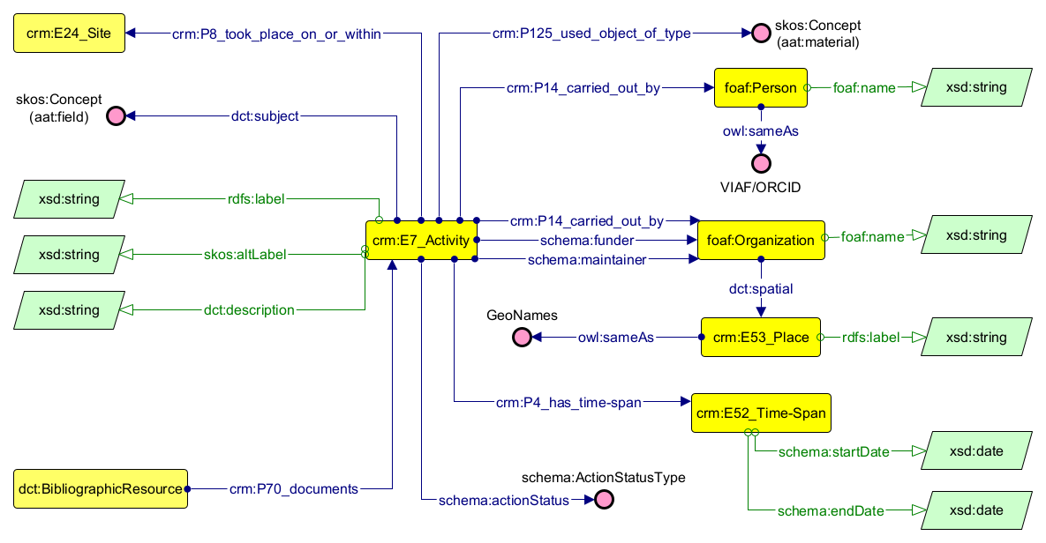
Figure 14. Activities and Projects conceptual model architecture.

Semantic refinement of these activities is managed through specialized controlled vocabularies. The material focus of the activity is described by crm:E57_Material via the crm:P125_used_object_of_type property and cross-referenced with the AAT Thesaurus. The skos:Concept describes both the area of the work, such as archaeology or conservation, via dct:subject, while the administrative or operational state of the project is tracked via crm:P2_has_type relationship.
Disciplinary fields of actuation, such as epigraphy, architecture, or geotechnical engineering, are assigned using dct:subject pointing to an AAT domain concept node. Furthermore, the operational life-cycle phase of the project is tracked using schema:actionStatus, which maps to a standardized schema:ActionStatusType controlled vocabulary to indicate whether an intervention is active, completed, or suspended.
The human and institutional dimensions, as research directors, are captured via foaf:Person cross-referenced with VIAF/ORCID. Organizations are modeled as foaf:Organization entities, with specific roles assigned according to their function in the project: execution of the activity via crm:P14_carried_out_by, financial support via schema:funder, and institutional oversight by national bodies such as APSARA National Authority via schema:maintainer. The use of schema prevents the creation of specialized intermediate nodes to fulfill CIDOC CRM axioms. These institutions are situated geographically by linking them to a crm:E53_Place, via dct:spatial, which is then disambiguated with GeoNames via owl:sameAs.
Finally, activities are anchored across spatial, temporal, and bibliographic dimensions. Temporally, the activity is connected via crm:P4_has_time-span to a crm:E52_Time-Span entity through schema:startDate and schema:endDate using the xsd:date datatype. Spatially, the intervention is tied to its field location through the crm:P8_took_place_on_or_within property, which points to a crm:E27_Site. Lastly, reports and scholarly documentation of these operations is secured by an incoming property from the second axis, crm:P70_documents, which associates the activity with its corresponding dct:BibliographicResource.

3.2.2.5. The Complete Ontology
The integrated conceptual model, synthesized in Figure 15, represents the structural convergence of the four distinct research axes into a unified knowledge graph for Khmer cultural heritage. By abstracting literal values and specific authority files, this graph highlights semantic intersections between CRM, BIBO, DC Terms, FOAF, and SKOS.
This comprehensive graph demonstrates how movable artifacts (crm:E22_Human-Made_Object), immovable sites (crm:E27_Site), documented activities (crm:E7_Activity), and bibliographic publications (dct:BibliographicResource) are harmonized through shared agents, temporal frameworks, and spatial contexts. By normalizing these relationships into a single interoperable network, the resulting architecture reconciles the semantic friction between event-centric ontologies (crm:) and metadata- or document-centric schemas (dct: and bibo:), establishing a data model for complex semantic queries and visualization methods, while retaining links to the institutional sources and custodial contexts represented in the dataset back to the custodial institutions that hold physical and legal ownership of the heritage assets.
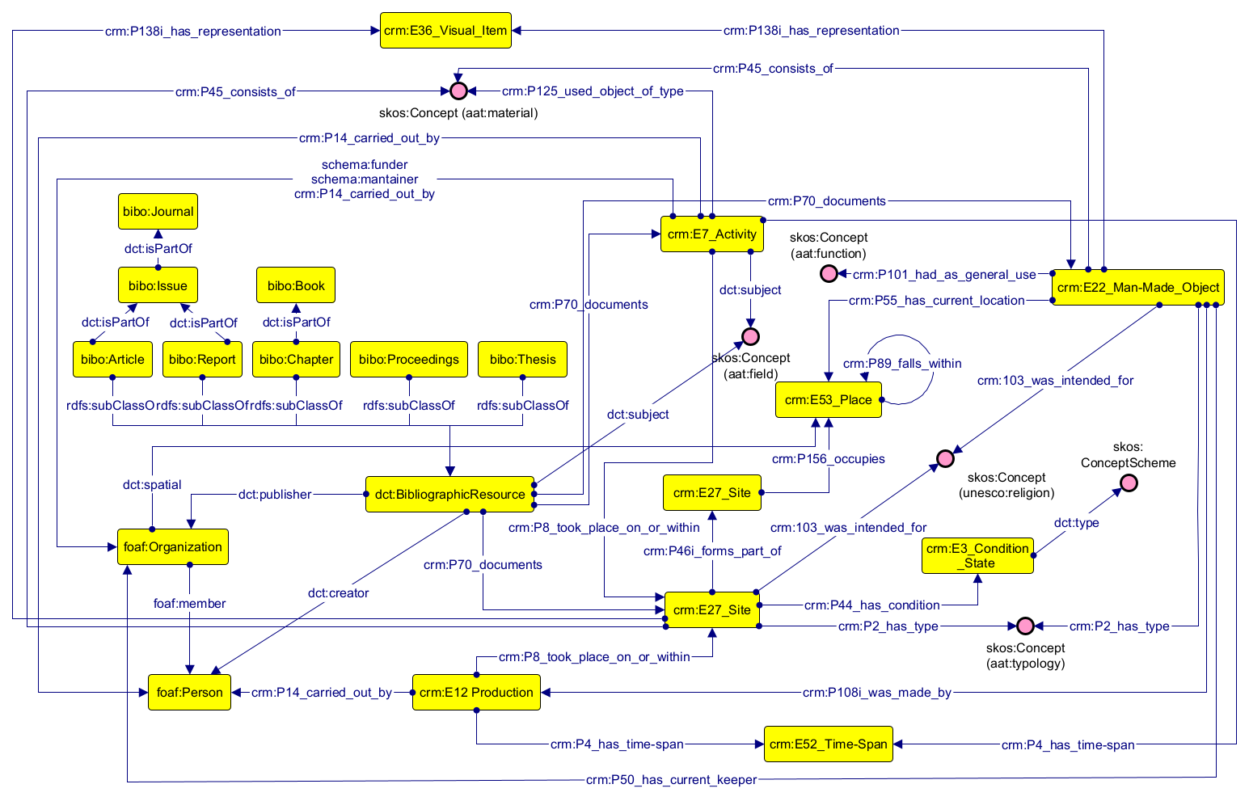
Figure 15. Complete conceptual model.

3.2.3. Knowledge Graph
For the implementation of the RDF knowledge graph, the ontology namespace kh: (< http://www.semanticweb.org/ontologies/2026/khmerLOD/>) was created as a base for entity instantiation and for implementation of additional concepts designed to complement semantic classes not addressed by the reused ontologies. The full RDF Graph is available in the GitHub repository [Link].
The foundational ontological schema and structural alignments were modeled within the Protégé semantic editor, introducing necessary intermediary nodes to meet the conceptual model's criteria and serializing the final output into RDF Turtle syntax. Conversely, to scale the system, the instantiation and population of individual data entries from source datasets were managed programmatically. The source tables were normalized with the Conceptual Model vocabulary, exported as CSV files and subsequently processed using custom Python scripts, automating the assertion of the data.
To categorize the conservation state of Khmer monuments, a custom skos:ConceptScheme was engineered within the Protégé editor. This scheme (kh:SiteCondition) accommodates degradation typologies characteristic of ancient Khmer structures, aligned with international classification schemes. The vocabulary establishes a standardized four-tier classification system consisting of the following condition concepts: Good, Fair, Poor, and Ruin. The qualitative parameters and evaluation criteria for each tier are explicitly operationalized using the skos:definition annotation property. The Code Listing 1 shows an excerpt of the RDF implementation.
kh:SiteCondition rdf:type owl:NamedIndividual , skos:ConceptScheme ;
skos:definition “A standardized 4-tier condition vocabulary
aligned with international heritage tracking standards.
“@en ;
skos:hasTopConcept kh:Fair , kh:Good , kh:Poor ,
kh:Ruin ;
skos:prefLabel “Condition Status for Khmer Heritage Sites
“@en .

kh:Poor rdf:type owl:NamedIndividual , skos:Concept ;
skos:inScheme kh:SiteCondition ;
skos:definition “Structure displays bold structural
remotion, collapse, or significant material loss.”@en ;
skos:prefLabel “Poor”@en ;
skos:topConceptOf kh:SiteCondition .

Code Listing 1. Excerpt of the Khmer Ontology defining the Site Condition Scheme.

The structure and corresponding URI normalization keys for each individual ontological class within the kh: namespace are systematized in Table 4. To ensure algorithmic reproducibility and unique identifiers across the graph ecosystem, variable placeholders within the minting keys follow standardized syntax conventions.

Class | Dataset entry | Entity (kh:)
dct:BibliographicResource  (bibo:Article, bibo:Thesis,  bibo:Chapter, bibo:Report, bibo:Proceedings) | Publication | PUB_(ID)
bibo:Journal | Journal | JNL_(ID)
bibo:Issue | Journal, Volume, Issue, Number | J(n)_V(n)_I(n)_N(n)
bibo:Book | Book | BOOK_(ID)
crm:E22_Human-Made_Object | Object | OBJ_(ID)
crm:E36_Visual_Item | Representation | URL_(ID)
foaf:Organization | Organization (Keeper, National Body, Publisher, Affiliation) | MUS_(ID), NATB_(ID), PBSH_(ID), ORG_(ID)
crm:E12_Production | Production (Object, Site foundation) | OBJPR_(ID),FOUN_(ID)
crm:E52_Time-Span | Time-Span (Activity, Site, Object) | TSAC_(ID),  TSSI_(ID),  TSOB_(ID)
crm:E27_Site | Site | SITE_(ID),  UNESCO_(ID)
crm:E3_Condition_State | Site Status | STATUS_(ID)
crm:E53_Place | Place (City, District, Province, Country) | (PlaceName)
crm:E7_Activity | Activity | ACTV_(ID)
foaf:Person | Author, Responsible, Ruler | AUTH_(2f)(4l), DIR_(ID),  KING_(4f)_(n)

Table 4. URI naming conventions and identifier minting patterns for the kh: localized entities.

The parenthetical ID token represents five-digit sequential integers padded with leading zeros (e.g., 00001). The variable n denotes an integer value (for historical Khmer rulers, records regnal titles formatted as Roman numerals). For person name parsing, alphanumeric keys utilize substring extractions: 2f and 4f extract the first two or four characters of an individual’s given name, while 4l isolates the first four characters of their surname (if identical string patterns generate colliding identifiers, a numeric suffix is appended to maintain entity differentiation). The (PlaceName) token is derived from the normalized English toponym. In cases of lexical ambiguity, an additional disambiguation term is appended corresponding to the administrative unit (e.g., Province, District) to ensure unique URI generation.
The logical consistency of the ontology was evaluated utilizing the HermiT OWL reasoner, with no inconsistencies found during reasoning, and the Shapes Constraint Language (SHACL) validation framework integrated within the Protégé editor. SHACL constraints were implemented to enforce a set of domain-specific validation rules. For instance, these include ensuring that every publication is linked to at least one author (I) and one title (II); that the crm:P70_documents property is used only in relation to sites, activities, or objects (III); or that each minor site is related to a major UNESCO site through a UNESCO_(id) identifier (IV). The Code Listing 2 shows an excerpt of the constraint validation with these instances. The additional prefixes for the query are in Tables 2 and 3. The complete validation available in the GitHub Repository [Link].
@prefix ex: <http://example.org/shapes/> .
@prefix sh: <http://www.w3.org/ns/shacl#> .
@prefix rdf: <http://www.w3.org/1999/02/22-rdf-syntax-ns#> .
@prefix bibo: <http://purl.org/ontology/bibo/> .
@prefix dct: <http://purl.org/dc/terms/> .
@prefix crm: <http://www.cidoc-crm.org/cidoc-crm/> .
@prefix kh: <http://www.semanticweb.org/ontologies/2026/khmerLOD/> .
ex:PublicationShape
rdf:type sh:NodeShape ;
sh:targetClass bibo:Article, bibo:Report, bibo:Chapter, bibo:Thesis, bibo:Proceedings ;

# (I) Publication must have at least one author
sh:property [
sh:path dct:title ;
sh:minCount 1 ;
] ;

Code Listing 2. Excerpt of SHACL validation rules for the Knowledge Graph.

# (II) Publication must have at least one title
sh:property [
sh:path dct:creator ;
sh:minCount 1 ;
] ;

# (III) P70_documents values must be Site, Activity, or Object
sh:property [
sh:path crm:P70_documents ;
sh:or (
[ sh:class crm:E27_Site ]
[ sh:class crm:E7_Activity ]
[ sh:class crm:E22_Human-Made_Object ]
) ;
] .
ex:SiteToUnesco
rdf:type sh:NodeShape ;
sh:targetClass crm:E27_Site ;

# (IV) All sites must belong to one UNESCO property
sh:property [
sh:path crm:P46i_forms_part_of ;
sh:or (
[sh:hasValue kh:UNESCO_01 ;]
[sh:hasValue kh:UNESCO_02 ;]
[sh:hasValue kh:UNESCO_03 ;]
[sh:hasValue kh:UNESCO_04 ;]
[sh:in ( kh:UNESCO_01 kh:UNESCO_02 kh:UNESCO_03 kh:UNESCO_04 ) ;]
) ;
] .

Code listing 2. Excerpt of SHACL validation rules for the Knowledge Graph.
The final RDF graph deployment, displaying the network topology and implementing required property restrictions, was rendered via the WebVOWL visualization interface, as illustrated in Figure 16.
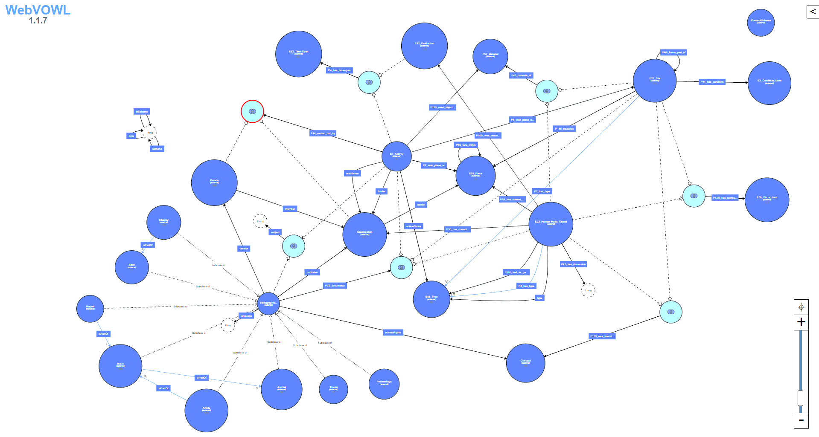
Figure 16. RDF Visualization on WebVOWL platform.

Chapter 4. Results
This chapter presents the results obtained from the implementation and population of the Knowledge Graph developed in Chapter 3. The first section evaluates whether the model supports the analytical requirements defined by the competency questions, translating them into SPARQL queries and testing their execution across the four interconnected axes. These queries assess both intra-axis retrieval and cross-axis traversal, demonstrating how the ontology supports structured access to publications, museum objects, archaeological sites, institutions, materials, and heritage-related activities.
The second section examines the broader interpretive potential of the model through instance-level navigation across the graph. It traces relationships between specific publications, activities, objects, and sites in order to show how semantic integration produces contextual knowledge that is not available within the individual source datasets. Through these examples, the chapter evaluates the capacity of the knowledge graph to function as a data integration framework.

4.1. Competency Questions
The six competency questions formulated in Section 3.1 serve as the primary validation instrument for the knowledge graph. Each question is first stated in natural language and then executed as a SPARQL query against the populated graph in Protégé, demonstrating that the model design successfully supports the cross-institutional queries it was built to answer. Successful execution of the query (Q1 to Q6) demonstrates that the populated graph supports the relationships questions (the class hierarchy, property chains, and controlled vocabulary mappings) and retrieval patterns specified by the competency questions. The results are presented as tables showing the normalized top 10 rows of each result set; the full outputs are available in the GitHub repository [Link].

- Q1. Which scientific fields produce most publications related to Khmer heritage?

PREFIX rdf: <http://www.w3.org/1999/02/22-rdf-syntax-ns#>
PREFIX rdfs: <http://www.w3.org/2000/01/rdf-schema#>
PREFIX dct: <http://purl.org/dc/terms/>
PREFIX skos: <http://www.w3.org/2004/02/skos/core#>

SELECT ?area ?label (COUNT(?publication) AS ?count)

Query 1. Publications by field query.
WHERE {
?publication rdf:type/rdfs:subClassOf* dct:BibliographicResource ;
dct:subject ?area .
?area rdf:type skos:Concept ;
rdfs:label ?label .
}
GROUP BY ?area ?label
ORDER BY DESC(?count)

Results:

 | ?area | ?label | ?count
1 | http://vocab.getty.edu/aat/300054328 | Archaeology | 67
2 | http://vocab.getty.edu/aat/300054394 | History | 26
3 | http://vocab.getty.edu/aat/300054453 | Sociology | 25
4 | http://vocab.getty.edu/aat/300054412 | Law | 24
5 | http://vocab.getty.edu/aat/300054138 | Art | 22
6 | http://vocab.getty.edu/aat/300137339 | Remote Sensing | 22
7 | http://vocab.getty.edu/aat/300054315 | Anthropology | 21
8 | http://vocab.getty.edu/aat/300054546 | Geology | 20
9 | http://vocab.getty.edu/aat/300054543 | Geochemistry | 19
10 | http://vocab.getty.edu/aat/300054156 | Architecture | 19

Table 5. Publication by field; top 10 rows out of 42 retrieved results.

- Q2. Which publications are associated with museum objects?
PREFIX crm: <http://www.cidoc-crm.org/cidoc-crm/>
PREFIX dct: <http://purl.org/dc/terms/>
PREFIX rdfs: <http://www.w3.org/2000/01/rdf-schema#>
PREFIX rdf: <http://www.w3.org/1999/02/22-rdf-syntax-ns#>

SELECT DISTINCT ?object ?objectLabel ?publication ?publicationTitle
WHERE {
?object rdf:type crm:E22_Human-Made_Object .
?object rdfs:label ?objectLabel .
?publication rdf:type/rdfs:subClassOf* dct:BibliographicResource .
?publication dct:title ?publicationTitle .
?publication crm:P70_documents ?object .
}

Query 2. Objects documented in publications query.

Results:
 | ?object | ?objectLabel | ?publication | ?publicationTitle
1 | OBJ_00142 | Jayavarman VII Head | PUB_00092 | Large Terrace Structure Unearthed in the Heart of the City Zone of Isanapura: Could It Be the ‘Great Hall’ Described in the Book of Sui
2 | OBJ_00142 | Jayavarman VII Head | PUB_00116 | Prasat Sambor as a Prototype of the Pyramidal State-Temple in Khmer Temple Construction
3 | OBJ_00183 | Deity Figure | PUB_00191 | Towards a Quantitative Petrographic Database of Khmer Stone Materials-Koh Ker Style Sculpture
4 | OBJ_00141 | Horse Deity Figure | PUB_00091 | Estimated Construction Order of the Major Shrines of Sambor Prei Kuk Based on an Analysis of Bricks
5 | OBJ_00094 | Harihara Figure | PUB_00006 | Evidence of Sandstone Usage for Sculpture During the Khmer Empire in Cambodia Through Petrographic Analysis
6 | OBJ_00183 | Deity Figure | PUB_00006 | Evidence of Sandstone Usage for Sculpture During the Khmer Empire in Cambodia Through Petrographic Analysis
7 | OBJ_00142 | Jayavarman VII Head | PUB_00166 | Location of a pre-Angkor capital city in relation to geomorphological features of lower reach of the Stung Sen River, central Cambodia
8 | OBJ_00177 | Lintel (Ramayana representation) | PUB_00053 | Khmer decorative lintels and the allocation of artistic labour
9 | OBJ_00123 | Buddhist Figure | PUB_00169 | Khmer Stone Sculptures: A Collection Seen from a Material Point of View
10 | OBJ_00125 | Buddha Figure | PUB_00169 | Khmer Stone Sculptures: A Collection Seen from a Material Point of View
Table 6. Objects documented in publications; top 10 rows out of 12 retrieved results.

- Q3. Which materials were employed in the construction of temples at Sambor Prei Kuk?
Query 3. Materials employed in Sambor Prei Kuk temples query.
PREFIX crm: <http://www.cidoc-crm.org/cidoc-crm/>
PREFIX rdfs: <http://www.w3.org/2000/01/rdf-schema#>
PREFIX rdf: <http://www.w3.org/1999/02/22-rdf-syntax-ns#>

SELECT DISTINCT ?material ?materialLabel
WHERE {
?subSite crm:P46i_forms_part_of ?mainSite .
?mainSite rdfs:label ?siteLabel .
FILTER(REGEX(str(?siteLabel), "sambor prei kuk", "i"))

?subSite crm:P2_has_type ?type .
?type rdfs:label ?typeLabel .

FILTER(REGEX(str(?typeLabel), "temple", "i"))
?subSite crm:P45_consists_of ?material .
?material rdfs:label ?materialLabel .
}

Results:
 | ?material | ?materialLabel
1 | http://vocab.getty.edu/aat/300010463 | brick
2 | http://vocab.getty.edu/aat/300011376 | sandstone
3 | http://vocab.getty.edu/aat/300014334 | laterite
Table 7. Materials employed in Sambor Prei Kuk temples; 3 retrieved results.

- Q4. Which countries host institutions that preserve objects dating back to the ninth century?
Query 4. Countries hosting institutions with 9th century Khmer objects query.
PREFIX crm: <http://www.cidoc-crm.org/cidoc-crm/>
PREFIX foaf: <http://xmlns.com/foaf/0.1/>
PREFIX dct: <http://purl.org/dc/terms/>
PREFIX schema: <http://schema.org/>
PREFIX rdfs: <http://www.w3.org/2000/01/rdf-schema#>
PREFIX xsd: <http://www.w3.org/2001/XMLSchema#>
PREFIX rdf: <http://www.w3.org/1999/02/22-rdf-syntax-ns#>

SELECT DISTINCT ?countryLabel
WHERE {
?object rdf:type crm:E22_Human-Made_Object ;
crm:P50_has_current_keeper ?institution ;
crm:P108i_was_produced_by ?production .
?institution rdf:type foaf:Organization ;
dct:spatial ?place .
?place crm:P89_falls_within ?country .

FILTER NOT EXISTS { ?country crm:P89_falls_within ?broader }
?country rdfs:label ?countryLabel .
?production rdf:type crm:E12_Production ;
crm:P4_has_time-span ?timeSpan .
?timeSpan schema:startDate ?startYear .

FILTER(?startYear >= "0801"^^xsd:gYear && ?startYear <= "0900"^^xsd:gYear)
}

PREFIX crm: <http://www.cidoc-crm.org/cidoc-crm/>
PREFIX foaf: <http://xmlns.com/foaf/0.1/>
PREFIX dct: <http://purl.org/dc/terms/>
PREFIX schema: <http://schema.org/>
PREFIX rdfs: <http://www.w3.org/2000/01/rdf-schema#>
PREFIX xsd: <http://www.w3.org/2001/XMLSchema#>
PREFIX rdf: <http://www.w3.org/1999/02/22-rdf-syntax-ns#>

SELECT DISTINCT ?countryLabel
WHERE {
?object rdf:type crm:E22_Human-Made_Object ;
crm:P50_has_current_keeper ?institution ;
crm:P108i_was_produced_by ?production .
?institution rdf:type foaf:Organization ;
dct:spatial ?place .
?place crm:P89_falls_within ?country .

FILTER NOT EXISTS { ?country crm:P89_falls_within ?broader }
?country rdfs:label ?countryLabel .
?production rdf:type crm:E12_Production ;
crm:P4_has_time-span ?timeSpan .
?timeSpan schema:startDate ?startYear .

FILTER(?startYear >= “0801”^^xsd:gYear && ?startYear <= “0900”^^xsd:gYear)
}

Results:
 | ?countryLabel
1 | France
2 | Cambodia
3 | United States of America
Table 8. Countries hosting institutions with 9th century Khmer objects; 3 retrieved results.

- Q5. Which institutions produce the largest volume of publications concerning Preah Vihear Temple?
PREFIX crm: <http://www.cidoc-crm.org/cidoc-crm/>
PREFIX dct: <http://purl.org/dc/terms/>
PREFIX foaf: <http://xmlns.com/foaf/0.1/>
PREFIX rdfs: <http://www.w3.org/2000/01/rdf-schema#>
PREFIX rdf: <http://www.w3.org/1999/02/22-rdf-syntax-ns#>

SELECT ?institution ?institutionName
(COUNT(DISTINCT ?publication) AS ?volume)
WHERE {
?site rdf:type crm:E27_Site ;
rdfs:label ?siteLabel .

FILTER(REGEX(str(?siteLabel), "preah vihear", "i"))
?publication rdf:type/rdfs:subClassOf* dct:BibliographicResource ;
crm:P70_documents ?site ;
dct:creator ?author .

?institution foaf:member ?author .
?institution rdf:type/rdfs:subClassOf* foaf:Organization ;
foaf:name ?institutionName .

}

GROUP BY ?institution ?institutionName
ORDER BY DESC(?volume)

Query 5. Number of publications about Preah Vihear by author’s institution query.

Results:
 | ?institution | ?institutionName | ?volume
1 | ORG_00137 | University of Tokyo | 4
2 | ORG_00117 | University of Gothenburg | 4
3 | ORG_00147 | Waseda University | 3
4 | ORG_00135 | University of Singapore | 3
5 | ORG_00087 | Royal University of Phnom Penh | 3
6 | ORG_00001 | APSARA National Authority | 2
7 | ORG_00139 | University of Tsukuba | 2
8 | ORG_00122 | University of Illinois | 2
9 | ORG_00098 | Tokyo National Research Institute for Cultural Properties | 2
10 | ORG_00012 | Australian National University | 2

Table 9. Number of publications about Preah Vihear by author’s institution; top 10 rows out of 58 retrieved results.

- Q6. Which projects focus on constructions commissioned during the reign of Jayavarman IV?
Query 6. Projects held on Jayavarman IV's commissioned buildings query.
PREFIX crm: <http://www.cidoc-crm.org/cidoc-crm/>
PREFIX rdfs: <http://www.w3.org/2000/01/rdf-schema#>
PREFIX schema: <http://schema.org/>
PREFIX xsd: <http://www.w3.org/2001/XMLSchema#>
PREFIX rdf: <http://www.w3.org/1999/02/22-rdf-syntax-ns#>
PREFIX foaf: <http://xmlns.com/foaf/0.1/>

SELECT DISTINCT ?project ?projectLabel ?site ?siteLabel ?kingName
WHERE {
?project rdf:type crm:E7_Activity ;
crm:P8_took_place_on_or_within+ ?site ;
rdfs:label ?projectLabel .
?site rdf:type crm:E27_Site ;
rdfs:label ?siteLabel .

FILTER(LANG(?siteLabel) = "en")

?production rdf:type crm:E12_Production ;
crm:P8_took_place_on_or_within ?site ;
crm:P14_carried_out_by ?king .
?king foaf:name ?kingName .

FILTER(REGEX(str(?kingName), "jayavarman iv", "i"))
}

Results:
 | ?project | ?projectLabel | ?site | ?siteLabel | ?kingName
1 | ACTV_00013 | Angkor Inscriptions Survey | SITE_00107 | Prasat Neang Khmau | Jayavarman IV
2 | ACTV_00003 | Japan-APSARA for Safeguarding Angkor | SITE_00081 | Prasat Thom Prang | Jayavarman IV
3 | ACTV_00002 | Jaya Koh Ker Project | SITE_00081 | Prasat Thom Prang | Jayavarman IV
4 | ACTV_00002 | Jaya Koh Ker Project | SITE_00082 | Rahal | Jayavarman IV
5 | ACTV_00002 | Jaya Koh Ker Project | SITE_00105 | Prasat Chen | Jayavarman IV
6 | ACTV_00016 | Prasat Kraham Project | SITE_00104 | Prasat Kraham | Jayavarman IV
7 | ACTV_00018 | Restoration of the Monumental Dancing Shiva | SITE_00081 | Prasat Thom Prang | Jayavarman IV

Table 10. Projects held on Jayavarman IV's commissioned buildings; 7 retrieved results.

The queries were designed in a non-redundant manner in order to demonstrate both intra-axis retrieval and cross-axis traversal across the knowledge graph, thereby testing different dimensions of semantic connectivity. The scope of each query is presented in Table 11.

Query | Axis / Dimension
Q1 | Bibliographic axis / Scholar field classification and counting
Q2 | Integration between Publications and Objects axes.
Q3 | Sites axis / Filtering architectural types and materials
Q4 | Objects axis / Filtering institutions by creation date
Q5 | Integration between Publication and Sites axes.
Q6 | Integration between Activities and Sites axis

Table 11. Knowledge retrieval parameters across ontology axes

Collectively, these questions demonstrate that the four axes of the ontology can function both independently and as an interconnected semantic network. The successful execution of the queries confirms that the class hierarchy, property chains, and vocabulary mappings have been implemented consistently.

4.2. Model Application
This section demonstrates the capacity of the knowledge graph for cross-institutional knowledge discovery through the navigation of interconnected instances across the four axes of the model. Rather than operating through predefined aggregate queries, as in the preceding section, this approach traces two concrete subgraphs of real individuals, illustrating how semantic links between instances produce contextual knowledge that no single institutional dataset could generate independently. It is guided by interpretative questions such as what, when, where, who and how.

4.2.1. Case 1. Publication and Activity
The first example of transversal connection is established between the bibliographic and activity axes through the shared instance of kh:ACTV_00003, illustrated in Figures 17 and 18.
(What). The kh:PUB_00100 is a 2014 open-access article published in the journal Heritage Science, volume 2, issue 10, titled “Construction sequence of the Koh Ker monuments in Cambodia deduced from the chemical composition and magnetic susceptibility of its laterites.” The publication is classified under three disciplinary fields: Archaeology (aat:300054328), Materials Science (aat:300054496), and Archaeometry (aat:300122729).
(Where). The article is spatially linked via crm:P70_documents to eleven individual Koh Ker site instances (SITE_00081, SITE_00084, SITE_00087, SITE_00088, SITE_00094, SITE_00100, SITE_00101, SITE_00103, SITE_00107, SITE_00106, SITE_00109 and UNESCO_04), explicitly addressing which structures within the heritage zone are the subjects of the research.
(Who). Its three authors, Ichita Shimoda (AUTH_ICSHIM), Etsuo Uchida (AUTH_ETUCHI), and Kojiro Tsuda (AUTH_KOTSUD), are individually identified through ORCID persistent identifiers and affiliated with two Japanese institutions, Waseda University (ORG_00147) and the University of Tsukuba (ORG_00139), both institutions spatially connected to kh:Japan and its GeoNames authority. Within the bibliographic axis alone, the graph already exceeds what the original journal record provides: the authors are disambiguated, their institutions are geolocated, and the publication's disciplinary and spatial scope is formally encoded.
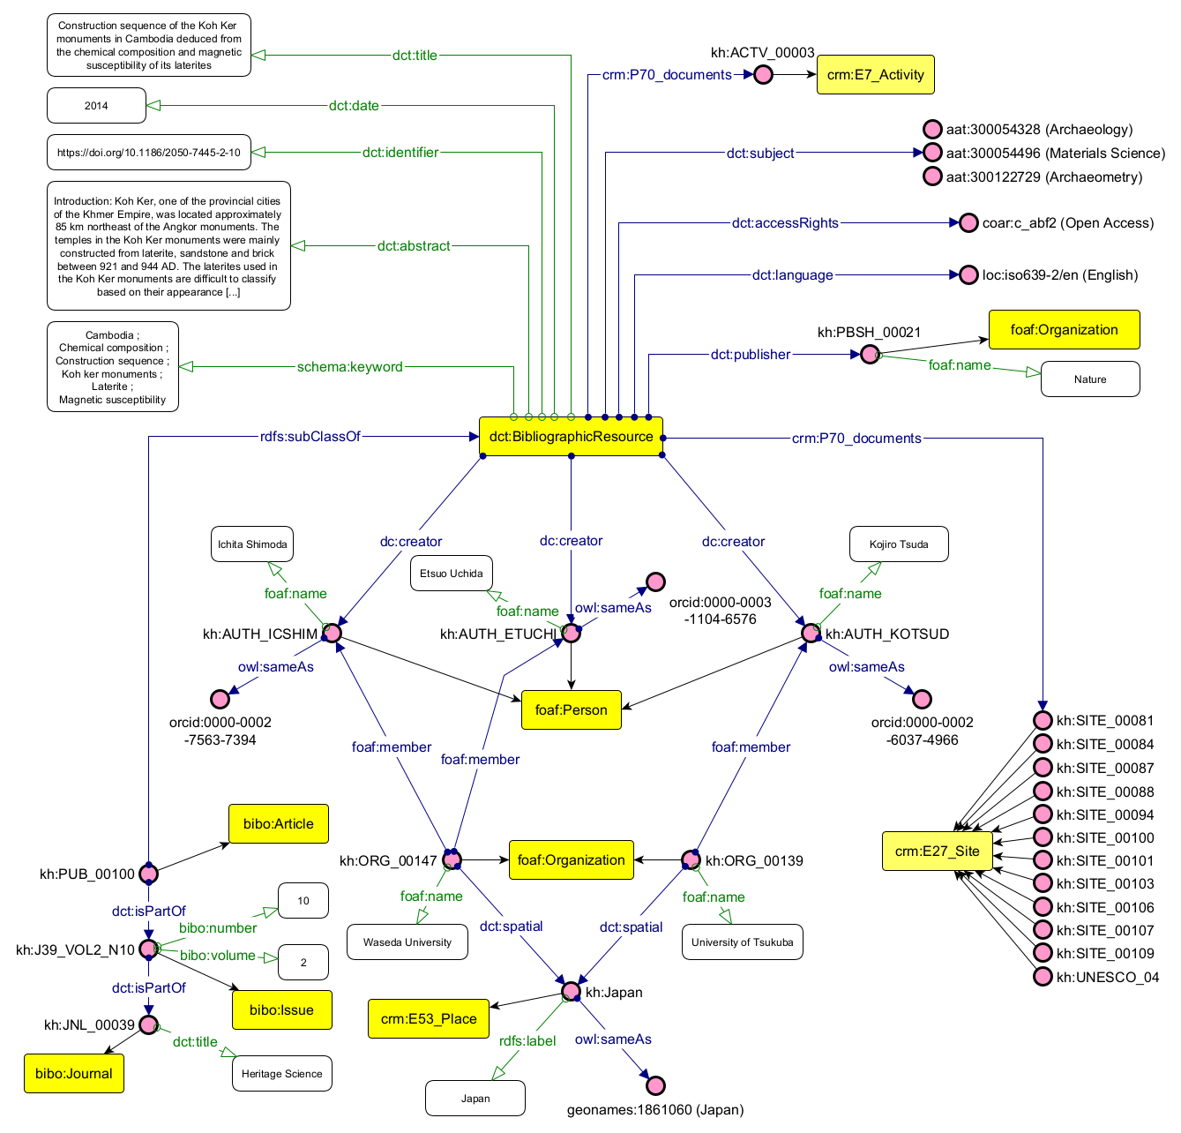
Figure 17. Instance-level representation for Publications axis.

(What, When, Who). The publication's most significant output connection, however, is established through crm:P70_documents, which links kh:PUB_00100 directly to kh:ACTV_00003, the Japan-APSARA for Safeguarding Angkor project (JASA), identifier UNESCO-JFIT. This conservation activity, ongoing since 1994, is carried out jointly by Takeshi Nakagawa (AUTH_TANAKA, and his ORCID) and Waseda University (ORG_00147), funded by Japan Funds-in-Trust (ORG_00155), and maintained under the institutional oversight of the APSARA National Authority (NATB_00001), whose spatial context is resolved to Cambodia via GeoNames (geonames:1831722).
(How). The activity's disciplinary scope (Geotechnical Engineering, Archaeology, Materials Science, Architecture, and Conservation Science) contextualizes the article's research questions as directly serving an active preservation mandate. The schema:actionStatus property records the project as ongoing (schema:ActiveActionStatus), adding operational currency to the scholarly record. This connection was not present in any single source: the academic databases held the article; institutional reports described the project; the knowledge graph fuses them into a single queryable network through the shared CIDOC CRM property crm:P70_documents.

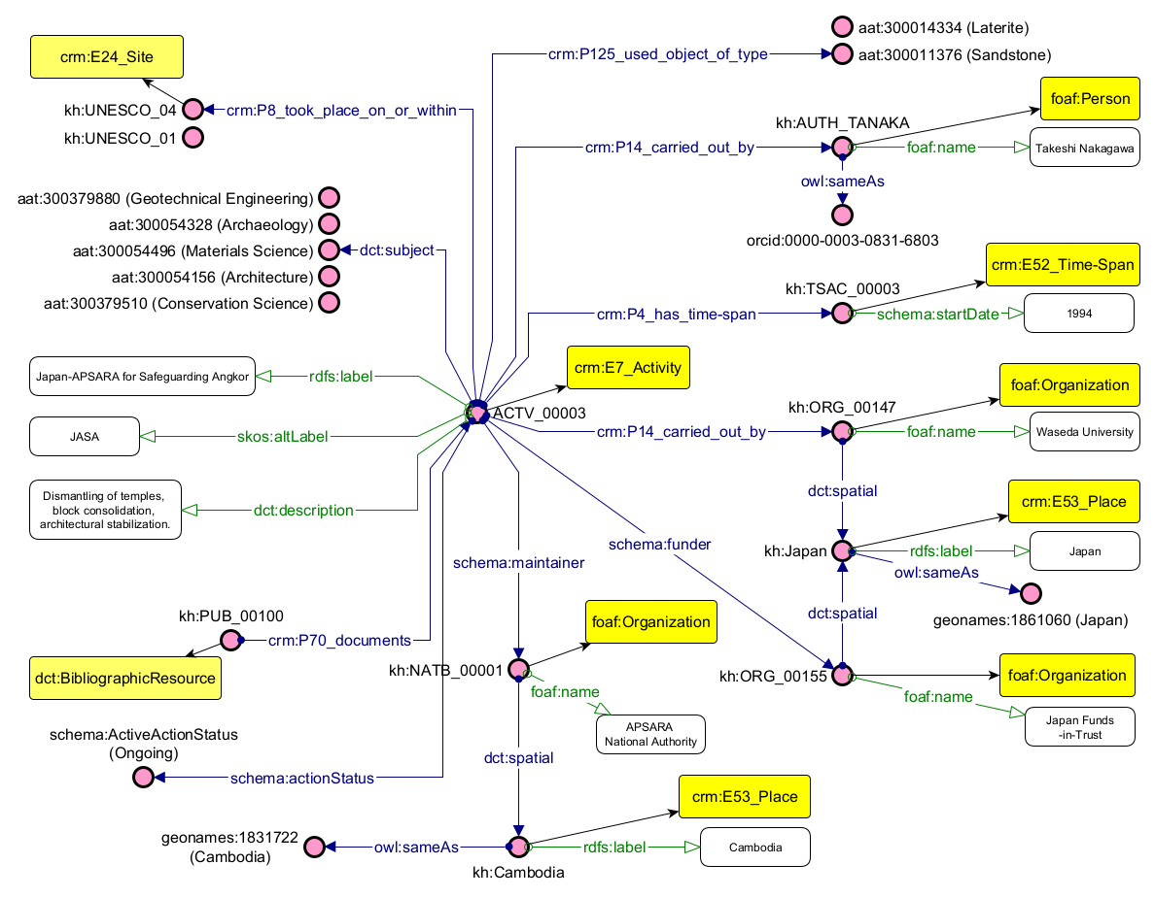
Figure 18. Instance-level representation for Activity axis.

4.2.2. Case 2. Object and Site
The second example connection is established between the museum object and site axes through the shared instance of kh:SITE_00010, illustrated in Figures 19 and 20.
(What). The kh:OBJ_00009 is a sandstone sculpture (aat:300047090) currently held at the Musée Guimet in Paris (MUS_00002) under inventory number MG18912. Labeled “Relief of Shiva” and measuring 87×134×33 cm, the object depicts the legend of Parvati refusing to listen to Shiva disguised as an ascetic, and is classified as architectural in general use (aat:300000885), intended for Hinduism (unesco:concept2347).
(Where, When, Who). Its digital representation is accessible via a Grand Palais RMN URI (kh:URL_00009), and its current location is resolved through a spatial hierarchy from Paris (geonames:2988507) to France (geonames:3017382). The production event (OBPR_00009) attributes the object's creation to the period of Indravarman II (kh:KING_INDR_II), aligned to wd:Q879225), with normalized date bounds of 1218-1243 alongside the descriptive label “Early 13th century,” implementing the dual temporal structure established in the conceptual model.

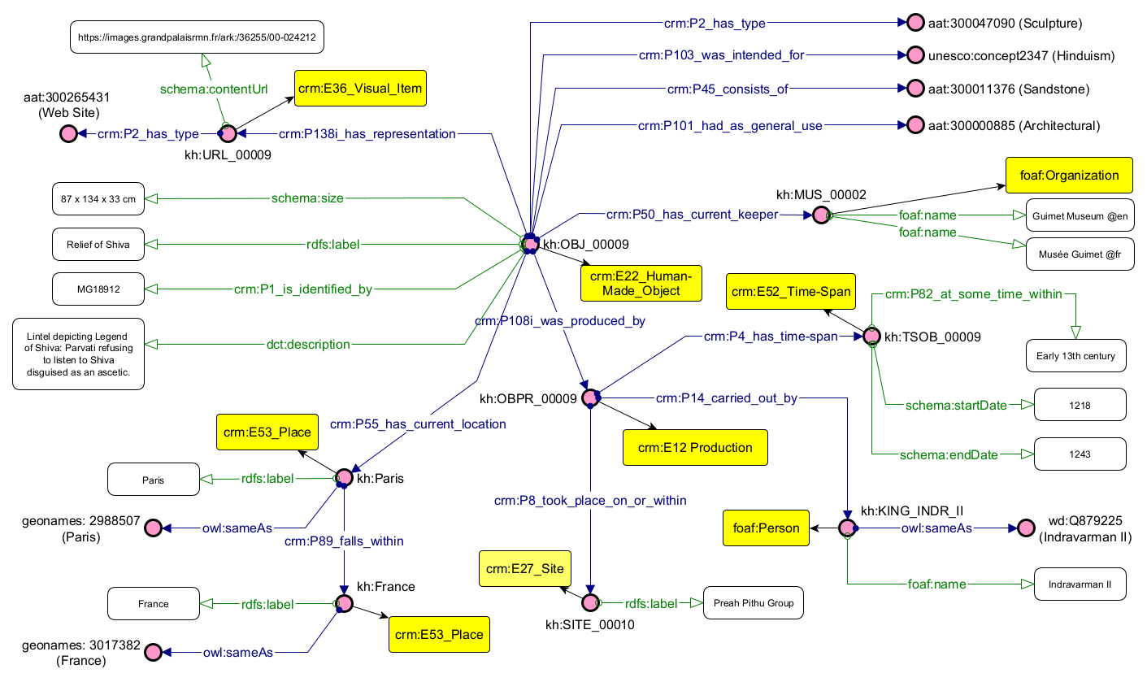
Figure 19. Instance-level representation for Objects axis.

(What, How, Where). The linking decisive property is crm:P8_took_place_on_or_within, which anchors the production event to kh:SITE_00010, the Preah Pithu Group. This site instance, described in Figure 20, is a Hindu temple complex constructed in sandstone between 1113 and 1150 under Suryavarman II (wd:Q501356), classified as a Temple Complex (aat:300007596), in good conservation condition (kh:Good), and situated within a complete administrative hierarchy: Nokor Thom (geonames:12206268) → Krong Siem Reap (geonames:7647224) → Siem Reap Province (geonames:1822213) → Cambodia (geonames:1831722), all controlled by GeoNames authority identifiers. The site forms part of the Angkor Complex (kh:UNESCO_01) whose spatial boundary is defined by a WKT polygon geometry via geo:asWKT.
In a traversal graph, a physical object held in a Parisian museum has been connected to its precise Cambodian site of origin, together with the site's full spatial, temporal, historical, and conservation context. This information was distributed across museum catalogs, UNESCO documentation, and geospatial repositories, with no machine-readable link between them prior to this integration.
(Where) A further dimension this subgraph makes computationally explicit is the geographical displacement between production and custody. The object was produced in Cambodia between 1218 and 1243; it is currently held in Paris. The graph encodes this displacement as a queryable semantic statement: crm:P55_has_current_location to kh:Paris (geonames:2988507), while the production event resolves to kh:SITE_00010 within Cambodia geonames:1831722). This directly operationalizes one of the objectives stated in Chapter 3 (O5. the contextualization of the geographical displacement of objects over time) and represents a form of knowledge that emerges specifically from the integration of the museum and site axes, not from either source in isolation.
However, the current implementation presents a known limitation in this regard: most museum datasets (and this project dataset) include an acquisition date recording when an object entered institutional custody, a temporal qualification that applies not to the object itself but to the relationship between the object and its current keeper. Standard RDF cannot natively attach metadata to a triple, meaning the crm:P50_has_current_keeper relation cannot carry a date value without the introduction of intermediate nodes, which would compromise the model's structural simplicity. A necessary future implementation would adopt RDF-Star, which extends the RDF data model by allowing triples to be the subject of other triples, enabling the acquisition date to be asserted directly on the relation. This would complete the temporal dimension of the displacement narrative, allowing the graph to express not only where an object moved, but when the transition of custody occurred.

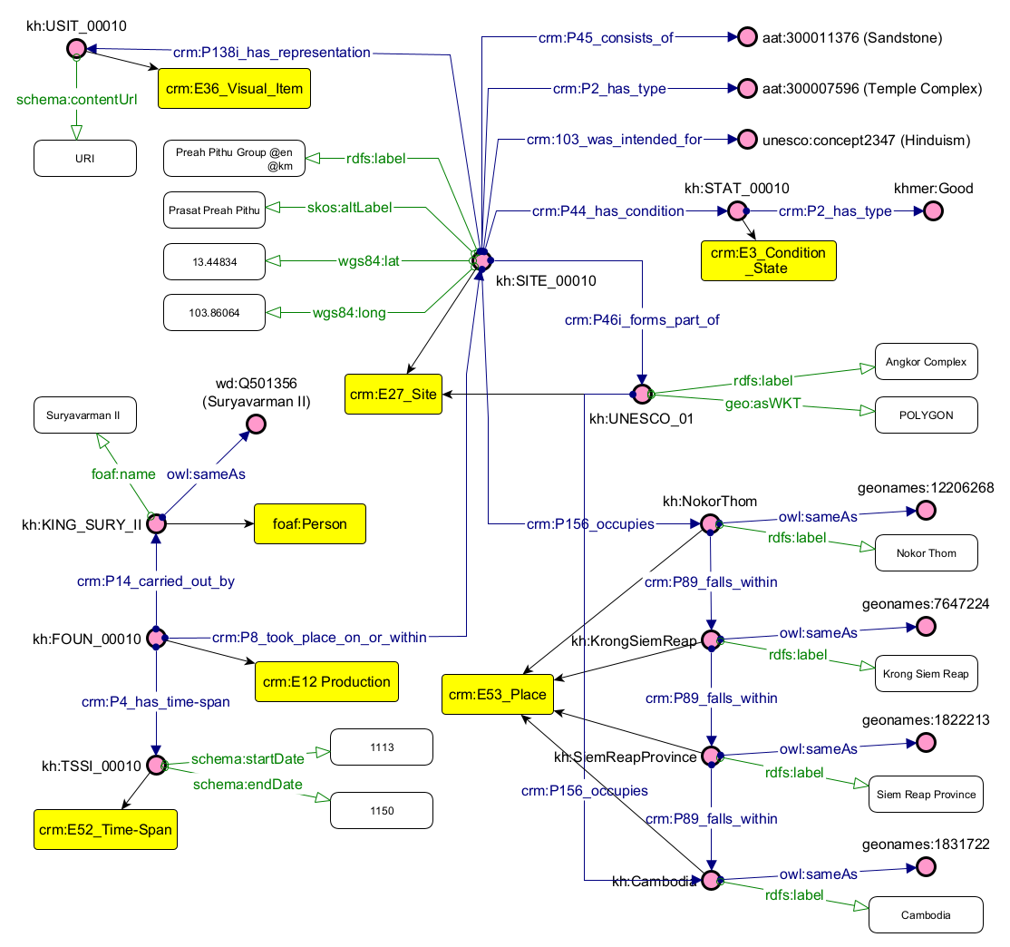
Figure 20. Instance-level representation for Site axis.

Taken together, these two connections demonstrate that the knowledge graph does not merely store records from disparate institutions: it makes the relationships between those records meaningful and traversable. A researcher can move from a journal article to the conservation project it documents, from a museum object to the temple complex where it was produced, and from both entry points outward toward the shared spatial, temporal, and institutional contexts that connect them. This is the concrete realization of the research question posed in Chapter 3, the integration of fragmented data into a comprehensive digital representation, validated not only through formal SPARQL queries, but through the interpretive depth revealed by navigating the graph as a unified semantic network.

Chapter 5. Discussion
This chapter discusses the study's results in relation to its research question, objectives, and initial hypothesis, while considering the broader methodological implications of semantic modeling for Digital Humanities and cultural heritage research. The central research question asked how fragmented data could be integrated to provide a comprehensive digital representation of a cultural heritage domain within the Semantic Web. The results presented in Chapter 4 demonstrate that such integration is technically achievable: the four operative axes of Sites, Objects, Publications, and Activities can be connected within a common semantic structure, enabling relationships distributed across independent institutional repositories to become computationally retrievable.
The discussion considers the research question beyond the technical implementation. Instead, it examines what occurs when information produced within different institutional and disciplinary contexts is transformed into a shared semantic representation. From this perspective, the results suggest that interoperability does not require eliminating heterogeneity. Rather, it depends on establishing explicit relationships between heterogeneous sources while determining which differences can legitimately be normalized and which must remain visible as part of their provenance and interpretative context.

5.1. Semantic Modeling as an Epistemic Process
The construction of a semantic model cannot be understood as a purely technical process in which information is transferred from documentary sources into a machine-readable structure without changes. Ontological modeling necessarily demands decisions concerning which aspects of a domain are relevant, how entities are distinguished from one another, which relationships are made explicit, and at what level of granularity they should be represented. As Tomasi (2018) argues, ontologies are neither neutral nor limited to a single viable implementation. Rather, they possess a dual dimension: first, an epistemic dimension that captures a specific cut of reality as interpreted by the author and thus contingent on the author's perspective; second, a technical framing that translates this interpretation into machine-readable parameters.
This translation, however, is constrained. The entire epistemic process must take into account both the existing structures of the chosen ontology and the formalization required for its proper expression. This is evident during the development of the Khmer Ontology, designed to connect heterogeneous areas of documentation through a shared semantic architecture. CIDOC CRM provides a highly expressive event-centric structure for cultural heritage documentation, but such expressiveness often requires creating intermediate entities and relationships that are not present in every dataset or introducing complex paths for peripheral metadata.
The representation of physical dimensions provides an example, illustrated by the selection of schema:size over the standard crm:E54_Dimension. While the CIDOC CRM framework is suited for documenting an object's dimension precisely, its structure requires a complex path, specifically employing crm:P90_has_value ranging to E60_Number and crm:P91_has_unit ranging to crm:E58_Measurement_Unit. In other words, to fully represent a three-dimensional object would generate many additional triples. Because this information was deemed peripheral and carried less semantic weight within the scope of this project, the schema:size property was adopted instead, as it condenses the metric data into a single string literal.
Conversely, a different approach was taken to represent temporal information, structured via crm:P4_has_time-span. Although this temporal component could have been simplified similarly, it holds significantly greater semantic value due to its ordinal and comparative utility. Therefore, the implementation incorporated both the standard CIDOC CRM string representation (crm:P82_at_some_time_within), which accounts for temporal uncertainty as a literal, and an additional schema validation layer (schema:startDate, schema:endDate) that uses the xsd:gYear datatype with an approximate numeric value, enabling sorting and comparison.
The contrast between these two modeling decisions illustrates an important consequence of ontology design. Semantic modeling determines not only how much information is represented, but also which aspects of that information can become objects of computation. Representing dimensions as an unstructured literal preserves their human-readable content but limits their independent computational interrogation. Structuring chronological information, by contrast, enables temporal filtering and comparison. Granularity establishes the analytical operations that the resulting knowledge graph can support.
A similar boundary appears in the representation of object displacement. The model connects the historical production context of an object to its current institutional keeper (crm:P50_has_current_keeper → foaf:Organization), making spatial displacement visible as a continuous, queryable path. It does not, however, reconstruct every intermediate transfer of ownership or custody. Such a representation would require substantially greater CIDOC CRM granularity and, in many cases, documentary evidence that is not consistently available. Consequently, the resulting representation should not be interpreted as a complete biography of an object but as a formalization of the aspects of its trajectory relevant to the current object context.
These choices also qualify the intended “comprehensive digital representation” contained in the research question. Comprehensive representation does not mean exhaustive reproduction of every characteristic and historical relationship associated with the entities represented in the graph. Any model necessarily selects and abstracts information. In this study, comprehensiveness refers to the capacity to integrate multiple dimensions of the cultural heritage domain into a coherent structure that supports cross-domain questions.
The question shifts from whether a model perfectly reproduces reality to whether its abstractions are methodologically appropriate, explicit, and consistent with its research purposes. Reusing CIDOC CRM and established vocabularies improves interoperability and reduces idiosyncratic modeling, but standards cannot determine which information should be privileged or how ambiguous evidence should be interpreted. These remain scholarly decisions. Semantic modeling consequently formalizes interpretation rather than eliminating it.

5.2. From Historical Sources to Semantic Data: Metadata Mediation
The interpretative dimension of semantic modeling becomes particularly significant when considering the nature of the knowledge integrated in this study. Although the research question refers to “fragmented data,” these data do not constitute a homogeneous body of information distributed across different technical systems. Instead, they originate from sources produced within distinct institutional, disciplinary, and documentary contexts. Museum catalogs, scholarly publications, archaeological and geospatial documentation, and heritage and conservation reports were created for different purposes and, consequently, describe cultural heritage according to divergent structures, terminologies, levels of granularity, and epistemic perspectives.
This condition is characteristic of the cultural heritage domain. Bruseker, Carboni, and Guillem (2017) describe cultural heritage information as originating from diverse disciplines, techniques, traditions, positions, and technologies, resulting in substantial diversity in both its forms and methods of documentation. At the same time, these heterogeneous resources constitute a potentially interconnected body of evidence concerning the same cultural heritage domain. Importantly, the authors distinguish between forms of heterogeneity that can be resolved through harmonization and those that arise from legitimate differences among disciplinary and methodological perspectives, differences that should not simply be eliminated through standardization.
This distinction is directly observable in the corpus assembled for the present study. The four axes bring together information produced within distinct documentary environments. Furthermore, the sources incorporated into the model had already undergone processes of selection and digital mediation prior to their integration into the knowledge graph. While some information was obtained through structured formats such as APIs, JSON files, CSV exports, or bibliographic datasets, other material required manual extraction and interpretation from web interfaces, scholarly publications, institutional reports, and geospatial documentation. Consequently, transforming these materials into RDF involved far more than format conversion; it constituted an additional stage in a sequence through which cultural heritage information had already been selected, documented, structured, digitized, and made accessible by different institutions.
This process can be situated within the “sources as data” perspective articulated by Owens and Padilla (2020). Rather than treating digital sources solely as individual objects to be read and interpreted, this perspective asks how historical arguments can be developed when sources are processed computationally as data. Such a shift enables new forms and scales of inquiry while simultaneously requiring critical attention to the material and technical conditions through which sources become computationally accessible. In the present study, this issue extends beyond the digitization of individual historical sources. Museum catalog entries, bibliographic metadata, institutional reports, and geospatial records were already mediated through different digital architectures prior to their incorporation into the knowledge graph. Their subsequent transformation into RDF constitutes another representational layer in which selected information is formalized as entities, properties, and relationships.
From this perspective, digital availability itself becomes methodologically significant. Owens and Padilla (2020) emphasize that traditional questions of source criticism (how a source was created, why and how it was preserved, and why it became available within a particular archive, museum, library, or research environment) remain essential when working with digital materials. Digitization also introduces processes of selection, as institutional decisions about what is digitized and exposed directly shape the evidentiary corpus available to researchers and, in turn, the claims that can be constructed from it. This consideration is particularly relevant to the corpus of this study, whose composition was necessarily conditioned by the availability, accessibility, and technical structures of digital resources across different institutions.
The distinction between a physical cultural heritage entity and the digital resources that document it is therefore fundamental. A museum object, its catalog record, a digital photograph depicting it, and a scholarly publication discussing it are related resources, but they are not ontological equivalents. This principle is explicitly reflected in the Europeana Data Model (EDM), which distinguishes the cultural heritage object described by the data provider (edm:ProvidedCHO) from its digital representations (edm:WebResource) (Doerr et al. 2010). Although the present model does not reproduce the EDM architecture, this ontological distinction provides an important precedent for recognizing that a cultural heritage entity and the digital resources through which it becomes accessible possess different provenances, characteristics, and conditions of production.
Metadata itself consequently constitutes a further layer of mediation. As Bruseker et al. (2017) argue, data and metadata structures represent particular conceptualizations of a domain rather than transparent reproductions of the entities they describe. A museum catalog record, for instance, reflects institutional decisions concerning classification, chronology, provenance, terminology, and descriptive schemas. When such information is incorporated into the knowledge graph, the semantic model is therefore not directly formalizing the cultural heritage object itself, but rather a description of that object that has already undergone prior processes of documentation and interpretation.
This distinction becomes especially critical when source records contain uncertainty or competing assertions. A provenance expressed by an institution as “Cambodia or Thailand,” for example, is not simply an incomplete geographical value awaiting normalization; its ambiguity expresses the exact epistemic state of the source record. Transforming such a value into a single, normalized spatial location might improve computational consistency while also imposing a degree of artificial certainty that is absent from the original description. The resulting semantic relationship incorporates an additional layer of scholarly interpretation rather than merely reproducing an explicitly asserted statement from the source.
The uniform syntax of RDF does not imply epistemic uniformity among the statements represented within the graph. An attribution explicitly provided by a museum catalog, a material term reconciled with a controlled vocabulary, and a relationship established through researcher interpretation may all ultimately be expressed as RDF statements while possessing vastly different documentary origins and degrees of interpretative intervention. Treating these statements as equivalent merely because they share the same computational form risks obscuring precisely the distinctions essential to understanding how the resulting knowledge base was constructed.
This challenge directly intersects with what Owens and Padilla (2020) describe as the “stratigraphy of digital sources.” They argue that rigorous digital source criticism requires sustained attention to the successive technological and contextual layers through which digital evidence is produced and encountered. Applied to the present study, this perspective suggests that the information represented in the knowledge graph can be understood as passing through a sequence of mediations: Cultural Heritage Entity ⟶ Documentary/Institutional Representation ⟶ Digital Resource and Metadata ⟶ Data Extraction and Normalization ⟶ Semantic Representation. The precise sequence varies by source type, but the underlying principle remains constant: the RDF graph represents the outcome of successive acts of documentation, selection, transformation, and formalization rather than an unmediated representation of the cultural heritage domain.
Formal ontologies provide a mechanism through which these heterogeneous representations can nevertheless be brought into relation. Bruseker et al. (2017) characterize a formal ontology as a mediated exchange point through which existing information structures can retain their plurality while acquiring a generalized representation capable of supporting cross-structure retrieval and data exchange. This principle is in accordance with the architecture implemented in this study: the purpose of the Khmer Ontology is not to supplant the descriptive systems already employed, but to provide a flexible semantic layer through which selected information from these systems can be interconnected and collectively interrogated.
Once semantic integration is recognized as operating upon heterogeneous and already mediated representations, the methodological question is no longer simply whether the data can be harmonized, but which differences can legitimately be reconciled, which uncertainties must be retained, and what may be lost when heterogeneous descriptions are normalized into a common semantic structure.

5.3. Harmonization, Uncertainty, and the Limits of Semantic Interoperability
The heterogeneous and mediated character of the sources discussed in the preceding sections directly conditions semantic interoperability. Controlled vocabularies provided the primary mechanism for resolving terminological heterogeneity. Material descriptions, for instance, varied considerably across museum catalogs despite referring to equivalent material concepts. Mapping these descriptions to persistent identifiers from the Getty Art & Architecture Thesaurus (AAT) established a shared semantic reference frame independent of individual institutional cataloging conventions. As demonstrated by Competency Question 3 (Q3), materials associated with places could be retrieved across institutional boundaries through this reconciled terminology, reducing lexical variation without altering the content of the original records. The use of authorities for agents, organizations, and geographic entities similarly supported entity resolution by connecting resources via persistent URIs rather than literal string matching.
As already stated, normalization is legitimate only when distinct values can be interpreted as referring to the same concept or real-world entity. As Bruseker et al. (2017) emphasize, while certain forms of heterogeneity can be resolved through common standards, others derive from valid disciplinary, methodological, or conceptual differences. Where source documentation lacked sufficient evidence for a granular attribution, broader or approximate values were intentionally retained rather than replaced by artificially precise normalized values. Normalization reconciles variant lexical representations of an explicitly identified entity, whereas interpretation begins when available evidence does not uniquely determine which entity, date, or relationship should be instantiated. Selecting a definitive value under ambiguous circumstances fundamentally alters the data's epistemic content; preserving ambiguity is just as vital to semantic accuracy as successfully reconciling equivalent values.
This tension between computational utility and historical certainty was evident in temporal and spatial harmonization, as illustrated by the provenance ambiguity discussed in 5.2. A comparable challenge emerged when linking the Publications axis to Objects and Sites. Because these relationships were rarely explicitly encoded in bibliographic metadata, establishing semantic links required qualitative examination of titles, keywords, abstracts, and, where available, full texts. A term such as “Angkor,” for instance, could refer specifically to the central archaeological park, to a broader geographic region, or more abstractly to Angkorian civilization as a whole. Establishing these associations relied on domain-specific knowledge rather than automated string matching. Furthermore, where full texts were not open access, or abstracts lacked spatial detail, links could not be asserted with confidence. The boundaries of integration in these instances were dictated not by the ontology itself, but by the descriptive completeness and accessibility of the surrounding academic publishing ecosystem.
The integrated architecture demonstrates how these reconciliation mechanisms operate across the entire model. CIDOC CRM and its complementary ontologies establish a shared conceptual framework, while recurring entities (sites, objects, activities, persons, organizations, places, and bibliographic resources) serve as semantic junctions that connect the four axes. Integration does not collapse these axes into a single monolithic schema; it constructs explicit semantic paths between them. Where explicit equivalences could be established, these alignments reduced important forms of structural and lexical fragmentation; where sources were vague or implicit, integration relied on qualitative evaluation. Semantic interoperability was thus achieved through a hybrid methodology in which computational standardization and scholarly validation performed complementary roles.
This reliance on manual curation reveals a structural limit to scalability. While the model successfully integrates heterogeneous data within the scope of the selected corpus, expanding the volume and diversity of input sources would likely increase the number of cases requiring qualitative evaluation. The current implementation illustrates this trade-off: while cross-axis queryability was successfully established, several inter-axis relationships depended on curated editorial links rather than automated mapping rules. The architecture itself is transferable to other cultural heritage corpora, but the reconciliation procedures required to populate it demand human mediation.
The competency questions provide empirical validation of the interoperability achieved within these constraints. SPARQL queries connecting museum objects to publications, publications to sites, material terms to physical objects, and conservation projects to monuments demonstrate that information originating in isolated documentary environments can be retrieved through a unified semantic layer. Successful query execution, however, must be distinguished from epistemic validation: a SPARQL query confirms that expected relationships are computationally retrievable, but the historical authority of a query result remains bound to the quality of the original documentation and the editorial decisions made during reconciliation.
Ultimately, semantic interoperability in this study is best understood not as the enforcement of semantic uniformity, but as the capacity to establish meaningful, context-aware computational relationships across heterogeneous descriptions. The role of the Khmer Ontology is not to supplant institutional records with a single authoritative narrative, but to provide an interoperable layer through which disparate descriptions can be connected, compared, and collectively interrogated. Once these relationships are made computationally explicit, the integrated graph can be approached through distinct relational perspectives, bibliographic, spatial, temporal, institutional, and object-centered, providing the structural foundation for the multidimensional visualizations examined in the following section.

5.4. Interlinked Data as a Basis for Multidimensional Visualization
The integration across the four axes expands the ways the resulting information can be explored and visualized. This potential derives from a core affordance of semantic knowledge representation: information is structured not only as descriptions of individual resources, but by explicit relationships among identifiable entities. In digital hermeneutics, Semantic Web technologies can formalize connections among sources, scholarly assertions, agents, and contextual perspectives (Daquino, Pasqual, and Tomasi 2020). Daquino et al. (2020) describe computational methods as intermediary tools between sources and readers, participating in the hermeneutical process rather than functioning as transparent channels of information. Visualization can consequently be understood as a further layer of mediation between formal knowledge representation and the researcher: it does not simply display the contents of the graph, but selects particular entities and relationships and renders them perceptually accessible from a specific analytical perspective.
This relational structure enables a transition from record-centered to relationship-centered exploration. Conventional collection interfaces are generally organized according to the descriptive priorities of individual repositories: museum platforms foreground objects, bibliographic databases publications, and archaeological repositories sites. The semantic model developed here instead connects these documentary domains within a shared graph, allowing the same interconnected entities to be traversed through multiple relational perspectives without reorganizing the information into separate datasets. An object is no longer explored exclusively as an isolated catalog record but can become a point of departure for examining production contexts, archaeological sites, current custodial institutions, and scholarly literature. Similarly, a publication can be approached through the objects, sites, and activities to which it is semantically linked. A comparable relational approach is demonstrated by the RDF transformation of the Paolo Bufalini Notebook discussed by Daquino et al. (2020), which supports the exploration of explicitly modeled relationships among works, people, excerpts, citations, and influences.
The competency questions establish the computational foundation for these visual projections. SPARQL queries that connect museum objects to scholarly publications (Q2) or link site-related publications to institutions across different countries (Q5) demonstrate relational paths that extend beyond separate repository boundaries. While these relationships are currently retrieved through SPARQL rather than displayed through a dedicated interface, the query results provide the underlying data from which network representations connecting objects, publications, authors, institutions, activities, and sites could be constructed. Visualization would therefore constitute an analytical projection of relationships already encoded within the knowledge graph rather than an independently reconstructed layer of information.
Spatially, the model connects sites to geographical entities and geospatial representations, and relates objects to their production contexts and present-day custodial locations. These relationships provide the basis for comparing distinct spatial dimensions of Khmer cultural heritage. A cartographic projection could, for example, juxtapose historical production contexts in Cambodia with contemporary institutional holdings elsewhere.
Temporally, the representation of time spans and normalized temporal boundaries enables objects, sites, and activities to be organized and queried by chronological criteria. When combined with spatial information, these structures provide a basis for spatiotemporal exploration, allowing chronological and geographical patterns in object production, archaeological research, conservation, or heritage management to be examined within a single information environment. The analytical potential lies not in treating maps and timelines as independent products, but in applying spatial and temporal perspectives to entities and relationships derived from the same integrated graph.
From an institutional and activity-oriented perspective, research and conservation activities can be linked to the persons and organizations that participated, the sites where they occurred, their temporal extent, and the publications that document them. Network representations could consequently foreground patterns of institutional and scholarly participation, while temporal projections could organize activities chronologically, and spatial projections could locate them across heritage sites. These perspectives are all derivable from the same underlying RDF graph rather than requiring independently curated datasets for each form of analysis.
The analytical value of such visualizations nevertheless depends upon the semantic structure from which they are generated. A network edge, spatial connection, or temporal association is meaningful only insofar as the underlying model specifies the nature of the relationship it represents. Visualization alone does not provide this semantic context; the knowledge graph supplies the formal structure through which visually perceived connections remain traceable to explicitly modeled entities and relationships. This distinction is particularly relevant in Digital Humanities, where computational interfaces mediate scholarly knowledge rather than replacing its interpretation.
Visualization must consequently be regarded as selective rather than neutral. A map privileges spatial distribution, a timeline emphasizes chronology, a network graph foregrounds connectivity, and an institutional view emphasizes patterns of custody, documentation, or collaboration. Each representation makes certain structures more perceptible while reducing the visibility of others. The epistemic considerations discussed in Sections 5.1 to 5.3 extend directly to the presentation layer, particularly with respect to uncertainty. Displaying an approximate date as a precise point on a timeline or an uncertain geographical attribution as an exact coordinate risks reintroducing the false certainty that the semantic model seeks to avoid during integration. A robust visualization layer should consequently allow approximate dates, uncertain geographical attributions, and interpretative assertions to remain distinguishable from precise or directly documented assertions.
Because the present study realizes these possibilities primarily at the level of semantic and query architecture rather than through a deployed user interface, the fourth research objective O4, using the integrated data to support new forms of knowledge access, visualization, and interaction, should be considered partially fulfilled. The competency questions confirm that the relational structures required for multidimensional exploration are present and computationally retrievable, but the implementation and evaluation of a complete visualization interface remain outside the current scope. The present results demonstrate the model's capacity to support multidimensional visualization rather than the usability or effectiveness of a particular interface.
Access and visualization are consequently not independent presentation layers added only after semantic modeling. The possibilities for exploration are conditioned by the entities and relationships formalized within the graph. Semantic modeling determines which relationships become computationally expressible, while visualization determines how selected relationships become perceptible and explorable to human users. This relationship also reinforces the intermediary role of computational representations identified by Daquino et al. (2020): both formalization and presentation help shape the conditions under which digital scholarly knowledge can be examined and interpreted.
Establishing this relational infrastructure nevertheless constitutes a significant contribution to semantic architecture. Because entities are represented by explicit relationships rather than confined to repository silos, the knowledge graph provides the structural basis for exploring Khmer cultural heritage across documentary, geographical, chronological, institutional, and material dimensions. Treating visualization as a further layer of mediation reinforces a central finding of this study: greater computational accessibility does not eliminate the need for scholarly interpretation, but rather restructures the conditions under which heterogeneous cultural heritage information can be interrogated, compared, visualized and understood.

5.5. Weaknesses and Further Steps
The results of this study demonstrate the technical feasibility of integrating heterogeneous Khmer cultural heritage data through a shared semantic model, but they also reveal several methodological and technical limitations. Rather than invalidating the model, these constraints define the analytical boundaries of the current knowledge graph and identify priorities for subsequent development.
Corpus Scope and Reconciliation Workflows. The datasets assembled for the four axes constitute a structured sample conditioned by digital availability, API access, and metadata completeness rather than an exhaustive inventory of Khmer cultural heritage. Expanding the corpus will require more systematic documentation of how source selection and accessibility affect the graph's representativeness. Furthermore, while controlled vocabularies and authority resources supported terminology normalization and entity reconciliation, key inter-axis relationships, such as publication-site associations, depended substantially on qualitative human evaluation. Although necessary to prevent false equivalences, this manual workflow creates a bottleneck for scalability. Future iterations should then investigate semi-automated reconciliation pipelines that generate candidate alignments computationally for subsequent validation by domain specialists.
Epistemic Granularity: Provenance, Uncertainty, and Argumentation. A significant limitation concerns the provenance's statement-level granularity. Although the model avoids imposing artificial certainty on ambiguous source data, it does not systematically encode the epistemic status or evidentiary lineage of every individual assertion. Consequently, an assertion directly extracted from a museum record and a relationship established through scholarly interpretation can currently coexist in the graph without an equally granular mechanism for distinguishing their respective origins.
Future development should therefore evaluate complementary mechanisms for assertion-level provenance, including PROV-O for provenance modeling and named graphs or RDF-star for associating provenance information with individual statements or groups of statements. Such mechanisms could explicitly connect assertions to documentary sources, responsible agents, and processes of extraction or interpretation. Additional modeling would be required to represent degrees or types of uncertainty. This extension would also provide a stronger basis for accommodating competing scholarly arguments. Rather than resolving conflicting chronologies, contested attributions, or divergent interpretations into a single value, an expanded model could represent alternative assertions together with their provenance and supporting evidence, reinforcing the distinction between semantic interoperability and semantic homogenization.
Modeling Granularity and Object Biographies. The current ontology reflects deliberate parsimony. As established during model design, more complex CRM structures were omitted where additional granularity did not directly serve the target competency questions. This boundary is particularly evident regarding object displacement: while the graph connects an object's modeled production context to its contemporary custodial and spatial context, it does not reconstruct a continuous sequence of excavation, ownership, acquisition, transfer, or restitution events. Developing more complete event-centric object biographies represents an important direction for future modeling, particularly given the complex movement of Khmer cultural heritage through colonial, commercial, and institutional contexts.
Validation and Interface Development. The validation conducted in this study also has defined limits. SHACL constraints and competency-question queries demonstrate structural consistency and confirm that the graph supports the information requirements for which it was designed, but they do not establish the historical reliability of every represented assertion. Future evaluation should therefore combine technical validation with systematic comparison against source records and, where possible, expert assessment of mappings and interpretative relationships. Additional competency questions developed independently of the initial modeling process could further test whether the ontology supports research requirements beyond those that directly informed its construction.
The user-facing dimension remains similarly incomplete. As discussed in Section 5.4, the integrated graph provides the semantic infrastructure required for spatial, temporal, institutional, bibliographic, and object-centered exploration, but these possibilities have not yet been implemented and evaluated through a complete visualization interface. A subsequent development stage should connect the RDF graph and SPARQL endpoint to a web environment capable of generating coordinated maps, timelines, network representations, and entity-centered views. Particular attention should be given to the visual communication of uncertainty and provenance so that the interface does not imply greater geographical, chronological, or interpretative certainty than the underlying assertions support. User evaluation would then be necessary to assess whether these representations improve access, comprehension, and scholarly exploration.
Transferability. Finally, the model's transferability remains a hypothesis requiring further empirical testing. Reuse of CIDOC CRM and complementary standards reduces dependence on project-specific structures and provides a basis for adaptation, but it does not guarantee that the model can be transferred unchanged to other cultural heritage domains. Different corpora may involve distinct documentary traditions, source types, institutional practices, or research requirements. Applying the methodology to a second cultural heritage corpus would therefore provide a stronger test of which components are genuinely reusable, which require domain-specific extensions, and which depend on characteristics specific to the Khmer case.
These limitations define the present knowledge graph as an extensible research infrastructure rather than a definitive representation of Khmer cultural heritage. Future development should prioritize richer assertion-level provenance, semi-automated reconciliation, expanded event-based object histories, and the implementation and evaluation of the multidimensional interface outlined in Section 5.4. Such extensions would increase the model's scale and analytical capacity while preserving the central methodological principle established throughout this study: semantic integration should enhance computational interoperability without obscuring the provenance, uncertainty, and interpretative conditions of the information represented. In summary, advancing these areas will both scale and strengthen the research utility of semantic integration in cultural heritage studies.

Conclusion
This thesis began from a straightforward but persistent problem: information concerning Khmer cultural heritage is abundant, yet it remains fragmented across museum catalogs, bibliographic databases, archaeological and geospatial resources, and institutional documentation that rarely communicate directly with one another. The research question asked how such fragmented data could be integrated to provide a comprehensive digital representation of a cultural heritage domain within the Semantic Web. The study addressed this question through the design and population of an RDF knowledge graph based on Linked Data principles, connecting four operative axes through CIDOC CRM as its principal conceptual framework. This structure was complemented by Dublin Core, BIBO, FOAF, GeoSPARQL, controlled vocabularies such as the Getty Art & Architecture Thesaurus, and external identifier and knowledge resources. At the scale of the structured sample examined, the resulting graph demonstrates that information documented independently by different institutions and disciplines can be connected within a shared, queryable semantic structure.
Chapter 4 provided the empirical evaluation of this integration. The six competency questions defined during ontology development were translated into SPARQL queries and executed against the populated graph. They retrieved relationships extending across the original documentary boundaries, including publications associated with museum objects, materials represented across the temples of Sambor Prei Kuk, countries hosting institutions that preserve ninth-century Khmer objects, and research projects associated with monuments attributed to a particular historical ruler. The two subgraph analyses presented in Section 4.2 complemented these aggregate queries by tracing individual entities across multiple semantic relationships. Together, these results demonstrate that the populated knowledge graph supports the retrieval patterns for which it was designed and that its four axes can operate both independently and as components of an interconnected semantic network.
The discussion in Chapter 5 demonstrated, however, that this technical integration should not be understood as a neutral or purely mechanical operation. Constructing the semantic model required interpretative decisions concerning entity identity, chronology, terminology, geographical attribution, and modeling granularity, decisions that could not be determined by the reused ontologies alone. A central methodological argument of this thesis is consequently that interoperability does not require eliminating the heterogeneity of the underlying sources. Certain differences among museum, bibliographic, archaeological, and institutional descriptions can legitimately be reconciled through shared concepts and identifiers, while others represent uncertainty, documentary provenance, or distinct disciplinary and institutional perspectives that should remain visible. The knowledge graph should therefore not be understood as a replacement for the original documentation, but as an interoperable layer through which selected information from distributed sources can be connected, compared, and collectively interrogated.
Measured against the five objectives established in Chapter 3, the research successfully aggregated and harmonized heterogeneous data originating from cultural heritage institutions and adjacent fields (O1) and aligned different metadata practices within a formal semantic framework grounded principally in CIDOC CRM (O2). The study also demonstrated the capacity of the integrated data to support cross-source retrieval and established the semantic structures required for multidimensional forms of exploration. However, the visualization and interaction component of O4 remains partially fulfilled, since these possibilities were demonstrated through the graph and its queries rather than through an implemented and evaluated public interface. The remaining objectives were also only partially realized. Temporal and spatial variability was managed through controlled vocabularies, identifiers, explicit time-span modeling, and cautious treatment of uncertain values, but the graph does not yet provide a systematic mechanism for representing degrees or types of uncertainty at assertion level (O3). Similarly, object displacement can be examined through relationships between production contexts and present custodial institutions, but the current model does not reconstruct the complete sequence of ownership, custody, or transfer events constituting an object biography (O5).
These limitations define the scope of the present implementation. The corpus constitutes a structured sample rather than an exhaustive inventory of Khmer cultural heritage and is necessarily conditioned by the availability, accessibility, and descriptive completeness of digital sources. Certain inter-axis relationships required manual scholarly reconciliation, limiting immediate scalability. Provenance is not systematically represented at the level of individual RDF assertions, and the visualization possibilities discussed in Chapter 5 remain a prospective application of the semantic architecture rather than an evaluated interface. The current implementation should consequently be understood as a research prototype and extensible semantic infrastructure, rather than as a complete Linked Open Data system.
These limitations also indicate concrete directions for further development. Expanding the corpus would make it possible to evaluate the model against a broader range of institutions and documentary practices. More systematic provenance modeling could distinguish assertions derived directly from institutional documentation from those established through scholarly reconciliation. Additional structures could represent competing interpretations and degrees of uncertainty without reducing them to artificially definitive values. Semi-automated reconciliation procedures could also support larger datasets while retaining human validation for ambiguous cases. Finally, implementing and evaluating a web interface integrating maps, timelines, networks, and provenance views would test how effectively the relationships represented in the knowledge graph can support scholarly and public exploration.
Taken together, the contribution of this research is both technical and methodological. Technically, it demonstrates that CIDOC CRM and complementary semantic resources can support a four-axis architecture connecting museum collections, bibliographic resources, archaeological and geospatial information, and research or conservation activities concerning Khmer cultural heritage. Methodologically, it demonstrates that semantic integration cannot be reduced to data conversion or syntactic standardization. The construction of a knowledge graph determines which distinctions and relationships become computationally expressible and therefore requires explicit decisions regarding normalization, granularity, uncertainty, and documentary context.
Khmer cultural heritage provides a particularly revealing case for this problem because its contemporary documentation results from complex historical, archaeological, institutional, and digital processes. Semantic interoperability cannot undo this history of fragmentation, nor should it erase the differences among the sources through which that heritage is documented. It can, however, provide a shared computational environment in which those distributed representations become more explicitly connected and jointly interrogable. In this sense, the principal outcome of the thesis is not a definitive digital representation of Khmer heritage, but a methodologically explicit and extensible framework for transforming fragmented documentation into interconnected knowledge while preserving the distinctions necessary for its interpretation.

References
Berners-Lee, Tim. 2009. “Linked Data.” Design Issues. World Wide Web Consortium. Originally published July 27, 2006; last modified June 18, 2009. https://www.w3.org/DesignIssues/LinkedData.html.
Berners-Lee, Tim, James Hendler, and Ora Lassila. 2001. “The Semantic Web.” Scientific American 284 (5): 34-43. https://www.scientificamerican.com/article/the-semantic-web/.
Berry, David M. 2011. “The Computational Turn: Thinking about the Digital Humanities.” Culture Machine 12: 1-22.
Brennen, J. Scott, and Daniel Kreiss. 2016. “Digitalization.” In The International Encyclopedia of Communication Theory and Philosophy, edited by Klaus Bruhn Jensen and Robert T. Craig, 1-11. Hoboken, NJ: Wiley. https://doi.org/10.1002/9781118766804.wbiect111.
Briggs, Lawrence Palmer. 1951. The Ancient Khmer Empire. Transactions of the American Philosophical Society, New Series, 41 (1). Philadelphia: American Philosophical Society.
Bruseker, George, Nicola Carboni, and Anaïs Guillem. 2017. “Cultural Heritage Data Management: The Role of Formal Ontology and CIDOC CRM.” In Heritage and Archaeology in the Digital Age: Acquisition, Curation, and Dissemination of Spatial Cultural Heritage Data, edited by Matthew L. Vincent, Víctor Manuel López-Menchero Bendicho, Marinos Ioannides, and Thomas E. Levy, 93-131. Cham: Springer. https://doi.org/10.1007/978-3-319-65370-9_6.
Buckley, Brendan M., Kevin J. Anchukaitis, Daniel Penny, Roland Fletcher, Edward R. Cook, Masaki Sano, Le Canh Nam, Aroonrut Wichienkeeo, Ton That Minh, and Truong Mai Hong. 2010. “Climate as a Contributing Factor in the Demise of Angkor, Cambodia.” Proceedings of the National Academy of Sciences of the United States of America 107 (15): 6748-6752. https://doi.org/10.1073/pnas.0910827107.
CIDOC CRM Special Interest Group. 2024. CIDOC Conceptual Reference Model (CRM), Version 7.x. https://www.cidoc-crm.org/.
Coe, Michael D. 2003. Angkor and the Khmer Civilization. London: Thames & Hudson.
Concordia, Cesare, Stefan Gradmann, and Sjoerd Siebinga. 2009. “Not (Just) a Repository, nor (Just) a Digital Library, nor (Just) a Portal: A Portrait of Europeana as an API.” Paper presented at the World Library and Information Congress: 75th IFLA General Conference and Council, Milan, August 23-27.
Coningham, Robin, Prishanta Gunawardhana, Mark Manuel, Gamini Adikari, Mangala Katugampola, Ruth Young, Armin Schmidt, K. Krishnan, Ian Simpson, Gerry McDonnell, and Cathy Batt. 2007. “The State of Theocracy: Defining an Early Medieval Hinterland in Sri Lanka.” Antiquity 81 (313). https://doi.org/10.1017/S0003598X00095673.
Daquino, Marilena, Valentina Pasqual, and Francesca Tomasi. 2020. “Knowledge Representation of Digital Hermeneutics of Archival and Literary Sources.” JLIS.it 11 (3): 59-76. https://doi.org/10.4403/jlis.it-12642.
Davis, Tess. 2011. “Supply and Demand: Exposing the Illicit Trade in Cambodian Antiquities through a Study of Sotheby’s Auction House.” Crime, Law and Social Change 56 (2): 155-174. https://doi.org/10.1007/s10611-011-9321-6.
Doerr, Martin, Christian-Emil Ore, and Stephen Stead. 2007. “The CIDOC Conceptual Reference Model: A New Standard for Knowledge Sharing.” Tutorial presented at the 26th International Conference on Conceptual Modeling (ER 2007), Auckland, New Zealand, November 5-9. https://doi.org/10.13140/2.1.1420.6400.
Doerr, Martin, Stefan Gradmann, Steffen Hennicke, Antoine Isaac, Carlo Meghini, and Herbert Van de Sompel. 2010. The Europeana Data Model (EDM). Paper presented at the World Library and Information Congress: 76th IFLA General Conference and Assembly, Gothenburg, August 10-15.
Dublin Core Metadata Initiative. 2026. “About DCMI.” Dublin Core Metadata Initiative. Accessed September 18, 2026. https://www.dublincore.org/about/.
European Commission. 2026. Digital Europe Programme. Brussels: European Commission. https://digital-strategy.ec.europa.eu/en/activities/digital-programme.
Europeana Foundation. 2011. Europeana Strategic Plan 2011-2015. The Hague: Europeana.
Europeana Foundation. 2015. Europeana Strategic Plan 2015-2020. The Hague: Europeana.
Europeana Foundation. 2025. Europeana Strategy 2025-2030: Towards the European Data Space for Cultural Heritage. The Hague: Europeana.
Fasti Online. 2026. Fasti Online Archaeological Database. https://www.fastionline.org/.
Harpring, Patricia. 2010. Introduction to Controlled Vocabularies: Terminology for Art, Architecture, and Other Cultural Works. Los Angeles: Getty Research Institute.
Hendrickson, Mitch, and Damian Evans. 2015. “Reimagining the City of Fire and Iron: A Landscape Archaeology of the Angkor-Period Industrial Complex of Preah Khan of Kompong Svay, Cambodia (ca. 9th-13th Centuries A.D.).” Journal of Field Archaeology 40 (6): 637-653. https://doi.org/10.1080/00934690.2015.1105034.
Higham, Charles. 2001. The Civilization of Angkor. Berkeley: University of California Press.
Hogan, Aidan. 2020. “The Semantic Web: Two Decades On.” Semantic Web: Interoperability, Usability, Applicability 11 (1): 169-185. https://doi.org/10.3233/SW-190387.
Hyvönen, Eero. 2023. “Digital Humanities on the Semantic Web: Sampo Model and Portal Series.” Semantic Web: Interoperability, Usability, Applicability 14 (4): 729-744. https://doi.org/10.3233/SW-223034.
International Council of Museums, “What Is the CIDOC CRM?,” accessed December 14, 2025, https://www.cidoc-crm.org/.
International Court of Justice. 1962. Case Concerning the Temple of Preah Vihear (Cambodia v. Thailand). Judgment of 15 June 1962. The Hague: ICJ.
International Organization for Standardization (ISO). 2017. Information and Documentation—Records Management Processes—Metadata for Records—Part 1: Principles. ISO 23081-1:2017. 2nd ed. Geneva: International Organization for Standardization.
Johnson, Michael, Florence Laino, and Stuart Eve. 2018. “Fasti Online: Excavation, Conservation and Surveys. Twelve Years of Open Access Archaeological Data Online.” In CAA2016: Oceans of Data, 245-252. https://doi.org/10.2307/jj.15135958.26.
Merriam-Webster. 2026. "Corvée." Merriam-Webster.com Dictionary. Accessed February 2026. https://www.merriam-webster.com/dictionary/corv%C3%A9e.
Nhim Sotheavin. 2009. “Essay on Cambodian History from the Middle of the 14th Century to the Beginning of the 16th Century: According to Cambodian Chronicles.” In Investigation of the Angkor Monuments, 11-25. Tokyo: Sophia Asia Center for Research and Human Development.
Noy, Natalya F., and Deborah L. McGuinness. 2001. Ontology Development 101: A Guide to Creating Your First Ontology. Technical Report KSL-01-05. Stanford, CA: Stanford Knowledge Systems Laboratory.
Owens, Trevor, and Thomas Padilla. 2021. “Digital Sources and Digital Archives: Historical Evidence in the Digital Age.” International Journal of Digital Humanities 1 (3): 325-341. https://doi.org/10.1007/s42803-020-00028-7.
Richards, Nina, Stefan Eichert, and Alexander Watzinger. 2022. “One Ontology to Rule Them All - CIDOC CRM in the Humanities and Its Use in OpenAtlas.” In goINDIGO 2022 Proceedings, 220-223. Vienna: Austrian Academy of Sciences.
Riley, Jenn. 2017. Understanding Metadata: What Is Metadata, and What Is It For? Baltimore, MD: National Information Standards Organization (NISO).
Scherp, Ansgar, Gerd Gröner, Petr Škoda, Katja Hose, and Maria-Esther Vidal. 2024. “Semantic Web: Past, Present, and Future.” Transactions on Graph Data and Knowledge 2 (1): 3:1-3:37. https://doi.org/10.48550/arXiv.2412.17159.
Schimmenti, Andrea, Valentina Pasqual, Fabio Vitali, and Marieke van Erp. 2026. “Knowledge Graphs Generation from Cultural Heritage Texts: Combining LLMs and Ontological Engineering for Scholarly Debates.” Journal of Documentation 82 (7): 206-250. https://doi.org/10.1108/JD-07-2025-0203.
Socheat, Chea, Muong Chanraksmey, and Louise Tythacott. 2021. “The Looting of Koh Ker and the Return of the Prasat Chen Statues.” In Returning Southeast Asia’s Past: Objects, Museums, and Restitution, edited by Louise Tythacott and Panggah Ardiyansyah, 62-86. Singapore: NUS Press. https://doi.org/10.2307/j.ctv1r4xctd.8.
Stark, Miriam T. 2006. “From Funan to Angkor: Collapse and Regeneration in Ancient Cambodia.” In After Collapse: The Regeneration of Complex Societies, edited by Glenn M. Schwartz and John J. Nichols, 144-167. Tucson: University of Arizona Press.
Studer, Rudi, V. Richard Benjamins, and Dieter Fensel. 1998. “Knowledge Engineering: Principles and Methods.” Data & Knowledge Engineering 25 (1-2): 161-197. https://doi.org/10.1016/S0169-023X(97)00056-6.
Thun, Theara. 2020. “The Epistemological Shift from Palace Chronicles to Scholarly Khmer Historiography under French Colonial Rule.” Journal of Southeast Asian Studies 51 (1-2): 132-153. https://doi.org/10.1017/S0022463420000235.
Tomasi, Francesca. 2018. “Modeling in the Digital Humanities: Conceptual Data Models and Knowledge Organization in the Cultural Heritage Domain.” Historical Social Research, Supplement 31: 170-179. https://doi.org/10.12759/hsr.suppl.31.2018.170-179.
Tully, John. 2006. A Short History of Cambodia: From Empire to Survival. Chiang Mai: Silkworm Books.

United Nations Economic and Social Commission for Western Asia. "Civilizing Mission." Accessed February 2026. https://www.unescwa.org/civilizing-mission.
United Nations Educational, Scientific and Cultural Organization. 1972. Convention Concerning the Protection of the World Cultural and Natural Heritage. Paris: UNESCO.
United Nations Educational, Scientific and Cultural Organization. 1989. Draft Medium-Term Plan 1990-1995. Paris: UNESCO.
United Nations Educational, Scientific and Cultural Organization. 1992. Angkor. World Heritage List Nomination File. Paris: UNESCO.
United Nations Educational, Scientific and Cultural Organization. 2008. Preah Vihear Temple. World Heritage List Nomination File. Paris: UNESCO.
United Nations Educational, Scientific and Cultural Organization. 2017. Temple Zone of Sambor Prei Kuk, Archaeological Site of Ancient Ishanapura. World Heritage List Nomination File. Paris: UNESCO.
United Nations Educational, Scientific and Cultural Organization. 2023. Koh Ker: Archaeological Site of Ancient Lingapura. World Heritage List Nomination File. Paris: UNESCO.
United Nations Educational, Scientific and Cultural Organization. 2025. Operational Guidelines for the Implementation of the World Heritage Convention. Paris: UNESCO.
Vickery, Michael. 2004. “Cambodia and Its Neighbors in the 15th Century.” Asia Research Institute Working Paper Series No. 27. National University of Singapore.
Wilkinson, Mark D., Michel Dumontier, IJsbrand Jan Aalbersberg, Gabrielle Appleton, Myles Axton, Arie Baak, Niklas Blomberg, et al. 2016. “The FAIR Guiding Principles for Scientific Data Management and Stewardship.” Scientific Data 3: 160018. https://doi.org/10.1038/sdata.2016.18.
World Wide Web Consortium. 2004. OWL Web Ontology Language Reference. https://www.w3.org/TR/owl-ref/.
World Wide Web Consortium. 2009. SKOS Simple Knowledge Organization System Reference. https://www.w3.org/TR/skos-reference/
World Wide Web Consortium. 2012. OWL 2 Web Ontology Language Document Overview (Second Edition). https://www.w3.org/TR/owl2-overview/

Disclosure on the Use of Generative Artificial Intelligence
In accordance with the University of Bologna guidelines on the use of generative artificial intelligence in assessed student work, the author declares that generative AI tools were used during the preparation of this thesis solely as supportive instruments, in two areas: academic writing and technical development.
For the written component, AI-based tools were used to assist with translation, linguistic revision, clarity of expression in English, restructuring of paragraphs, and stylistic consistency. They were not used as a source of historical information, nor to produce analytical content or research results. All historical interpretation, methodological choices, data modeling decisions, and scholarly arguments remain entirely the responsibility of the author.
In addition, generative AI tools were occasionally used during the development of the digital prototype to assist with troubleshooting and debugging specific technical issues, particularly in Python code and data transformation scripts. In these cases, AI functioned as a problem-solving aid, helping to identify syntactic errors, logical inconsistencies, or implementation alternatives. All code architecture, modeling choices, validation of results, and final implementation decisions were conceived, evaluated, and approved by the author.
All AI-assisted outputs, both textual and technical, were critically reviewed, adapted, and integrated by the author, who retains full intellectual and scientific responsibility for the content, structure, functionality, and conclusions of the thesis and the associated digital prototype.

https://www.w3.org/TR/uri-clarification/; https://www.w3.org/policies/uri-persistence/
https://www.w3.org/2001/tag/doc/whenToUseGet.html
https://www.w3.org/TR/rdf-schema/
https://www.w3.org/TR/owl-ref/
https://json-ld.org/
https://cordis.europa.eu/datalab/sparql-endpoint
For instance, United States National Library of Medicine (https://id.nlm.nih.gov/mesh/query), Library of Congress (https://id.loc.gov/), Government Spending Open Data (https://api.usaspending.gov/), U.K. Land Registry Open Data (https://landregistry.data.gov.uk/qonsole).
REST (Representational State Transfer) is an architectural style for data retrieval where a client requests a resource and the server returns a representation of its state.
https://www.go-fair.org/fair-principles/
International Council of Museums, “What Is the CIDOC CRM?” accessed December 14, 2025, https://www.cidoc-crm.org/
https://cidoc-crm.org/html/cidoc_crm_v7.1.3.html
https://cidoc-crm.org/html/cidoc_crm_v7.1.3.html
https://cidoc-crm.org/lrmoo
https://www.dublincore.org/specifications/dublin-core/dcmi-terms/
https://www.dublincore.org/specifications/bibo/
https://xmlns.com/foaf/spec/
https://www.w3.org/2004/02/skos/
https://www.getty.edu/research/tools/vocabularies/aat
https://vocabularies.unesco.org/browser/thesaurus/en/index
https://www.europeana.eu/en
https://pro.europeana.eu/page/edm-documentation
https://www.fastionline.org/s/fasti/page/home
https://www.aiac.org/en/
https://www.archesproject.org/
https://danam.cats.uni-heidelberg.de/
https://hpla.lacity.org/
https://arches.soqotraculturalheritage.org/
Corvée: Labor exacted in place of taxes by public authorities (Merriam-Webster 2026)
Khñum: In the Hindu context, this refers to religious slaves or temple servants, individuals usually donated by their families and devoted to temple construction (Coe, 2003).
Avalokitesvara Bodhisattva (in Sanskrit बोधिसत्त्व, ‘Enlightenment Being): Is a compassionate individual who vows to help all people reach enlightenment before entering final nirvana themselves (Coe, 2003).
Mahayana Buddhism (in Sanskrit महायान, ‘Great Vehicle’): Is a major branch of Buddhism emphasizing the Nirvana ideal, where practitioners seek enlightenment not only for themselves but for all sentient beings through devotion to bodhisattvas (Coe, 2003).
Theravada Buddhism (in Pali: ‘Teaching of the Elders’): Is the oldest surviving branch of Buddhism, emphasizing individual liberation through monastic discipline and insight meditation (Coe, 2003).
Mission civilisatrice: (in French, “civilizing mission”) is a rationale for intervention or colonization, proposing to contribute to the spread of civilization, mostly in reference to the Westernization of indigenous peoples (UN ESCWA 2026).
https://www.guimet.fr/en
https://whc.unesco.org/en/list/668/documents/
https://icc-angkor.org/wp-content/uploads/2017/02/2014.01.08-20_years_of_icc-angkor-en.pdf
https://www.w3.org/TR/xmlschema11-1/
https://protege.stanford.edu/
http://www.hermit-reasoner.com/
https://www.w3.org/TR/shacl/
https://service.tib.eu/webvowl/
https://w3c-cg.github.io/rdf-star/cg-spec/editors_draft.html

